

**Saxmundham Town Council** ,

**Minutes of the Resource Committee Meeting 24 May 2021 at 2pm**

**In the Saxmundham Market Hall**

**Committee Members:**

Councillor. Di Eastman

Councillor. John Findlay (Chair)

Councillor John Fisher

Councillor. Nigel Hiley

Councillor. Jeremy Smith

**Also Present**: Rosalind Barnett (Town Clerk)

**Public Forum**

There were no members of the public present.

Please note all documents related to these minutes can be found in the May committee pack <http://www.saxmundham.org/council/template1-3/>

|  |  |
| --- | --- |
| **100/20R** | **Apologies for Absence**  The Clerk reported that no apologies were received. |
| **101/20R** | **Declarations of Interest**  None were declared. |
| **102/20R** | **Minutes of the Previous Meeting**  **RESOLVED: To accept the minutes of the 26 April 2021 with the addition of the details of the financial regs referred to in 93/20R.** |
| **103/20R** | **Finance**   * 1. The Committee noted payments and receipts and reconciliation reports for April for the Town Council (Appendix A)   2. The Committee noted the payments and receipts and reconciliation reports for April for the Market Hall (Appendix B)   3. The Committee approved the payments for May for the Town Council (Appendix C).   4. The Committee approved the payments for May for the Market Hall (Appendix D).   5. The Committee received the April budget and spending report For the Town Council.   6. The Committee received the April budget and spending report for the Market Hall. |
| **104/20R** | **Market Hall**  The Committee considered the report and the request for additional funding for the refit of the Market Hall kitchen from the Market Hall Committee.  **ReSOLVED: To recommend to the Town Council that an additional £10,000 be allocated for the kitchen refurbishment once firm quotes have been received for the works.** |
| **105/20R** | **Review of Community Infrastructure Levy (CIL) Priorities**   1. The Committee noted the report on CIL balances which showed that there was £78,453.50 available to spend. (Table Overleaf)      1. Councillors noted the report from February 2020.   **RESOLVED To recommend to the Town Council that an informal planning day be organised to allow councillors to review the allocation of CIL and to consider which assets would be advantageous for the Town Council to own.**   1. CIL Annual Return. The Committee reviewed the Annual CIL Return which had to be submitted to East Suffolk District Council   **ReSOLVED: To approve the Annual CIL Return.** |
| **106/20R** | **Review of Earmarked Reserves 2021-2022**   1. The Committee received the report on reserves and noted that at the end of March 2021 that the General Reserve was £101,715 and the Earmarked Reserve was £24,536.99. 2. The Committee discussed the levels of the reserves and agreed that the current General Reserves were more than sufficient to comply with the levels set within the Council’s Reserves Policy. It was therefore decided to move £10,000 to the Capital Replacement Fund.   **RESOLVED: That £10,000 be moved from the General Reserve to the Capital Replacement Fund.** |
| **107/20R** | **Asset Register**   1. The Committee reviewed the Asset Register and asked the Clerk to check whether there should be an additional bin and grit bin listed. It was agreed that the projector should be listed on the Market Hall list of assets. They noted that the revised Asset Register Total now stood at £425,175. 2. The Clerk explained to the Committee there was too much office furniture in the Town House, and she would be seeking to relocate it locally. (N.B. The furniture had been donated and was not shown on the asset register) |
| **108/20R** | **Future Use of the Town House**  The Clerk explained that during lockdown the Town House had become community hub, with IP17 GNS using the building. She reported that the arrangement had been beneficial to the Town Council as lone working was an issue before IP17 GNS moved in. Councillors stated that the Town Council operations should take priority but where interests were mutually beneficial, shared use could continue. The Clerk agreed to set up a meeting of key individuals to discuss the logistics of shared space. |
| **109/20R** | **Operational Matters**   1. The Committee discussed the County Council’s new requirement for lamp posts to be tested. The Clerk stated that the costs exceeded the Sax in Bloom budget. The Committee agreed the additional spend on the testing, as the lamp posts are used for the Christmas lights as well. The Clerk agreed to raise the issue with Richard Smith the County Councillor to make sure he is aware of the situation.   **RESOLVED: That £860 be spent from the general maintenance budget for Lamp post testing.**     1. Councillors noted the excellent progress made on the website which has now gone live. The Clerk reported there was a need for someone to do some data input and research for the Business and Community sections which are still under development. She reported that there was £360 remaining of the business grant and requested Councillors’ permission to spend a further £800 from the Newsletter/publicity budget.   **RESOLVED: That £800 be allocated from Newsletter/publicity budget for work on the website.** |
| **110/20R** | **Small Grant Applications**  The Clerk reported that no applications had been received. |
| **111/20R** | **RESOLVED that Pursuant to Section 1 (2) of the Public Bodies (Admission to Meetings) Act 1960 the public and press be excluded from the meeting on the grounds that publicity would be prejudicial to the public interest by reasons of the confidential nature of the business to be transacted** |
| **112/20R** | **Request from a local trust**  **The Committee discussed the implication of request from a local trust and possible actions that would need to be taken if the Town Council were to agree to consider the matter.** |
| **113/20R** | **Appointment of Environment Co-ordinator**  **The Committee received a report of the interview process and the recommendation that would be considered by the Town Council.** |

Meeting finished 3.44 pm

**Roz Barnett Clerk/RFO**

**Appendix A**

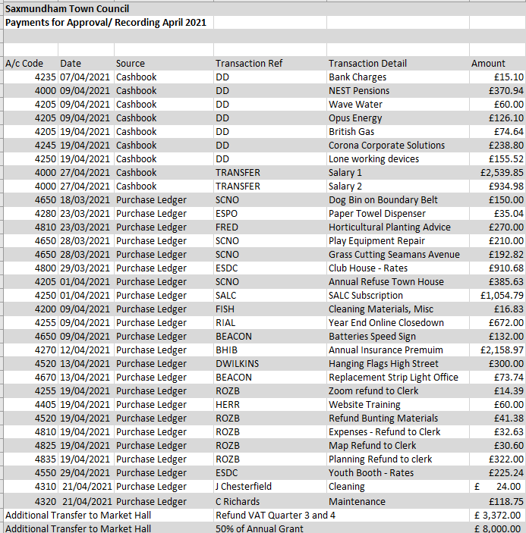

**Appendix B**

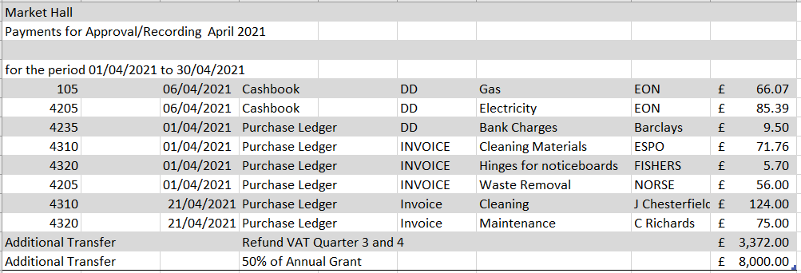

**Appendix C**

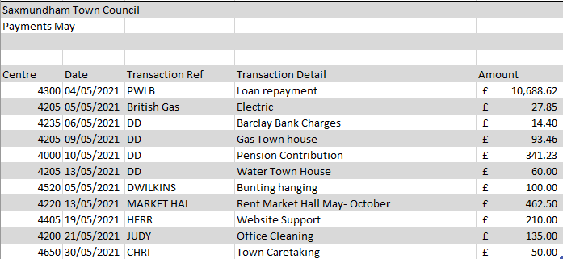

**Appendix D**

