

**Saxmundham Town Council** ,

**Minutes of the Resource Committee Meeting 26 April 2021 at 2pm**

**by Video Conference**

**Committee Members:**

Councillor. Di Eastman

Councillor. John Findlay (Chair)

Councillor John Fisher

Councillor. Nigel Hiley

Councillor. Jeremy Smith

**Also Present**: Rosalind Barnett (Town Clerk)

|  |  |
| --- | --- |
| **88/20R** | **Apologies for Absence**  No apologies were received. |
| **89/20R** | **Declarations of Interest**  Councillor Eastman declared a non-pecuniary interest as she is a trustee of the IP17 Good Neighbours Scheme. |
| **90/20R** | **Minutes of the Previous Meeting**  It was unanimously **RESOLVED: To accept the minutes of the 22 March 2021.** |
| **91/20R** | **Public Forum**  There were no members of the public present. |
| **92/20R** | **Finance**   1. Councillors noted the payments receipts and reconciliation for March. 2. **RESOLVED:** **Councillors approved the payments for the Town Council that had been circulated with the addition of two late payments C Richards for caretaking activities (£75) and J Chesterfield for cleaning activities £124. (Appendix A)**   **The Clerk asked the Committee to note the receipt of additional CIL Income of £30757 for April.**   1. **RESOLVED: Councillors agreed the payments for the Market Hall that had been circulated with the addition of two late payments C Richards for caretaking activities (£118.75) and J Chesterfield for Cleaning activities (£24) (Appendix B)** 2. The Chair noted the positive outcome in this year’s budget. He commented that the CIL income was still showing in the accounts and distorting the budget position. The Clerk advised that she had received advice that CIL must be shown in the accounts. However, the CIL income and expenditure should be coded to earmarked reserves.   Councillors noted the report and asked for separate reports one on the Town Council’s Budget without CIL and a separate report on CIL |
| **93/20R** | **Financial Regulations – Payments**  Councillors discussed the paper on payments and after discussion made the following decisions.   1. **RESOLVED: Councillors agreed that payments report to Council should be taken directly from the Rialtas software.** 2. **ReSOLVED: to recommend to the Town Council that the RFO shall prepare and submit a complete schedule of actual payments to the Town Council for retrospective ratification each month.** 3. **ReSOLVED: to recommend to the Town Council that to allow for the change above that the financial regulations are amended to:**   ***The RFO shall prepare and submit a schedule of payments to the Council for each month of the year and payments made shall be retrospectively ratified by the Council. (Where there is clear authorisation of the payment and sufficient funds in the budget the Clerk will make any payments). All invoices for payment shall be examined, verified and certified by the RFO to confirm that the work, goods or services to which each invoice relates has been received, carried out, examined and represents expenditure previously approved by the Council. Where the invoice exceeds the authorised expenditure by up to 20%, the Clerk will seek an additional approval from the chair of the Resources Committee. Where the excess amount exceeds the authorised expenditure by more than 20% the RFO will seek Committee approval.***   1. **ReSOLVED: to recommend to the Town Council that an amendment be made to the Financial Regulations to raise the expenditure threshold to £1000 for the requirement of three estimates.** (The Clerk however would be expected to always seek best value in all contract works as stated in the financial regulations). 2. **RESOLVED: Councillors agreed the annual pre-approved payment list (Appendix C)** |
| **94/20R** | **Year End Issues**   1. Councillors noted that there was a reported VAT underclaim of £175. 97 for the Market Hall (for the final quarter of 2019-2020). The Clerk advised that she had consulted with previous clerks and checked the records but had not been able to see what the claim related to and therefore it was difficult to pursue.   **ReSOLVED: to recommend to the Town Council that the Council agrees not to pursue the underclaim.**   1. Councillors discussed the risk registerand noted that some additional work would be required on the mitigation of risks especially about the instigation of bank electronic payments. It was agreed however that the document should be sent to the Town Council for approval.   **ReSOLVED: to recommend to the Town Council that the Council adopts the Risk Register**.   1. Councillors discussed the internal control statement and asked Councillor Eastman and the Clerk to complete the internal control document before the May Town Council meeting.   **ReSOLVED: to recommend to the Town Council that the Council approves the internal control statement and arrangements.** |
| **95/20R** | **Operational Issues**   1. The Clerk explained that she had reviewed the waste management contract for the Market with the traders and the Assistant Clerk and suggested that the disposal could move to fortnightly collection which would reduce the costs to £559.42. **resolved:** **that the Clerk make the reduction to the Market waste management contract.** 2. The Clerk explained that the new website would need ongoing technical support and the staff would require training on the maintenance of the site.   **RESOLVED: that Herring Bone Design be contracted for 20 hours of support at £60 per hour for 2021-2022. It was agreed not seek additional estimates for website support this year as Herringbone were given the contract for the website design and should be held responsible for any revisions.**   1. The Clerk gave a report in the increased costs around IT arrangements and alerted councillors that there will be an overspend in the budget line 4255.     **RESOLVED: That the payments listed were approved expenditure and the probably overspend was noted.** |
| **96/20R** | **Staffing Matters**   1. Councillors considered the paper on the Assistant Clerk’s hours and agreed with the revised workload that a slight increase in hours was required.   **RESOLVED: that the Assistant Clerk Hours will be increased to 22.5 hours from the 1st of June.**   1. It was agreed to defer the appraisal scheme guidance discussion. 2. The Clerk reported that the environment coordinator post had been advertised and there has been interest. The Closing date is set for the 13th of May with interviews scheduled for the 20th of May. |
| **97/20R** | **Small Grants**  Councillors discussed the grant application and supported the idea of the Community Cinema event. Councillors asked that the Clerk to review the grants programme with a view to advertising it to the whole community.   1. **RESOLVED: That a grant of £500 was agreed to St John’s Church for a Community Film Event.** |
| **98/20R** | **RESOLVED that Pursuant to Section 1 (2) of the Public Bodies (Admission to Meetings) Act 1960 the public and press be excluded from the meeting on the grounds that publicity would be prejudicial to the public interest by reasons of the confidential nature of the business to be transacted** |
| **99/20R** | **IP17 Good Neighbours Scheme (GNS)**  Councillor Eastman reported that the employment contract was about to be finalised. It was agreed that the Clerk should pay 50% of the grant when Councillor Eastman had confirmed the contract had been signed. |

Meeting finished 3.58 pm

**Roz Barnett Clerk/RFO**

**Appendix 1**

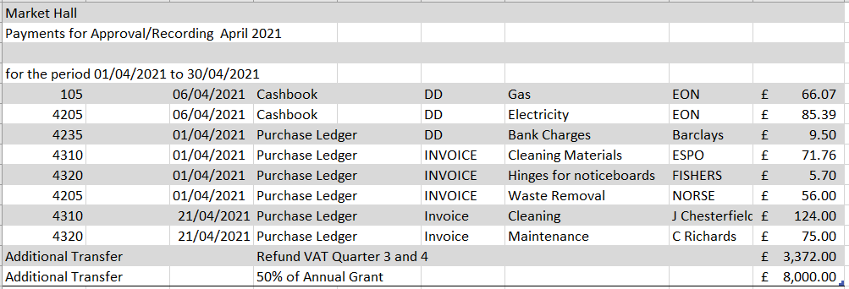**Appendix 2**