Roz Barnett
Saxmundham Town Council
Town Council 13 September 2021

Item 3 - Minutes of the Previous Committee Meetings:
- To receive and note the draft minutes of the Resources Committee held on the 26 July 2021. (Appendix 2).

Minutes of the Resource Committee Meeting 26 July 2021 at 2pm
In the Saxmundham Market Hall

Committee Members:
Councillor Di Eastman
Councillor John Findlay (Chair)
Councillor John Fisher
Councillor Nigel Hiley
Apologies: Councillor Jeremy Smith
Also Present: Rosalind Barnett (Town Clerk)
Public Forum: There were no members of the public present.
Please note all documents related to these minutes can be found in the committee pack http://www.saxmundham.org/council/template1-3/

123/21R | Apologies for Absence  The Clerk reported that apologies were received from Councillor J Smith.
124/21R | Declarations of Interest  Councillor Hiley reported a non- pecuniary interest in item 128/21 as he is a trustee of the Gannon Rooms.
125/21R | Minutes of the Previous Meeting  RESOLVED: The minutes of the 28 June 2021 were adopted as a true and accurate record.
126/21R | Finance  - RESOLVED: That the Committee noted and ratified the payments and receipts reconciliation reports for June for the Town Council (Appendix A) It was noted that there was an error in the payment list as the SALC payment should have been recorded as a £550.80. The Clerk explained that the correct amount was paid to SALC.  - RESOLVED: That the Committee noted and ratified the payments and receipts reconciliation reports for June for the Market Hall (Appendix B)  - The Committee noted that there were no additional approvals required for the listed payments for July for the Market Hall and Town Council.  - The Committee received the June budget and spending report For the Town Council.  - The Committee received the June budget and spending report for the Market Hall.
127/21R | Operational Matters  - The Resources Committee noted the Clerk had extended the existing photocopying contract with BNP Paribas Leasing for an additional year at an immediate reduced quarterly rental cost of £270.52 (making a saving of £460 per annum). She had sought cheaper quotes, but the nearest comparative cost secured was for £283.82 per quarter.  - The Clerk reported that the Scouts are requesting a payment for the electricity for the Youth Booth as the electrical power to the Youth Booth goes via the Scout Hut and the usage is monitored on a sub-meter. The scouts have not issued an invoice to Access Community Trust since March 2019 so there is over two years’ supply to be reimbursed at a cost of £1595.72. The Committee recommended that the electricity usage should be considered when the CYDS licence for the Youth Booth is renewed.  The Clerk reported that the manhole cover at the back of the Scout Hut had been removed and that this had been raised with the Scouts. She reported that this is a hazard, and the Town Council had sought a quote for a repair and would be liaising with the Scouts over its replacement.  RESOLVED: That the Committee agreed to the electricity payment at a cost of £1595.72 once the Clerk had secured the details from the electricity bills. The Clerk was asked to secure a copy of the Scout Hut lease and investigate costs of installing a separate electric meter.
128/21R | Banking  The Committee discussed the report on the banking arrangements for the Town Council.  It was noted that many Parishes now bank with Unity Trust Bank as they offer triple payment authorisation and offer specialist sector knowledge. The Unity bank also has strong ethical standards with a track record in investing in local communities and sustainable projects. Councillors raised concerns about the switch over process but the Clerk reassured the Committee that this would be handled by the bank.  RESOLVED: That the the Resources Committee recommend to the Town Council that they move their business bank accounts to the Unity Bank at an appropriate time.
129/21R | Gannon Rooms  The Clerk reported that the new trustees are working with the Clerk to become signatories for the Gannon Institute Accounts. She explained that she was having difficulties registering the new trustees online and is seeking further advice. The condition survey of the building will be completed by the end of July ready to be discussed at a meeting of the trustees in August. SALC has provided a consultant free of charge to investigate the best options for transferring the Gannon Rooms over to the Town Council, if this is agreed.  RESOLVED: That the Clerk will work with the trustees and Chair of the Council to prepare a full report for consideration at the September Town Council Meeting.
130/21R | Market Hall Trust Request for Finances towards the Kitchen Refurbishment  The Committee noted that the kitchen refurbishment is expected to cost around £18,500, and the Market Hall has a shortfall of £10,500 for the refurbishment costs. The Committee expressed concerns that if there was unexpected maintenance in the year that the Trust may have to come back for some additional resources.  The Clerk explained that she would still be looking for additional grant funding for the project over the summer.  RESOLVED: That the Resources Committee recommend to the Town Council that they allocate an additional £10,500 to the Market Hall Trust from the Capital Reserve to enable the completion of the kitchen restoration.
131/21R | Volunteer Management  The Committee discussed the volunteer documents and the arrangements for supporting volunteers. The Committee recommended that a volunteer agreement is used with every volunteer.  RESOLVED: That the Committee asked the Clerk to do some additional work on the documents with the Chair of the Staffing Committee before presenting the revised documents for final approval. The Committee agreed that the documents as presented should be used for operations until the final draft is approved.
132/21R | Appraisal Policy  The Committee discussed the Appraisal Scheme and agreed that the appraisal form should be amended to use the term appraiser rather than manager.  RESOLVED: That the Resources Committee recommend to the Town Council that the revised amended Appraisal Scheme and form be adopted.
133/21R | Small Grant Applications  The Committee discussed the application from the Marie Curie Cancer charity and whilst supportive of the idea of making a grant raised concerns that a donation to a national charity was outside of the scope of the Council’s grant giving policy.  RESOLVED: That the Clerk was asked to seek some additional information about how Marie Curie would spend the money in the Parish of Saxmundham.
134/21R | Town Centre Co-ordinator Post  The Committee discussed the fact that the Town Council had only received written feedback from three businesses on the idea of the appointment of a part-time Town Centre Co-ordinator. It was suggested that the Clerk and the Councillor Eastman talk to the businesses to obtain a wider selection of views.  The Committee recommended that if the advert goes ahead that the appointment panel should include the Chair of the Staffing Committee, Chair of the Council, the Clerk, and a representative of the business community.  East Suffolk District Council has given some feedback on the draft application for funding and have requested that the Town Council provide match funding for the laptop and programme budget.  The Committee asked for clarification on what will the post holder complete in relation to the website. The Clerk explained that they would take over the business listings and promotion articles in relation to the Town Centre Activities.  RESOLVED: That the Committee agreed to allocated £1500 from the events budget as match funding for the Town Centre Co-ordinator post if the business community give their support for the post.
135/21R | RESOLVED: that Pursuant to Section 1 (2) of the Public Bodies (Admission to Meetings) Act 1960 the public and press be excluded from the meeting on the grounds that publicity would be prejudicial to the public interest by reasons of the confidential nature of the business to be transacted
136/21R | Probation and Appraisal of Clerk  The Chair of the Staffing Sub-committee gave a report on the Clerk’s appraisal process and probation period which was then discussed by the Committee.  RESOLVED: That the Resources Committee approved the Staffing Committee report and agreed that the Clerk’s probation period had been completed successfully and confirmed her appointment as the Town Clerk for Saxmundham Town Council. The Chair confirmed and that this should be reported to the September Town Council Meeting.

Meeting finished 3.29 pm
Roz Barnett Clerk/RFO

Appendix A
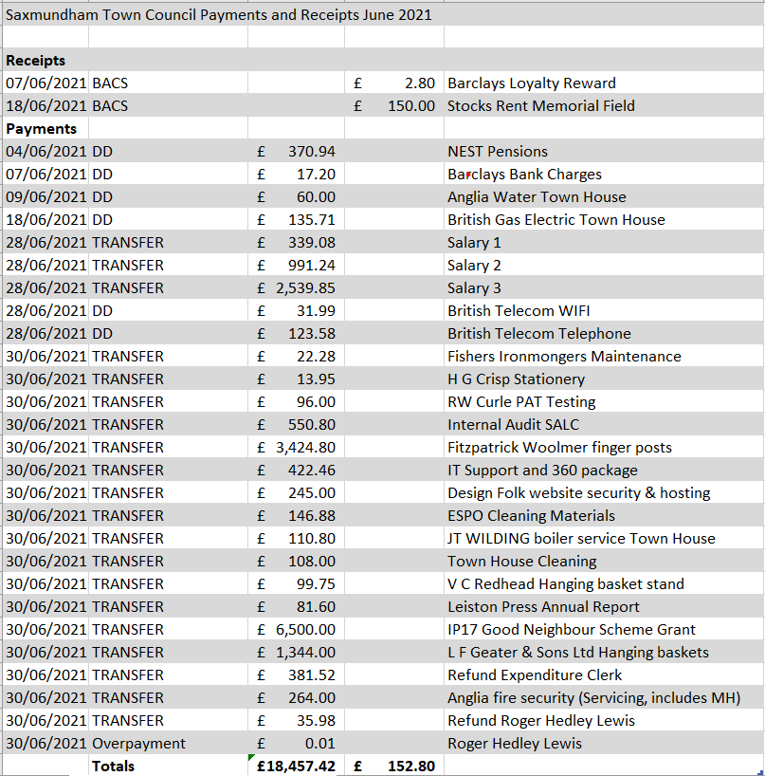

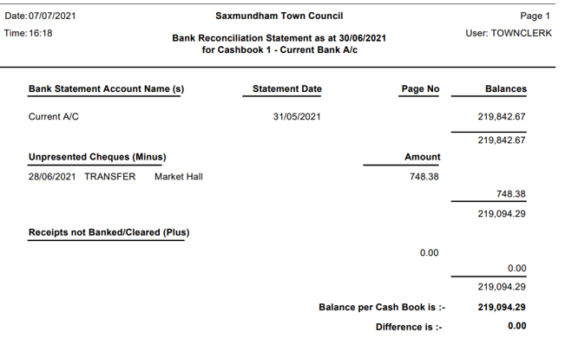

Appendix B
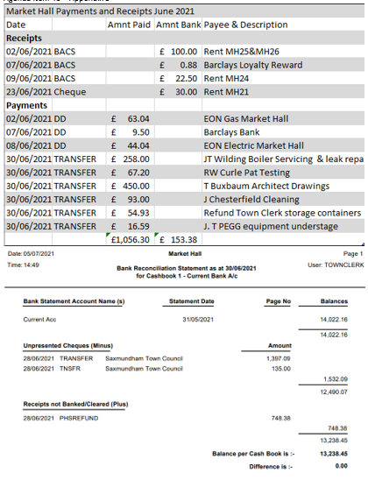

- To receive and note the draft minutes of the Amenities Committee held on the 19 July 2021. (Appendix 3).

-
Minutes of the Meeting of the Amenities & Services Committee
6.00 PM 19 July 2021 at Saxmundham Market Hall

Councillors:
Councillor D. Eastman
Councillor C. Hawkins
Councillor R. Hedley Lewis

Apologies: Councillor T. Lock (Chair)

Also Present: Roz Barnett (Town Clerk)

15/21AS | Apologies for absence  Apologies were received from Councillor T Lock.
16/21AS | Pecuniary/Non-Pecuniary Interests  There were no declarations of interests.
17/21AS | Minutes of the Previous Meeting  RESOLVED: It was unanimously RESOLVED to approve the minutes of the meeting 21 June 2021.
18/21AS | Updates from the Clerk  - The Clerk reported that East Suffolk have confirmed that dog waste can be deposited in any bin accept the recycling bins. They have offered to put stickers on the mixed waste bins in the Town Centre. The Clerk explained that she had reminded East Suffolk about the new dual use new litter bins on Fromus Green and Rendham Rd. East Suffolk District Council have kindly provided a map and details of the bins in Saxmundham. They have also informed the Clerk that they would expect the Town Council to pay for any new bins or renewals in the Town.  - The Clerk reported that the station has been completed but there are still some snagging issues to be completed. Greater Anglia have offered a couple of locations for the Saxmundham Town Map. One on the exit of the west bound platform and one on the Station East platform under the Saxmundham Station sign. The Clerk is liaising with them about costs and installation. The Clerk will be assisting Greater Anglia organise an official opening in September.  - The management of the Town Noticeboards was raised, and Councillor Hawkins offered to be noticeboard monitor and remove inappropriate and out of date information.  Resolved: East Suffolk District Council will place stickers on dual use rubbish bins in the Town Centre. That two Saxmundham maps will be installed at the Station and the Clerk will notify the Committee it there is any additional costs.
19/21AS | Memorial Landscape Project  - The Clerk reported that she has written to the Managing Agent of the Mayflower Estate, to see if they would consider a new entrance from Rendham Rd. She also explained that a site meeting has been arranged with Norse to discuss the mowing regime and potential costs. The Committee asked the Clerk to acquire costs for pitch marking and possible improvements to the football pitch area. They also suggested that Anglia Water be approached about creating a wildlife pond in the land that they manage. It was suggested that some thought be given to having a concession on the site for food and drinks.  - The Committee decided not to contract a landscape designer as they were happy with the plans tat had been developed by the inhouse team. It was agreed to allow up to £1000 to pay for CAD drawings when required and some consultation time with Frederic Whyte to review the current plans as devised by the Working Group.  - The Clerk explained that six play companies had visited the site and would be reporting back their ideas on the 5 of August. It was provisionally proposed that the working group meet to discuss the ideas on the 9th of August. (This has now been changed to 10am on the 17 August).  - It was agreed that the beginning of the September Town Council meeting would be open to the public to formally consult on the proposals for the Memorial Field.  It was agreed to have an informal consultation event at the Memorial Field to consult with site users. The Clerk was asked to liaise with CYDS and agree a date. The Committee asked the Clerk if she could ask CYDS to postpone the development of the raised bed until after the consultation. She explained that she would have to check as she had already given them permission as this had been agreed at the May Amenities Committee.  Resolved: The Clerk to arrange a consultation meeting with Frederic Whyte with the Memorial Field Working Group on the current plans. That a consultation event be organised at the Memorial Field to discuss the proposals with users of the site.
20/21AS | High Street Furniture and Floral Decorations  - The Committee discussed the proposals for a radical rethink of the floral decorations for the Town Centre. It was agreed that Councillor Eastman the Town Clerk would consult with Town Centre businesses on their displays and get their ideas and views on what can be improved. It was suggested that an online questionnaire be prepared to collate all their opinions. Once this was completed it was proposed that the Committee develop proposals for the Town Centre to present to the Town Council for additional funding. It was noted that all the planning would need completing by December if proposals were to be ready for implementing in January ready for summer season 2022.  - Welcome Back Fund Update: The Clerk reported that East Suffolk were offering money for Gazebos, signage and bunting, and the Clerk had placed an order for some bunting suitable for next year’s platinum jubilee celebrations. She also explained that she was hoping to secure an order for at least 3 gazebos and fly banners that could be used for events and publicising the Market. She informed the Committee that information on funding for plants and planting would be coming from another East Suffolk team later in the year.  Resolved: That the committee will work with local businesses to improve the Town Centre floral displays.
21/21AS | Annual Plan & Monitoring of Maintenance  The Clerk explained that the planned site visits would form the basis of the Town Council’s annual work programme for managing their assets and asked for feedback on the proposed maintenance form  Resolved: That committee members would conduct site visits to identify maintenance and development ideas for all the Town Council sites.
22/21AS | Town Gateways  The Committee discussed the proposed planting ideas for the entrances and approved the plans for native planting and bulbs, however they agreed that some evergreen and structural planting would be required for it to have all round seasonal appeal. It was suggested that elements of the Dutch urban planting installed at the station could be used. The Committee decided that they did not want any raised beds.  The Clerk reported that a meeting was recently held with The County Councillor and potential ideas for improvements to the Gateways were discussed. The Clerk has now written again to the Highways department with the support of the County Councillor and is waiting for their approval on the improvements to the planting on the existing entrances and their further advice on creating new entrances on Church Street and Rendham Road as detailed in the report prepared by Councillor Hedley Lewis. The Clerk has also requested their advice on speed calming measures.  Resolved: That improvements to the planting at the North and South Entrance as soon as approvals are received from Highways.
23/21AS | Street Furniture Requests:  None received.
24/21AS | Correspondence  The Committee expressed concern about the number of emails the Town Council had received in relation to mowing and the vegetation management in the Town. It was noted that only one complaint related to the Memorial Field, and this was the cutting of the grass on the football pitch. This issue is being dealt with under the new mowing regime that is being put in place.  Resolved: The Clerk was asked to raise the matter with East Suffolk District Council asking them to improve the communication to the public about the importance of creating areas of biodiversity and stressing that the areas used by the public for recreation should be mown regularly so that the amenity of usable open space is not lost.
The meeting closed at 7.42 p.m.
Roz Barnett
Clerk to Saxmundham Town Council, Old Police Station, Approach Road, Saxmundham, IP17 1BW
Tel: 01728 604595

- To receive and note the draft minutes of the Market Hall Committee held on the 19 July 2021. (Appendix 4)

Minutes of the Meeting of the Market Hall Management Committee
7.00 PM 20 July 2021
Members of the Committee:
Carole Cecil
Councillor Di Eastman
Councillor John Findlay
Councillor. Jeremy Smith (Chair)
Also Present:
Roz Barnett (Clerk)

1/21MHC | Apologies for absence  Councillor Charlotte Hawkins, Councillor Tim Lock and Rosie Hoare
2/21MHC | Pecuniary/Non-Pecuniary Interests  There were no Declarations of Interests.
3/21MHC | Minutes of the last meeting  It was RESOLVED to accept the minutes of the previous meeting held on the 5 May 2021.
4/21MHC | Finance Reports  The Committee received the budget report for April- June 2021. It was noted that there was an overspend on the cleaning budget due to the PHS sanitary disposal contract.
5/21MHC | - Market Hall Improvements Phase 1-  - It was noted that there are problems with the connections to the new projector. The Clerk explained that the wireless option is now working, and the Town Hall handbook had been updated with an instruction sheet. The plug-in option however was still proving problematic. The Assistant Clerk has arranged for the electricians to come and test the circuits that they installed. The Clerk also explained that the light switches had not been installed at an accessible height and was seeking quotes to have this rectified as a matter of urgency because of the health and safety issues.  RESOLVED: It was noted that the Clerk in consultation with the Chair may use delegated powers to arrange for the safe repositioning of the light switches because of the health and safety implications.  - The Committee discussed the report on kitchen improvements, costs, and schedule of works. It noted the Clerk’s proposal for budget of £18,500 for works plus kitchen units. The Committee agreed it would be best value to award the tender to DBS Projects subject to Town Council approval and references for the contractor. This would not include the stainless steel units. It was noted that there could be some negotiation on the price as the requirements of the fire risk assessment had changed slightly. The Committee were informed that the kitchen door and hatch had been referred to in the fire risk assessment but had been marked as a low priority. (Unusually low likelihood of fire as a result of negligible potential sources of ignition). It was agreed to try and arrange the installation for the first two weeks of January to ensure minimum disruption.  RESOLVED: The Committee agreed to recommend to Saxmundham Town Council that it award the tender for the kitchen refurbishment to DBS Projects at a cost of £13,879 plus VAT subject to references for the contractor, and any reduction from reduced specification. RESOLVED: The Committee agreed to purchase the kitchen equipment £4668 from Anglia Catering equipment if the Town Council agrees to the additional funding and choice of contractor.  - The Committee agreed to request an additional £10,500 for the kitchen improvements from the Town Council’s capital replacement reserve. This would be in addition to allocations from the Market Hall budget and reserve, and would also assist with the purchase of kitchen units. The Clerk was also asked to actively pursue additional external funding.  RESOLVED: The Committee agreed to request Saxmundham Town Council to allocate an additional £10,500 from the capital reserve as a grant contribution towards the kitchen refurbishment costs estimated at £18,500.
6/21MHC | Market Hall Improvements Phase 3- Frontage and Toilets  - The Committee agreed that a drainage survey was required to ensure there was enough capacity to move the toilets to the rear of the Market Hall.  Resolved: That the drainage survey be commissioned for the Market Hall at a cost not to exceed £300 from Bower Drains.
7/21MHC | Bookings 2021- 2022  The Committee received the bookings report up to 1 July that projected an income for the year of £7357.50. The Committee noted that the current regular bookings are:  - Town Council meetings,  - IP17 Good Neighbour Scheme, Gather and Grow and Line Dancing.  - Active Adults  - ABC Radio (licence)  - Driving test centre (monthly)  - Britten Pears Arts – Music Workshops (fortnightly)  The Clerk explained that from September carpet bowls, keep fit and U3A will be returning to the Hall. The Market Hall had also received one off bookings for a jumble sale and a Memorial Service in August. She mentioned that the booking for regular Friday night bingo had been cancelled.
8/21MHC | Developing the Market Hall as a venue  - The Committee discussed the guidance on the usage of the Market Hall and suggested an advisory limit of 70 people for events for the time being. They also made suggestions on wording of the ‘keeping safe’ poster. The Committee discussed the report provided by Rosie Hoare on the Autumn Events. They asked the Clerk to discuss arrangements with Rosie and agreed to underwrite any losses for the events, given their role in supporting community cohesion and the reduced attendance limits. The Committee had previously agreed to use the £1000 Events budget to support the events programme (especially in case numbers were limited by government guidance).  Resolved: It was agreed that the Clerk would discuss the financial arrangement with Rosie and either pay bills direct or provide an operating float (on the basis that Rosie keeps receipts and a record of expenditure as per previous programmes).  - Di Eastman, Chair of the Events Committee reported that there had been a meeting with the Art Station representatives with a view to setting up a Makers Market for Local Producers. The plan is to organise 4 events a year and it is proposed that stall holders will be charged £8 a table without electricity and £10 with.  RESOLVED: That the Market Hall Trust agrees to set up a Makers Market on a partnership basis with the Art Station with 50% of the income going to the Art Station and 50% going to the Market Hall Trust.  - The Committee welcomed the proposal from Britten Pears Arts for Music workshops at the Market Hall.  - The Committee noted that the Clerk had registered the Market Hall with Creative Arts East with a view to developing an annual programme of events (dependent on Covid 19 restrictions). The Committee hoped that this could be linked to the 750th anniversary celebrations and include a wide range of events and a historical display.

The meeting closed at 8.24pm.

Roz Barnett
Clerk to Saxmundham Town Council,

To receive and note the draft minutes of the Planning Control Committee held on the 21 July 4,11 and 25 August 2021. (Appendix 5).

Minutes of the Meeting of the Planning & Development Control Committee
6.00 PM 4th August 2021 in the Market Hall

Councillors:
Cllr. John Fisher (Chair) |  | Cllr. Roger Hedley-Lewis
Cllr Nigel Hiley

Also Present: Jenny Morcom,(Assistant Town Clerk (ATC).

46/21PD | Apologies for absence  Apologies were received from Cllr Charlotte Hawkins who is attending a memorial service.
47/21PD | Pecuniary/Non-Pecuniary Interests  None declared.
48/21PD | Minutes of the meeting held 21st July 2021  It was unanimously RESOLVED to approve the minutes of the meeting held on 21st July 2021.
49/21PD | Open Forum  No members of the public had joined the meeting.
50/21PD | Planning Applications  DC/21/3319/LBC 11 Albion St, IP17 1BN Paint exterior of brick built outbuilding and rear of 1970s extension.  It was unanimously RESOLVED to support the application.  DC/21/3457/TCA Fairfield House South, Fairfield Rd, IP17 1AX Fell one leylandii and reduce another  It was unanimously RESOLVED to support the application.  DC/21/3453/TCA 24 North Entrance, IP17 1AU Fell three trees, two thuja, one beech, and prune a copper beech.  It was unanimously RESOLVED to support the application.
51/21PD | Recent Planning Decisions.  The Committee noted the following decisions:  DC/21/0317/FUL Saxmundham Free School , Seckford Trust Construction of new 2-storey AP building and associated hard and soft landscaping Permitted  DC/21/2136/FUL 10 Manor Gardens, IP17 1ET Replacement of side extension to form open plan kitchen, alteration to first floor bedroom ensuite, changes to fenestration, cladding to exterior and proposed single garage Permitted  DC/21/2491/LBC Ipswich Building Society, 10 High St Proposed replacement of brand signage to shop front and replacement of existing hanging sign and new branding. Permitted  DC/21/2598/FUL 5 Manor Gardens, IP17 1ET Two-Storey Rear Extension and Replacement of Existing Roofs to Single-Storey Entrance Hall, Playroom and Garage. Permitted
52/21PD | To receive an update on the derelict building at 32 High St.  The ATC reported that Building Control have confirmed that they have identified the owner of the building and that East Suffolk Council are expecting a planning application imminently as a pre application has already been submitted. Building Control will, however, ask the owner to carry out some immediate works to make the building safe including:  - Removing the roof.  - Cutting the buddleia  - Partitioning/boarding-up so that the public cannot access the building.  The Committee noted the update.
 | The next meeting of the Planning and Development Control Committee will be at 5.30 pm on Wednesday 11th August 2021.

The meeting closed at 6.27 p.m.

Jennifer Morcom, Assistant Clerk to Saxmundham Town Council
The Town House, Station Approach
Saxmundham, IP17 1BW

Minutes of the Meeting of the Planning & Development Control Committee
5.30 PM 11th August 2021 in the Market Hall

Councillors:
Cllr. John Fisher (Chair) |  | Cllr. Roger Hedley-Lewis
Cllr Nigel Hiley |  | Cllr Charlotte Hawkins
Also Present: Jenny Morcom,(Assistant Town Clerk (ATC).

53/21PD | Apologies for absence  There were no apologies for absence.
54/21PD | Pecuniary/Non-Pecuniary Interests  None declared.
55/21PD | Minutes of the meeting held 4th August 2021  It was unanimously RESOLVED to approve the minutes of the meeting held on 4th August 2021.
56/21PD | Open Forum  No members of the public had joined the meeting.
57/21PD | Planning Applications  DC/21/3564/FUL: 70 Fairfield Rd, IP17 1BB - Single storey rear extension  It was unanimously RESOLVED to support the application.  DC/21/3677/FUL: Saxmundham Free School - New fence  It was unanimously RESOLVED to support the application.
58/21PD | Recent Planning Decisions.  The Committee noted the following decision:  DC/21/2939/TPO: T1 Ash Tree on council land to rear of 11-17 Ashfords Close: Weak lower union, encroaching heavily over the 3 private gardens. Reduce the crown all round by 30% to maintain safety and manage crown in relation to properties. permitted
 | The next meeting of the Planning and Development Control Committee will be at 6 pm on Wednesday 25th August 2021.

The meeting closed at 5.40 p.m.

Jennifer Morcom, Assistant Clerk to Saxmundham Town Council
The Town House, Station Approach
Saxmundham, IP17 1BW

Minutes of the Meeting of the Planning & Development Control Committee
6.00 PM 25th August 2021 in the Market Hall

Councillors:
Cllr. John Fisher (Chair) |  | Cllr. Roger Hedley-Lewis
Cllr Nigel Hiley |  | Cllr Charlotte Hawkins
Also Present: Jenny Morcom,(Assistant Town Clerk (ATC).

59/21PD | Apologies for absence  There were no apologies for absence.
60/21PD | Pecuniary/Non-Pecuniary Interests  None declared.
61/21PD | Minutes of the meeting held 11th August 2021  It was unanimously RESOLVED to approve the minutes of the meeting held on 11th August 2021.
62/21PD | Open Forum  No members of the public had joined the meeting.
63/21PD | Planning Applications  DC/21/3625/FUL 9 Aug 2021 31 Aug 2021 32 Albion St, IP17 1BL Single storey extension  It was unanimously RESOLVED that there were no objections to the application.  DC/21/3758/LBC 19 Aug 2021 10 Sept 2021 Old Bank House, Market Place, Saxmundham, Suffolk, IP17 1AG, Form new opening and gated access in existing rear boundary wall for new disabled access route to Old Bank House, with erection of new boundary wall to severance plot  It was unanimously RESOLVED to support the application especially as it will help disabled people..
64/21PD | Recent Planning Decisions. The Committee noted the following decisions:  DC/21/3274/DRC 12 July 2021 2 August 2021 Saxmundham Railway Station, IP17 1BW Proposal: Discharge of Condition 3 on Application DC/20/2930/VOC Variation of Condition 2 of Planning Permission DC/19/2685/FUL P and D 21 July 30/7/2021 P and D noted the application Permitted  DC/21/3453/TCA 22 July 2021 12 Aug 2021 24 North Entrance, IP17 1AU Fell three trees, two thuja, one beech, and prune a copper beech. P and D 4 Aug 2021 5 Aug 2021 – STC supports the application. Responded – no objections  DC/21/3457/TCA 22 July 2021 12 Aug 2021 Fairfield House South, Fairfield Rd, IP17 1AX Fell one leylandii and reduce another P and D 4 Aug 2021 5 Aug 2021 – STC supports the application. Responded – no objections
65/PD21 | Report on Sizewell C  Cllr Hiley reported that he had attended an on-line hearing about noise, pollution and air quality. Cllr Hiley used this opportunity to raise concerns about the potential for noise pollution and vibration caused by additional trains running through Saxmundham. EDF responded that there would be a maximum of four trains per night for a period of four or five years rather than for the entire development period, and that they would provide mitigation for those homes affected by the noise. Cllr Hiley is attending further meetings on 27th August and 1st September 2021.  Cllr Fisher mentioned that there would be a ‘Human Wall’ protest on Sizewell Beach at 10am on 19th September 2021
 | The next meeting of the Planning and Development Control Committee will be at 6 pm on Wednesday 15th September 2021.

The meeting closed at 6.25 p.m.

Jennifer Morcom, Assistant Clerk to Saxmundham Town Council
The Town House, Station Approach
Saxmundham, IP17 1BW

Item 8 - 59/21TC Financial Matters
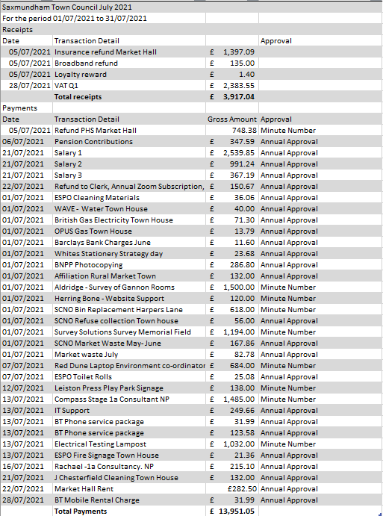
- To note and ratify the payments and receipts up to the 31 August 2021. (Appendix 6)

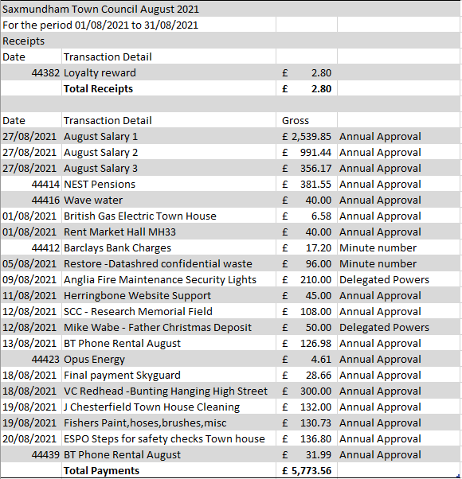

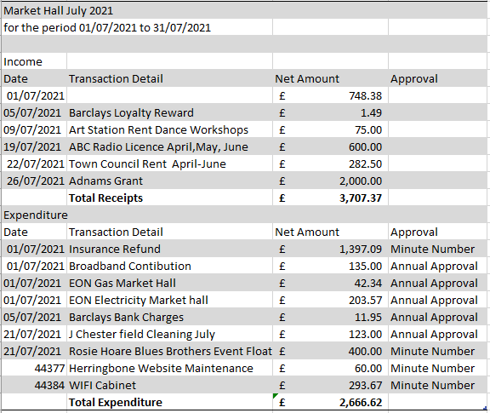

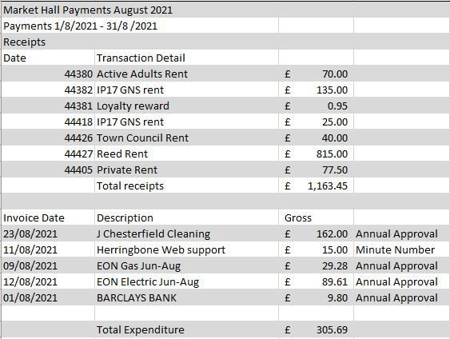
- To receive an income and expenditure report for the Town Council and Market Hall up to the 31 August 2021. (Appendix 7)
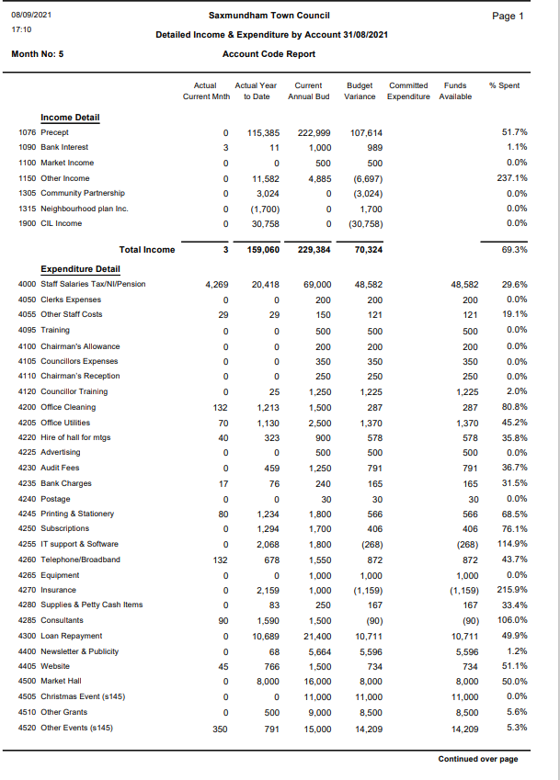

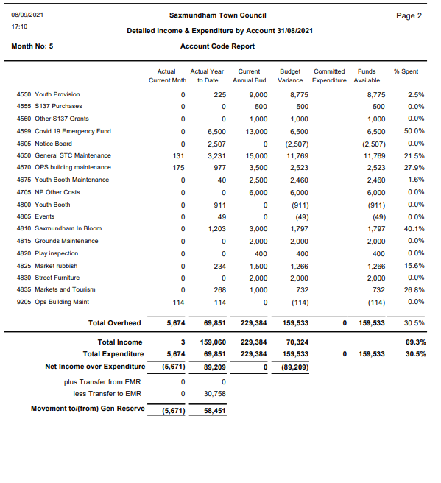

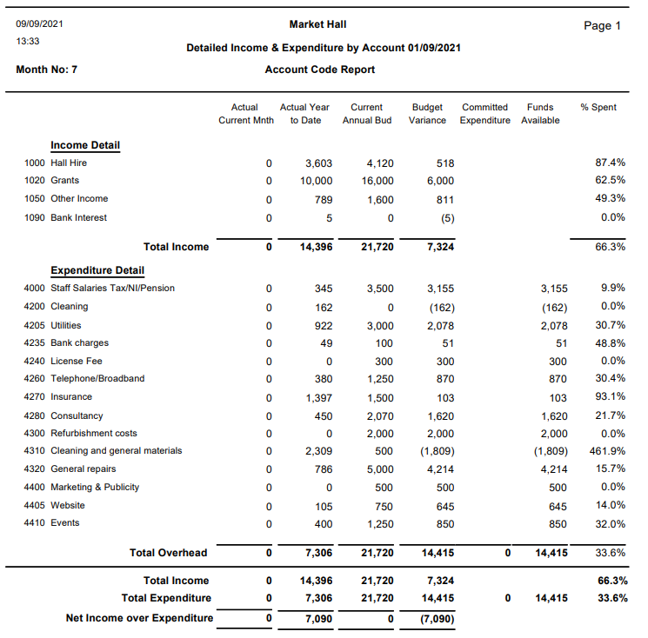

- To consider the Recommendation from the Resources Committee that the Town move their business bank accounts to the Unity Bank at an appropriate time.
Item no: | Item 4 - 59/21TC
Report dated: | Thursday, 22 July 2021
To the: | Resources Committee
Meeting on: | 26 July 2021
Subject: | Banking Arrangements
Contact/author: | Roz Barnett – Town Clerk

- Current Banking issues
  - Saxmundham Town Council currently holds accounts with the Cambridge Bank and Barclays Bank.

  - Two accounts are held with the Barclays bank; the first is the Town Council Account and the second is used for the Market Hall Trust. The current banking fee is £6 a month and 35p per transaction. They also provide a loyalty reward. (£17.64 received 2020-210

  - There are three main ongoing problems with Barclays Bank:
    - Poor customer care: to make a mandate change you must wait a minimum of 45 minutes before someone at a call centre answers the phone. They recently never received the request for a banking card which requires the Clerk to go through the process again. Their poor administration incurs additional costs to the Council.
    - Ethical banking: Barclays have been cited as having continued investment in fossil fuels and deforestation. https://www.ethicalconsumer.org/money-finance/whats-wrong-hsbc-barclays
    - Dual Authorisation: Barclays only offer dual authorisation which means that only one councillor can authorise payments. They also have unnecessary verification processes for regular payments which is inefficient.
    - Authorisations for regular payees: There are unnecessary security processes for regular payees which are time consuming.

- Proposal to consider moving to Unity Bank
  - Many Towns councils bank with Unity Trust Bank as they offer triple authorisation, consequently, they offer specialist sector knowledge. Who we help | Unity Trust Bank
The Unity bank has strong ethical standards investing in local communities and sustainable projects. https://www.ethicalconsumer.org/money-finance/shopping-guide/ethical-business-banking

  - They have excellent customer care and aim to answer the phone within 15 seconds by a person who is trained to deal with the business of the bank.

  - As well as being socially responsible, they are financially sustainable and have been a fully independent bank since 2015.

  - Unity Trust Bank offers:
    - Online and telephone banking, Online or paper statements,
    - Cheque book/ paying-in book upon request,
    - Triple authorisation of payments through online banking
    - Charges are £6 per month and 15p per individual debit and credit transaction
    - No credit interest is paid
    - No debit card is available. However, a charge card is available – the Unity Corporate MultiPay Card for which the charges are an initial £50 set-up fee and £3 per month for each card held.
    - They offer a service for a seamless transfer of all accounts and transactions.

- Recommendation.
That the Town Council move their business bank accounts to the Unity Bank at an appropriate time
(January 2022)

Item 9 60/21TC Memorial Field Consultation Update

- To consider feedback from the public consultation day (Appendix 9).

Consultation Event Tuesday the 31st of August
CYDS suggested to the Town Council that we run our consultation day to coincide with their planned skate jam. This ensured we had lots of people to talk to but also biased any findings towards the needs of the Skating contingent.
Key feedback from the Community Consultation Event
- Skaters would like a 4 ft skate bowl added to the skatepark
- Some skaters would like the area to be enlarged,
- Some skaters would like an area with small hills and jumps to accommodate beginners
- Lighting near the skate park and the youth shelter
- There are some safety issues identified with the existing layout.
- The basketball court is well used, and requests were made to extend the playing area.
- Request for toilets
- More benches
- Double Bridge over gully
- Pump Track
- More picnic benches required
- Suggested more flower beds
- The scramble boulder was the most popular piece of equipment.
- A climbing frame with a huge slide that feels like a tree house

- To receive a report from the Memorial Field Working Group on proposals (Appendix 10).

- Norse have instigated the new mowing regime and sent through the revised costs of maintenance. (This will be considered by the Amenities Committee).
- The Suffolk records office has produced a report and the Town Council has the minutes of the Memorial Committee to produce an information panel for the site.
- It was noted that a gate was part of the original plans for the site.
- Councillor Lock has produced a GANT chart to help the working group to manage the project.

Recommendations
That the Town Council conducts more consultation to get a wider cross section of views from residents.
That the Town Council asks the Amenities Committee to cost up the potential projects on the Memorial Field with a view to choosing 1-2 capital projects for completion during the 2021-23 planning period.

Item 10 - 61/21TC Events Working Group
- To receive the draft budget from the Chair of the Working Group on the arrangements for the Christmas Event (Appendix 11).
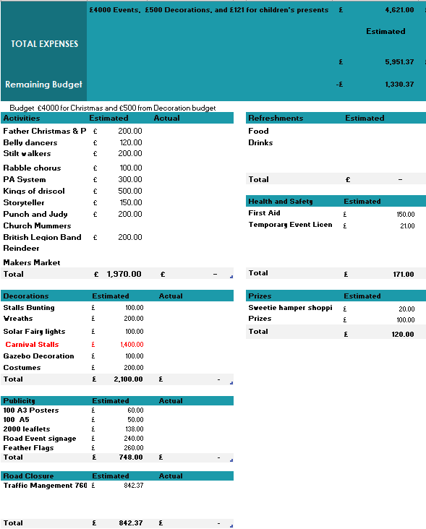
- To receive a verbal update on the festival funding application for the 750th celebrations and consider earmarking £2500 of the events budget in 2022 for Black Knight Historical for an enactment of the signing of the Market Charter.

Item 11- 62/21TC Report from the Environment Working Group
To receive a report from the Environment and Climate Change Working group and note terms of reference (Appendix 12)

Saxmundham Town Council Environment and Climate Working Group
Terms of Reference

Prime Objectives
To make recommendations on conducting an Environmental Audit and developing an action plan for the Town focussing on
- biodiversity
- Sustainable transport
- Energy use and strategies to enable the Council to become Carbon Neutral.
- local food resilience
- Improvements to the street and built environment
- Reduction in generation of avoidable waste
- Improvements to footpaths, hedgerows, green networks
- Water usage
Membership:
The Membership shall comprise:
- A minimum of three members of Saxmundham Town Council.
- Members of the public/local interest groups may be co-opted as members at the discretion of the working group.
- Other member of the community and special interest groups may, at the discretion of the Chair, be invited to attend specific meetings and/or provide expert advice to the committee.
- The Chair of the Working Group shall be a Councillor appointed by the Saxmundham Town Council
- The Vice Chair shall be elected from the Working Group.
Reporting and Recording
- Reports to Saxmundham Town Council
- Action notes to be kept
- Committee reports prepared by the working group would be submitted to the Town Council for consideration
- The working Group will be Clerked by the Environment co-ordinator and the Clerk will attend on occasion.
- Makes recommendations to Town Council other committees as appropriate.
Drafted by working Group 27/7/2021

Item 13 64/21TC The Gannon Institute Report (Appendix 13).
- To receive an update on the condition report on the Gannon Rooms. Below is an extract on the potential costs related to the Gannon Rooms and the building replacement costs.

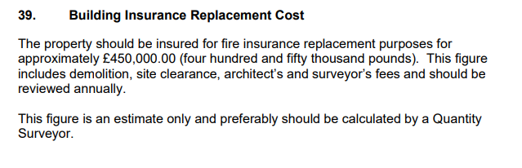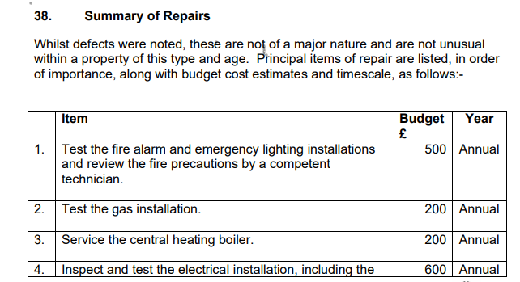
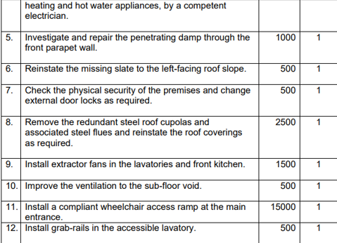
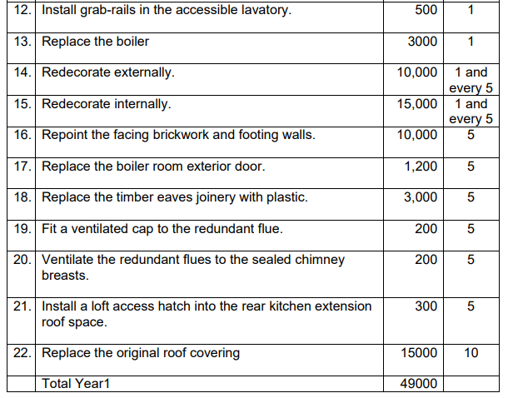
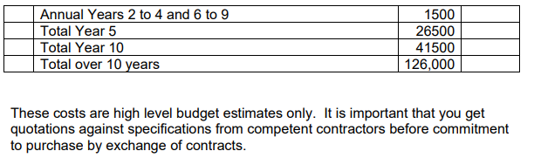

- To consider a request for grant funding for safety checks to enable the building to reopen
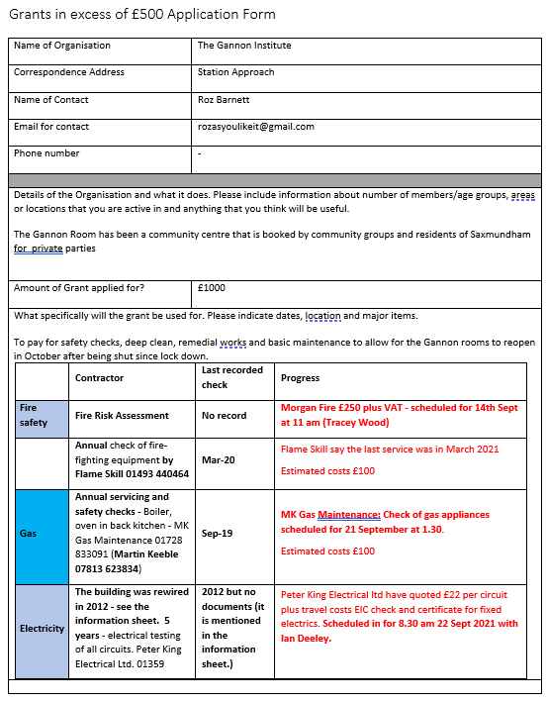
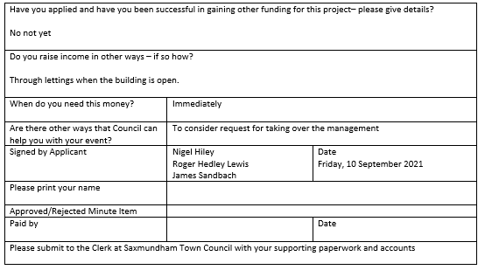
- To consider the options report and agree the next steps the Town Council should take in relation to the Gannon Institute. (Sent direct to Councillors by the Chairman)

Item 14 14 65/21TC Small Grants – To consider any applications
- To consider application for £500 from Britten Arts for music workshops for adults to combat social isolation (Appendix 14).

Dear Roz

I am writing to apply for a grant of £500 from Saxmundham Town Council to support delivery of the Participate project at Saxmundham Town Hall.

Participate aims to increase the health and wellbeing of older people in Saxmundham who are at risk of isolation, or living with conditions affecting their wellbeing such as Dementia. Before Covid-19, Age UK estimated that at least 10% of Suffolk’s 170,000 over-65s described themselves as “often or always lonely”. In our local area, the challenges of rural life increase with age; long distances and poor transport links can increase isolation and complicate accessing services. This is amplified for those living with conditions such as dementia, and has been intensified by Covid. We understand through conversation with local partners, as well as yourself, that there is a need in the local area. In order to support as many people as possible in Saxmundham to access the benefits of the programme, we aim to deliver activity in the Town Hall fortnightly from September.

Britten Pears Arts has a strong track record, over many years, of delivering programmes that harness the power of music to deliver positive impacts on the lives of individuals. A partnership project with Saxmundham Town Council, Suffolk Libraries, Access Community Trust and other key local partners will help bring these benefits to the people of Saxmundham. The project will support those living in the town to connect with others in their area and enjoy the benefits of social activity through high-quality music and heritage activity delivered by professional artists.

Britten Pears Arts is a charity whose mission is to improve lives through music. We are committed to ensuring that no-one is prevented from accessing our activities due to financial hardship. We therefore do not charge a fee to take part (although donations are welcomed). We work hard to raise funds to allow us to offer our activities free of charge, and a contribution from Saxmundham Town Hall towards the costs of delivering the programme in the town would be very gratefully received.

We would be grateful if this could be considered by the Town Council and look forward to hearing your response. I am copying my colleague Becky Marley, Trusts and Foundations Manager into this email and would be grateful if you could include her in your response.

With best wishes,
Callum

Callum Given
Head of Community
(he/him)

- To consider application for £500 from Greener Sax for a hedgehog awareness project and events (Appendix 15).
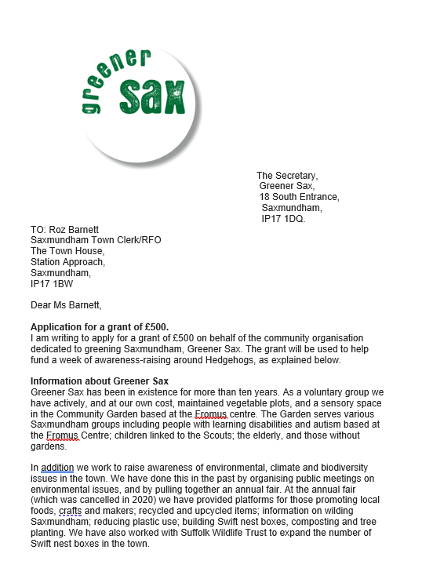
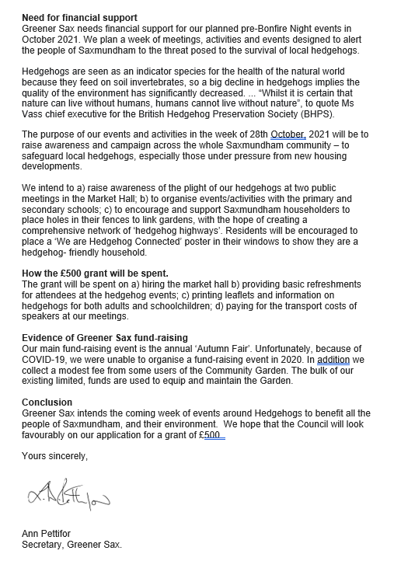

Item 15 66/21TC Staffing Matters
- To consider the Resources Committee recommendation to the Town Council that the revised Appraisal Scheme and form be adopted (Appendix 16).
SAXMUNDHAM APPRAISAL POLICY
INTRODUCTION
The appraisal scheme provides the Council with a framework to regularly review an employee’s performance, and the employees with an opportunity to give feedback to their employer.
The Resources Committee have the oversight of the Appraisal Scheme process and ensuring that it is completed.
WHO UNDERTAKE APPRAISALS?
The Town Clerk is responsible for the staff performance management meetings and appraisals of all staff.
The Staffing Committee are responsible for the performance management and appraising the Town Clerk.
The Chair of the Staffing Committee and the Chair of the Council are responsible for setting the Objectives in consultation with the Town Clerk at the beginning of each financial year.
Summary reports from all appraisals will be shared with the Resources Committee.
CORE ASPECTS OF THE PERFORMANCE MANAGEMENT PROCESS
The Council’s Annual Plan
The Council’s Annual Plan should set out the Council’s objectives and key areas of work for completion. The plan objectives should be reflected in the performance management target for staff.
The Role of the Staffing Committee (See Staffing Committee Terms of Reference)
The Staffing Committee will:
· ensure that annual appraisals are being conducted for all staff;
· organise the process for the Town Clerk’s appraisal;
· be responsible for reviewing the performance management process to ensure it continues to meet the Council’s needs;
· will countersign the appraisals for all staff; and
· will hear any grievances raised by staff in relation to their appraisal. (subject to compliance with the ACAS Code of Practice on the conduct of grievance procedures).
The Annual Appraisal and Mid-Year Review
The annual appraisal and mid-year reviews and catch-up meetings will follow the format set out in this document with supporting forms for the annual and mid-year reviews.
The Role of Regular Catch-Ups
Catch-ups should be conducted every six weeks or so. Meetings may be more frequent where staff are new to their post, the employee requires more regular support or the appraiser is concerned that the employee needs particular attention. Equally catch-ups can take place less frequently where appropriate. However, they should always take place at least every 8 weeks/2 months. Catch-ups provide the opportunity for regular discussions on progress against objectives highlighting where additional support may be needed or, in exceptional situations, where objectives should be amended. They also provide an opportunity to discuss a range of other day to day matters such as annual leave or TOIL arrangements; recent or planned absence; workload pressures; progress with learning and development plans etc.
STRUCTURE OF THE APPRAISAL MEETING AND MID-YEAR REVIEW
The appraisal meeting and mid-year reviews are in two parts. The first part looks back over the appraisal period. It looks at:
· the extent to which the objectives have been met;
· noting any achievements
· whether the job description has changed;
· whether the learning and development objectives have been achieved; as well as
· noting any other general comments.

The second part looks forward to the next appraisal period. It provides an opportunity to:
· discuss the objectives to be set;
· identify the learning and development needs.

USING THE RECORD OF APPRAISAL FORM
The form is produced as a Word document to allow flexibility. The form is not intended to restrict the amount which can be written or the number of objectives which can be set (The form Is an ACAS template).
SETTING OBJECTIVES
All team and individual objectives should be written as SMART objectives. The number of objectives set will depend on the ‘size’ of each objective and the other work which a member if staff is tasked with. If appropriate objectives should have supporting information such as ‘milestones’ to be achieved or additional information to clarify how the objective should be met or what support might be available.
RECORD KEEPING
A written record of the appraisal, mid-year review and catch-up meetings will be given to the employee for their own records and copies will be kept in the employee’s personnel file. The written record of appraisal, mid-year review and, catch-up meetings for the Town Clerk will be held by the Chairman of the Staffing Sub-Committee on behalf of the Committee, as well as in the Town Clerk’s own personnel file and a copy given to him/her. Should the Chairman of Staffing Committee change then these records will be made available to them and any other member of the Staffing Committee appointed to conduct an appraisal meeting (either full or mid-year)
SEEKING AGREEMENT
Wherever possible agreement should be sought for the objectives set. It is important for the appraiser to listen carefully to any concerns raised by the ‘appraisee.’ However, if agreement cannot be reached then the disputed objectives can be referred to the Staffing Committee who will consider whether to amend, withdraw, or retain them after having considered the matter. Wherever possible, agreement should be sought for the other aspects of the appraisal (i.e. looking back at past achievements, training required, etc.). However, where agreement cannot be reached a note of the employee’s comments/objections will be kept together with the appraisal report.
THE RELATIONSHIP BETWEEN THE TOWN CLERK’S APPRAISAL AND THE APPRAISALS OF OTHER STAFF
For clarity, the Town Clerk appraisal process is entirely independent from that of other members of staff. In other words, if for any reason any stage of the Town Clerk’s appraisal is delayed in full or in part - then this should not delay any element of the (including objective setting) appraisal process progressing for any other member of staff.

Item 16 67/21TC To consider tender report and recommendations from the Market Hall Committee on kitchen improvements, costs, and schedule of works (Appendix 17).

Details of Work | Prices received
Costs previously acquired for the Kitchen Refit

Supply of the Stainless-Steel Units  Three different companies were approached for the supply of the kitchen units, sinks and taps. | Stainless Steel Units £4494.00 + VAT  Taps £174 plus VAT  Cladding and flooring £3956 plus Vat  Total £8264  (Does not include dishwasher)
Building Works related to removal of existing kitchen, preparation of walls and the installation of the new kitchen.  Three different companies/individuals were approached for the building works. | Only one quote has been received for the removal of the kitchen £420+ vat  All repairs to walls would be charged at £22.50 per hour+ materials+ vat  Estimated costs £1500
Complete costs of works | Gratte Brothers Catering Equipment Ltd  3 Crompton Road, Stevenage, Hertfordshire  Quoted cost £26,968
The Clerk Advertised on the national contracts finder website and listed the job on three builder job sites.
Received one quote related to removal of existing kitchen, preparation of walls and the installation of the new kitchen. | DBS Projects for works and materials excluding kitchen supply. Sub Total £13,879.49  Stainless Steel Units £4494.00 + VAT  Taps £174 plus VAT  Total £18,547.49  The contractor is available from September to complete the works.  Some savings could be made on the specification but would suggest a budget of £18,500 to allow for contingencies.

There is currently £6,000 in the Market Hall budget, £2000 grant funding is secured. This leaves a short fall of £10,500, if there is no other maintenance in the year.

Recommendation: That Saxmundham Town Council award the tender for the kitchen refurbishment to DBS Projects at a cost of £13,879 plus VAT subject to references for the contractor, and any reduction from amended specification.

  - To consider a request from the Resources/Market Hall Committee for £10,500 from the capital reserve for the refurbishment of the Market Hall Kitchen.

The Resources Committee noted that the kitchen refurbishment is expected to cost around £18,500, and the Market Hall has a shortfall of £10,500 for the refurbishment costs. The Committee expressed concerns that if there was unexpected maintenance in the year that the Trust may have to come back for some additional resources. The Clerk explained that she would still be looking for additional grant funding for the project over the summer.

Recommendation: That the Resources Committee recommend to the Town Council that they allocate an additional £10,500 to the Market Hall Trust from the Capital Reserve to enable the completion of the kitchen restoration.

Item 17 68/21TC Correspondence - To note correspondence received since the last meeting. (Appendix 18)
Correspondence Log September 2021
Item Number | Correspondence received. | Action Taken | Outcome
 | Eleven businesses wrote in support of the Town Centre Co-ordinator post | Noted in correspondence | Resolved
 | Resident complained about fruit tree management on Memorial Field. | Clerk Responded | Resolved
 | East Suffolk offered car park meeting on the 10am 16 Sept 2021. | Clerk Responded | Ongoing
 | Notified of Station opening ceremony 24 Sept 2021 | Noted in correspondence | Ongoing
 | Resident complained of anti-social behaviour related to the Railway Tavern | Clerk Responded | Ongoing
 | Library requested help with signage for the new library | Clerk Responded | Resolved
 | Suffolk County Council and Anglia Car Charging offered the Town Council electric charging points | Clerk Responded | Ongoing
 | The external Auditors requested additional information related to the Council’s AGAR. | Clerk Responded | Resolved
 | The new poppy appeal coordinator contacted the Council and asked for help | Clerk Responded | Ongoing
 | Resident contacted the Council about a Town guide/new residents Pack | Clerk Responded | Referred to communications working group
 | The press contacted the Council after a resident complained of the dangerous junctions on the A12 | Clerk Responded | Referred to the Chair

