Roz Barnett
Saxmundham Town Council
Amenities Committee 25 October 2021

Item 4 Updates from the Clerk (not on the agenda)
  - Update on litter bins
  - Welcome back funding update
    - 2 x days gardening
    - 8 x seating – please define requirement
    - 4 x planters
    - 6 x pop-up gazebos
    - 4 x event banners
    - Trail markers
  - The painting of the Youth Booth has been completed.
  - Clerk has chased the County Council about the charging points again.
  - Phil Leon has provided a quote to repaint the Men’s Sheds garage doors a t a cost of £355.60.
This could be done under delegated powers (There is still £1,139 in the Town House Maintenance Budget

Item 5 - Report on the Environmental Co-ordinator’s Activities (Appendix 2)

The Green Team arranged a clean-up outside the Gannon Rooms their next scheduled task will be to rake up the arisings from the Memorial field.

The next task to be completed by the Green Team will be bulb planting. The bulbs have been dispatched but not yet received.

Item 6 – (Appendix 3)
Proposal for Tree Planting
3 Malus to the Welcome Area set in grass with bulbs
Mixed native trees to the Rendham Road boundary with poppies say around the Pill Box
Mixed fruit and nut trees to the FnN walk
Quince trees to the Lady Di terminus
Phase 1 also to include gates, fence and signs and memorial stone move, area of Breedon Golden Amber Self Binding Gravel area as manufacturers recommendation or video. Phase 1 could also include divider between u8 and over8 areas to Seaman Ave of chestnut paling fence and RSPB specified hedging (34m) say.
Also 23 hedges to the Seaman Ave fence either side of proposed parking.
Note planting bare root trees we would go small to reduce watering requirements.

To discuss proposals for memorial historical walk
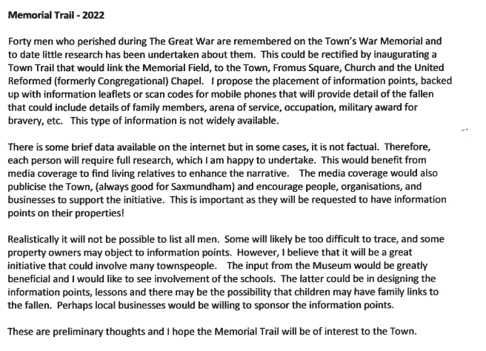
Item 10 – Station Planting (Appendix 7)

Last year the Council contributed £865. There is a current predicted underspend of £350 in the Sax in Bloom Budget. DO councillors wish to purchase more perennials & grasses to finish off scheme.
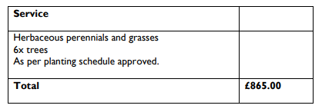
Correspondence (Appendix 11 should have been 8)

I am supportive of your efforts to set-aside some areas of memorial field to re-wild it; and I use my front garden for the very same purpose. However, I was alarmed to learn that it is the council’s intent to turn over yet more of the space to concrete by extending the skate park to be even larger. I understand that a local pressure group has been subject to a survey as to what new features the skatepark should have, as if to say the deal is done it is just a matter of defining what they want.
To what extent has the wider community, or neighbours of the memorial field, been surveyed with similar value given to their opinion too? Which voices on the Council are interested in the wants and needs of the other users of the memorial field, and the neighbours, or is there as in 2016, near unanimous agreement that Saxmundham Youth (or the voice of the pressure groups representing them) trump the needs of the wider community.
As a resident close by the Skatepark, I can confirm it is not in anything like constant use (across the available hours one might expect a youth not to be in school). Investing in unsociable flood lighting (with the aim to extend potential usable hours of the facility in winter) is a frivolous use of community funds. Arguments that it makes the skate park safer or reduces the crime or unsociable behaviour are spurious. Flood lighting will not reduce the usage of laser pointers, incidents of littering, smashing of glass, application of graffiti, consumption of marijuana, or burning of rubbish bins. They just, quite literally make it easier to see. And that’s it; there is no deterrent against these activities which are already concentrated at the existing skate park. Furthermore, justifying spending more money on concreting over yet more land to accommodate another section of ramps; in an attempt to reduce accidents between riders of different skill is a false argument. It is simply hijacking a safety perspective to nudge the council into expanding the facility further.
From my observations of usage of the skatepark, its appeal is limited to a minority of the Saxmundham children and your investment might well be better off directed into the various other play facilities, for example Chantry Road. Certainly my five year old boy is too reluctant to use the skatepark as it is now a grimey, litter strewn vandalised mess. In his own words; “Why do they leave broken glass on the floor?!
See the Alexandra Park (Ipswich) or Swinburne Play Area (Hitchin) developments for very fines example of how to spend funds on an inclusive range of youth. For example, roundabouts for wheelchair users, swings for the less able bodied etc. See the Ipswich Town skatepark for an example of what happens when an area is assigned for managed decline. (It should come as no surprise that Ipswich Town council didn't choose to site the skatepark in the middle of a green leafy park)
The park facility backing on to Thurlow Close is looking very sorry and is in desperate need of the rotting wood being replaced. The 5-a-side footy pitch on the Memorial field would benefit having lines painted and maintained. The bins at the skate park need replacing, again, and the youth educated about why litter should go in them, not on the floor. The basketball area in Seaman Avenue might benefit having an actual full court. The youth shelter in Seaman avenue is not safe for young children to go near and regularly attracts use of drugs in broad daylight. “What’s that smell Daddy?”

