

**Saxmundham Town Council**

**Minutes of the Meeting of the Market Hall Trustee**

**14 June Market Hall Saxmundham (10.08pm)**

Councillor Di Eastman (Vice-Chair)

Councillor John Findlay

Councillor John Fisher

Councillor Charlotte Hawkins

Councillor Nigel Hiley

Councillor Roger Hedley Lewis

Councillor James Sandbach

Councillor. Jeremy Smith (Chair)

Councillor Rose Webster

**Also present:** Rosalind Barnett (Town Clerk),

|  |  |  |
| --- | --- | --- |
| **1/21MHT** | **Apologies for Absence**  Councillor Tim Lock | |
| **2/21MHT** | **Declarations of Interest**  There were no Declarations of Interests. | |
| **3/21MHT** | **Minutes of the Previous Meeting**  **RESOLVED: The Council received and approved the draft minutes from the previous meetings 8th of February 2021 and the 8th of March 2021.** | |
| **4/21MHT** | **Finance**   1. **RESOLVED: The Trust received and approved the Accounts for the Market Hall for 2020-21 (Appendix A)** 2. **RESOLVED: The Trust received and approved the statement on the accounts from the internal auditor (Appendix B).** 3. The Trust noted that the Clerk will file the accounts with the charity commission once approved. | |
| **5/21 MHT** | **Phase 3 Improvements**   * 1. A verbal report on the Market Hall Committee site meeting was given to the Trust and a discussion was held on the report suggesting moving the toilets to the back of the building. The architect said that this would allow space for a bar/reception area and one disabled toilet at the front of the building. Concern was expressed that if the Webster room were converted to toilets that the Radio station would be homeless. It was noted that an alternative more suitable premises could be found for the radio station. Concerns were also expressed that traffic to the toilets in this area could impact on the kitchen and the stage area.   2. **RESOLVED: The Trust approved in principle the moving of the toilets to the back of the Market Hall as recommended by the architect in the preferred scheme. The Trust approved in principle to the installation of the full glass frontage windows. It was agreed that any works would be dependant on actual costs and securing external funding.** | |
|  |  |

**The meeting closed at 10.14 pm**

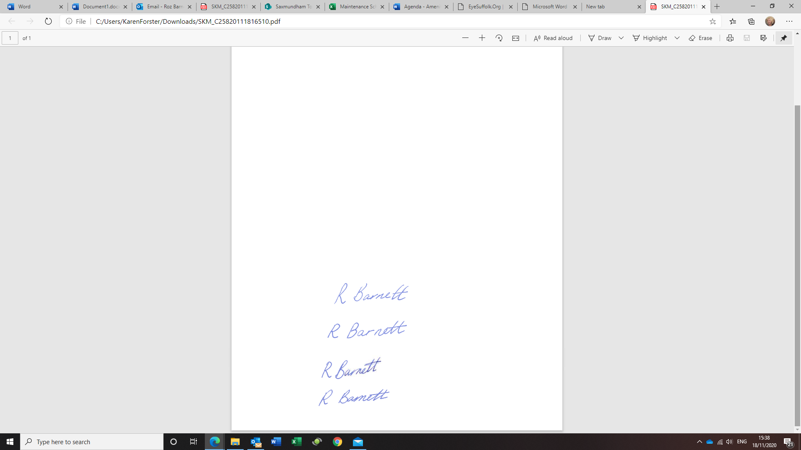

**Roz Barnett**

**Clerk/RFO to Saxmundham Town Council**

**The Town House, Station Approach. Saxmundham, IP17 1BW**