Roz Barnett
Saxmundham Town Council
Resources Committee 25 October 2021

Item 4 Finance
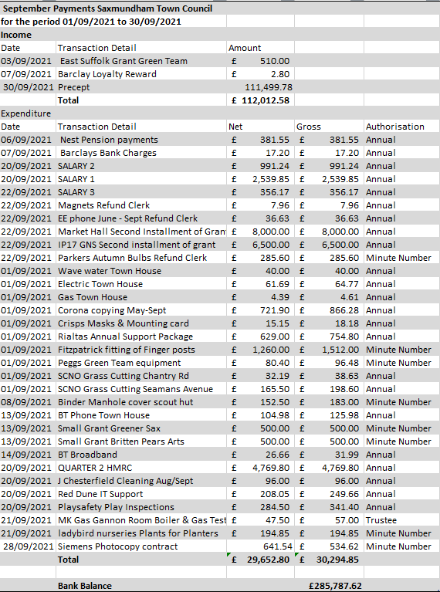
  - To note payments and receipts and reconciliation reports for September for the Town Council (Appendix 2)

  - To note payments and receipts and reconciliation reports for September for the Market Hall (Appendix 3)
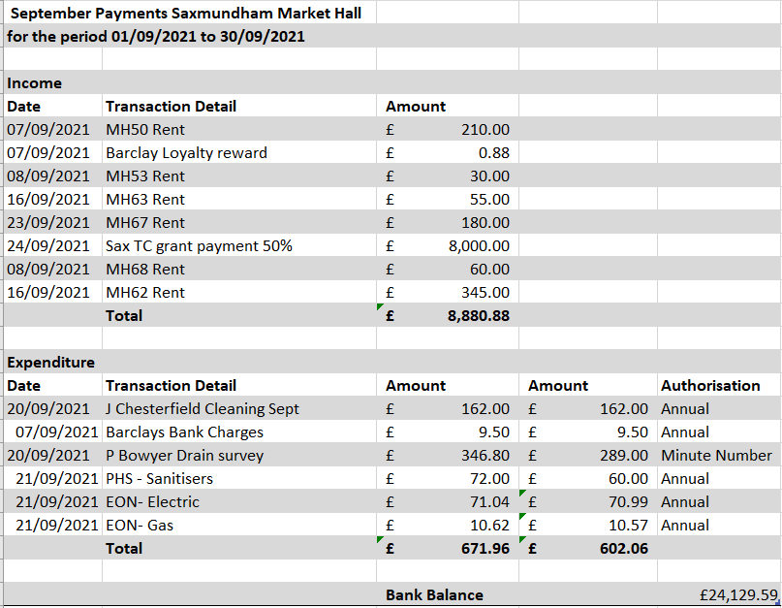

  - To authorise any October payments outside of the Clerk’s delegated powers for the Town Council and Market Hall (Appendix 4).

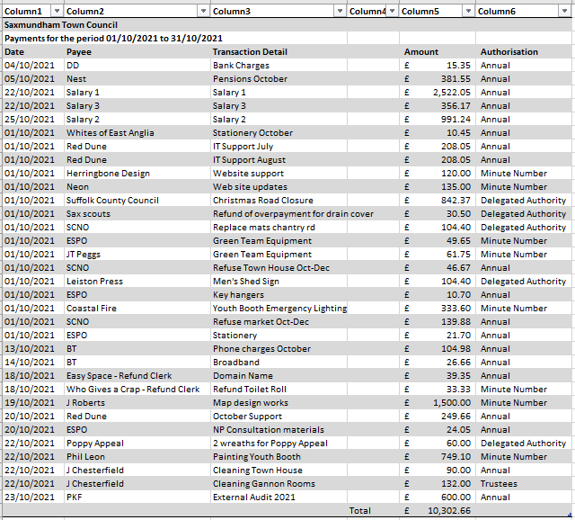

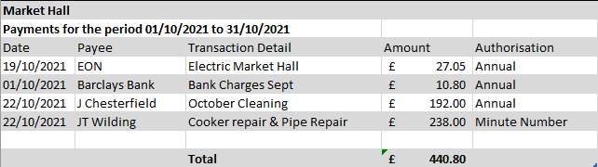

  - To consider the transfer of an additional £20,000 into the High Interest Account. (Appendix 5)

The current account at the end of September 2021 was £ 285,787.62 (0% Interest) The Cambridge building society account stands at £60,024.59 (0.1 % Interest) The current Reserves policy states that the Council should have a general reserve minimum of one third of the annual precept income which is £74,3333
Recommendation: In discussion with Chair of Resources the Clerk is recommending that an additional £50,000 be transferred into the Cambridge building society

  - To note conclusion of External Audit.
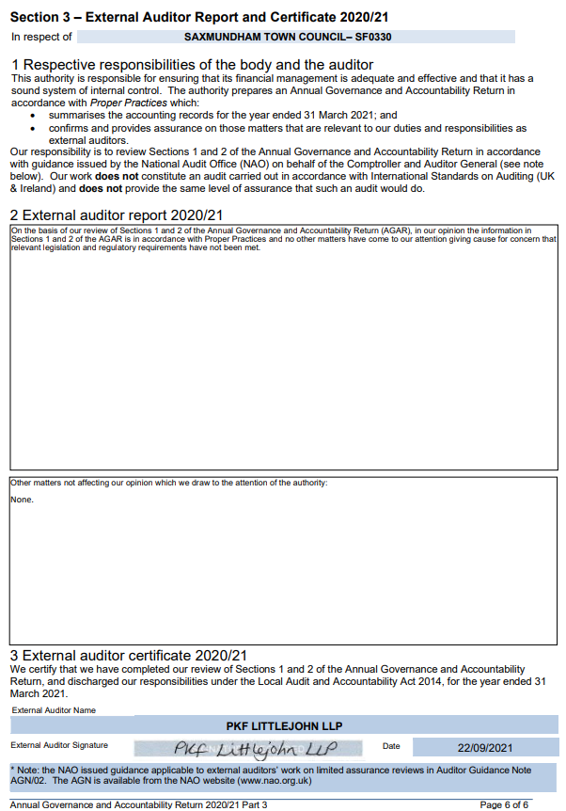

Item 5 Budget 2022-23
  - To receive October budget and out-turn report For the Town Council (Appendix 6 Separate to Pack).
  - To receive the draft budget papers for the Town Council 2022- 2023 (Appendix 7 Separate to Pack).
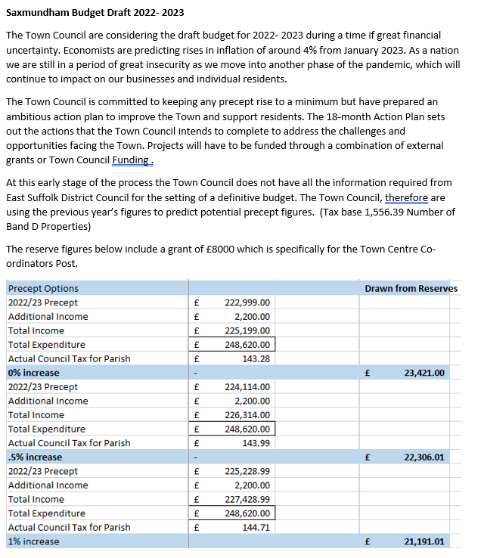

Item 7 Christmas Events - To consider request for the Businesses to pay for the High Street Christmas Trees at a cost of up to £1000

The Town Centre businesses and services annually erect small Christmas trees and lights along the High Street. This is organised by M. Light of The George Farnham Gallery. Last year because of the impact of COVID-19 the Council agreed to pay for the trees and their erection. The businesses have approached the Town Council again this year and requested financial help for this year of up to £1000. There is a predicted underspend in the general events budget.

NB: Legal power to make decision.
Local Government Act 1972 s.144
Power to encourage visitors and provide conference and other facilities.
(1)A local authority may (either alone or jointly with any other person or body)—
(a)encourage persons, by advertisement or otherwise, to visit their area for recreation, for health purposes, or to hold conferences, trade fairs and exhibitions in their area

Item 8 – Health and safety - To consider the option to seek costs for a ‘competent’ health & safety advisor (Appendix 8).

Item no: | 5
Report dated: | 14th October 2021
To the: | Resources Committee
Meeting on: | 25 October 2021
Subject: | Re- commissioning a health and safety consultant.
Contact/author: | Assistant Town Clerk (ATC), email:assistanttownclerk@saxmundham-tc.gov.uk

- Background.
1.1 The Town Council’s current health and safety consultant is Safetyboss Ltd, based in Melton. Safetyboss have worked with the Council’s administration for a number of years to help ensure that Council’s health and safety policy frameworks is fit for purpose and also to carry out risk assessments of the Council’s physical assets. This work was interrupted in 2020 due to a series of Covid lockdowns. Paperwork relating to the original commissioning process for Safetyboss is lacking and so it seems an opportune time to recommission this service.

- Why use an external consultant?
2.1 The consequences of falling short on either safe working practices or the safety of our public buildings and play areas are devasting, not only for the employees or members of the public who may be hurt, but also for the employees and councillors who may be held responsible. Sanctions include heavy fines and personal gaol sentences for those found negligent in serious cases.

2.2 Although our administration has developed a high level of hands-on expertise in health and safety, they are not experts in the field. A professionally qualified health and safety consultant would allow the Town Council and its staff to be confident that they were complying with all aspects of health and safety law.

2.0 Recommendation.
2.1 It is recommended that Saxmundham Town Council agree to seek costs to commission a health and safety consultant to act as a dedicated point of contact for officers of the Council and as the legally required Competent Person for Health and Safety on behalf of the Council.

2.2 Draft tender documents are attached for information.

3.0 Legal power to make decision.
3.1 Power to enter into contracts. Local Government Act 1972, s.111.

3.2 Power to do anything that will be conducive to or incidental to the discharge of its powers and functions. Local Government Act 1972, s.111.

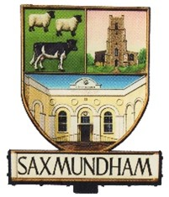
Saxmundham Town Council

The Town House, Station Approach, Saxmundham, Suffolk, IP17 1BW,
Tel: 01728 604595, Email: townclerk@saxmundham-tc.gov.uk, http://www.saxmundham-tc.gov.uk/
VAT Registration No: 571060663

Saxmundham Town Council is seeking tenders for a Health and Safety Consultant to advice the Council for the period January 2022 – December 2025, with an option to extend the contract for a further two years to December 2027 by mutual agreement.

Saxmundham Town Council require costs for the following services: -
- A qualified Health and Safety Consultant to act as a dedicated point of contact for officers of the Council.
- To act as the legally required Competent Person for Health and Safety on behalf of the Council.
- To undertake two days of onsite inspections annually, visiting sites and premises to review current arrangements and carry out a comprehensive General Risk Assessment (GRA) ass required by the Management of Health and Safety at Work Regulations 1999, and provide written reports of findings.
- Review existing Health and Safety Policies and documentation, and, if necessary, produce documentation for the Council e.g. Health and Safety Policy including Fire Policy, Health and Safety Handbook and Health and Safety Action Plan identifying priority actions and timescales.
- Access to unlimited telephone and email assistance to officers of the Council.
- Emergency assistance in the case of, for example, enforcement visits and accident investigations.
- Investigation and liaison with the authorities in the event of a serious accident.
- Access to a website providing a wide range of H and S materials, templates, tool kits etc.
- Access to good quality Health and Safety Training.
- Legal Expenses Insurance in the case of Health and Safety Prosecution.

Tender requirements:
- Fully costed quotations for the annual costs and for three years, and also for five years.
- Details of your company’s experience and qualifications (minimum Nebosh Diploma).
- Details of how you would provide the services listed above.
- Two references.
- A copy of your public liability insurance
- Sample risk assessments and safe systems of work.
- You must also complete the attached form which includes the contact details for two referees.

The closing date for tenders is Monday 1st November 2021 at 9 am Please send your tender in a sealed envelope marked clearly ‘Tender – Health and Safety’ to

Saxmundham Town Council.
The Town House
Station Approach
Saxmundham, IP17 1BW

Please be aware that failure to supply any of the information requested in the attached specification will result in the tender being rejected.

Item 9 Amenities Committee -To consider request for underground survey for the Memorial Field up to £2000.

The clerk wrote to 5 companies in June this year requesting quotes for topological survey and an underground service for the Memorial Field. Only two companies quoted for the underground survey. The Amenities Committee agreed to proceed with topological survey but now have indicated that they cannot proceed with any improvements on the Memorial field without the Services survey.
The two quotes received were from Survey Solutions £2950 and EDI Surveys Ltd £1530. The Amenities Committee would like to progress with the lower of these two quotes.

Item 10 Small Grants –
  - To consider any applications under £5000 (Standing agenda item).
