Roz Barnett
Saxmundham Town Council
Resources Committee 29 November 2021

Item 5 Finance
  - To note payments and receipts and reconciliation reports for October for the Town Council (Appendix 2)

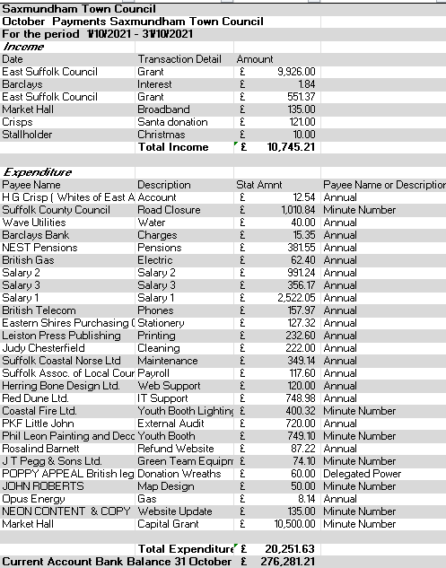

  - To note payments and receipts and reconciliation reports for October for the Market Hall (Appendix 3)
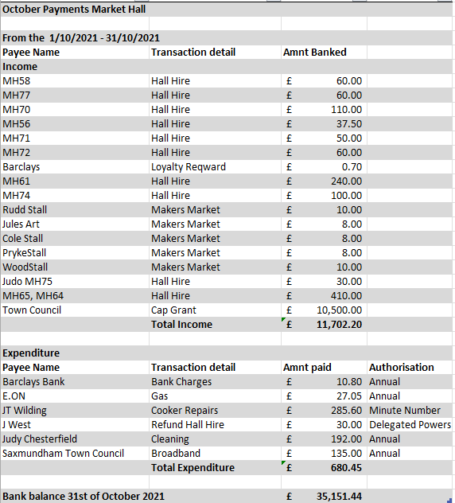

  - To authorise any November payments outside of the Clerk’s delegated powers for the Town Council and Market Hall (Appendix 4).
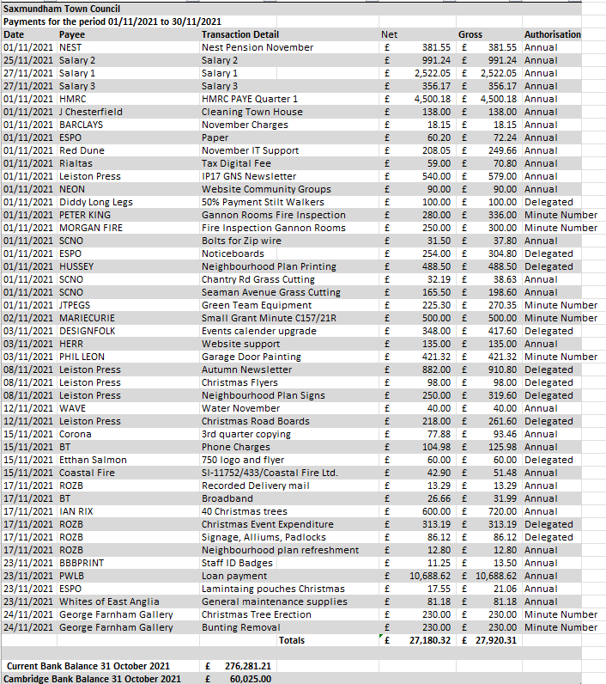

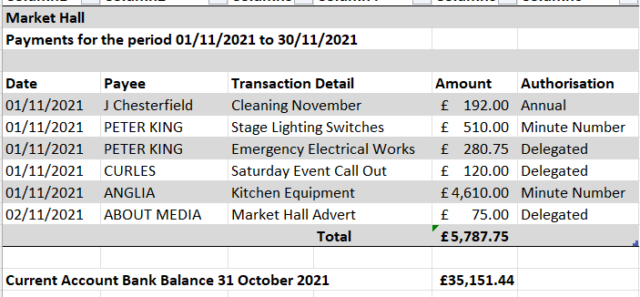

Item 6 Budget 2022-23 (Appendix 5)
- To receive an updated budget report for the Town Council and Market Hall
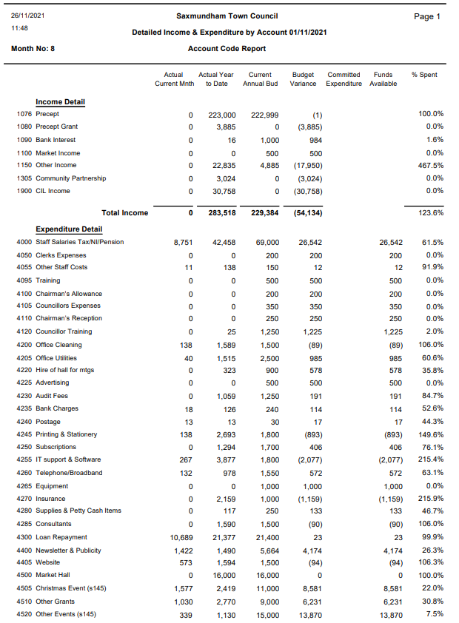

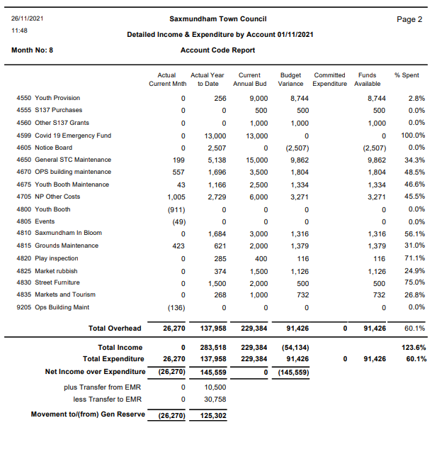

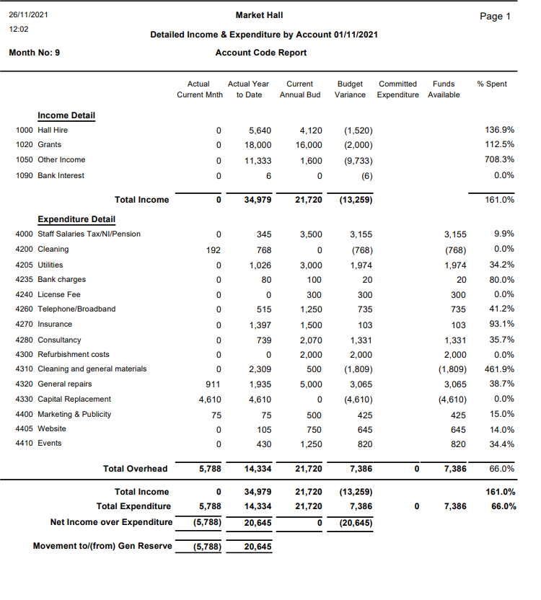

- To receive a report on Reserves (Appendix 6)
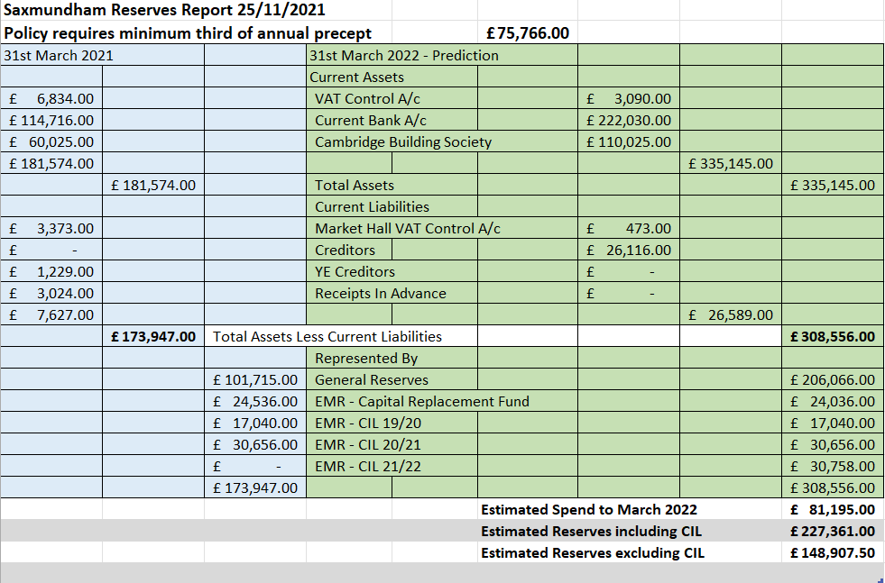

- CIL Report (Appendix 7)
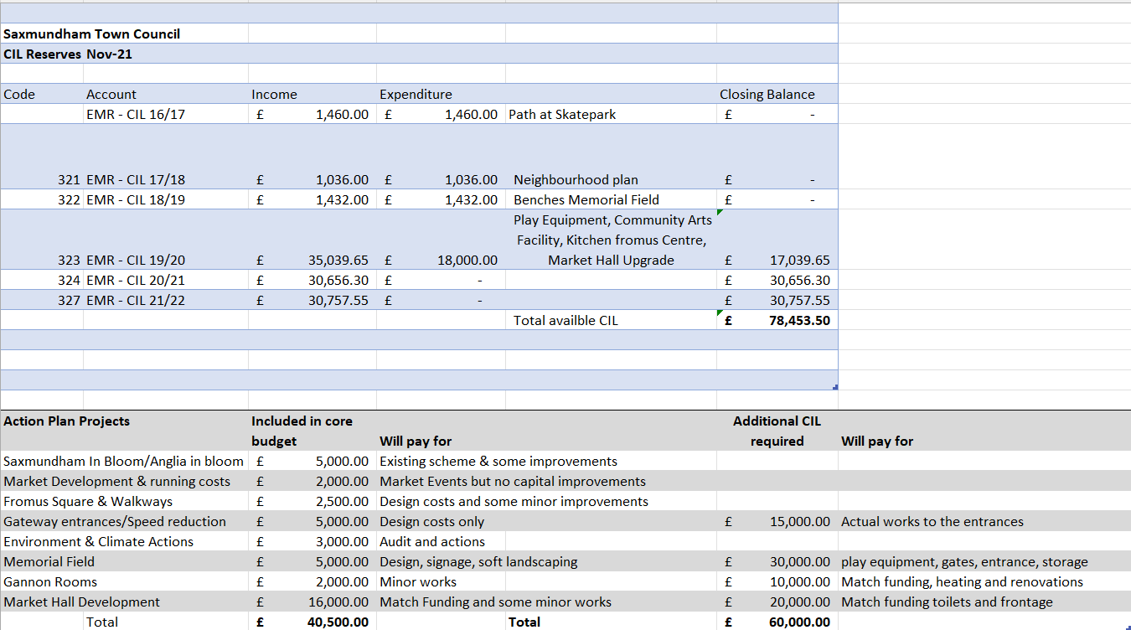

Item 11 – Staffing Structure Appendix 8
