Roz Barnett- Town Clerk
Saxmundham Town Council
market HALL COMMITTEE 15 DEcember 2021

Item 4 - To consider Dates for January – March 2022 and note changes to Clerking arrangements
Proposal to change the meeting dates from Mondays to the Wednesday – 26th of January & 23rd of March
Assistant Clerk Duties Market Hall
Market Hall Management and Administration
Hallmaster Bookings
- To confirm any provisional online bookings and make arrangements with hirers for access.
- To print off monthly booking schedules for Judy and let her know when bookings are added at short notice or are cancelled.
- To manage the Market Hall Handbook updating the information.
Invoicing & Finance
- To send out monthly invoices
- To mark invoices paid for the previous month using bank statements.
Promotional activities
- Beginning of Month – Format and Print off the calendar form Hallmaster and place on the Market Hall outside and indoor noticeboards
- Market Hall Noticeboard is for publicising Market Hall Activities –
- Ensure details of regular activities are displayed and kept up to date
- Any posters for special events are displayed on the noticeboard
- To send details of any new bookings and events to Clerk so these can be put on the website
Health and Safety Checks
- To carry out weekly/monthly health and safety tests.
Routine Maintenance
- To oversee the annual routine maintenance regime for the Market Hall
- To order any cleaning and maintenance supplies
Market Hall Committee
- Attend and take minutes of meetings
- Assist in the preparation of Agendas
- Assist in the preparation of Reports
Town Clerk Duties Market Hall
Market Hall Management and Administration
Hallmaster Bookings
- To cover for the Assistant Town Clerk during leave periods confirming provisional bookings and making arrangements for hirer access
- To prepare booking reports for the Market Hall Committee
Invoicing & Finance
- To manage the accounts, pay any bills and provide financial reporting to the Market Hall Committee
- To file charity returns and arrange audit of accounts
Promotional activities
- To add details of any new bookings and events to the website
Market Hall Event Programme
- To organise and advertise the annual Market Hall Event programme in partnership with other organisations in the Town.
Building Development Projects
- To oversee the phase two and three improvement projects to the building
- To apply and secure external funding for improvements.
Market Hall Committee
- Attend Meetings
- Responsible for preparation of Agendas
- Prepare Committee Reports
  - Finance Report To receive a report on The Market Hall Budget April – November 2021. (Appendix2) 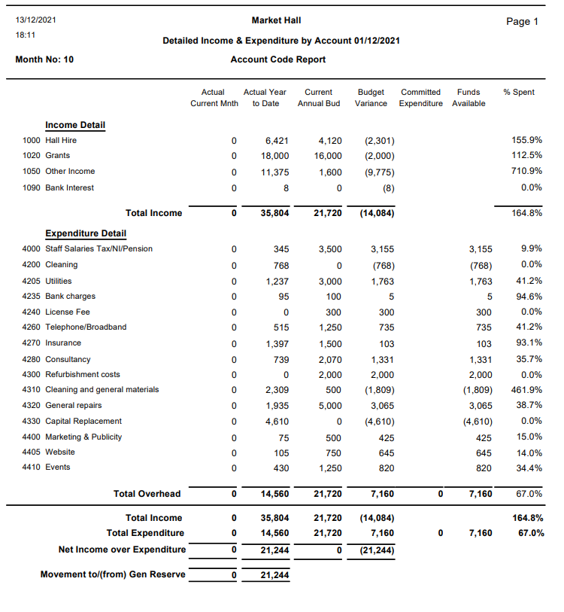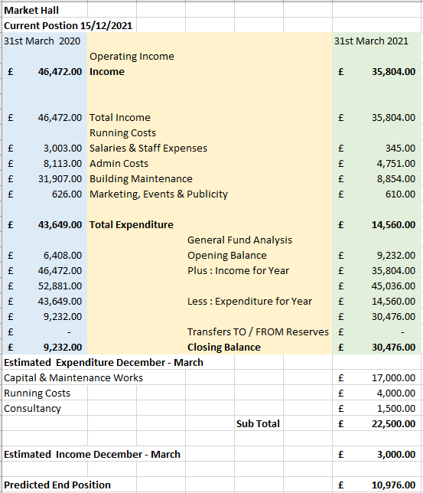

  - To consider draft Budget for 2022 -2023
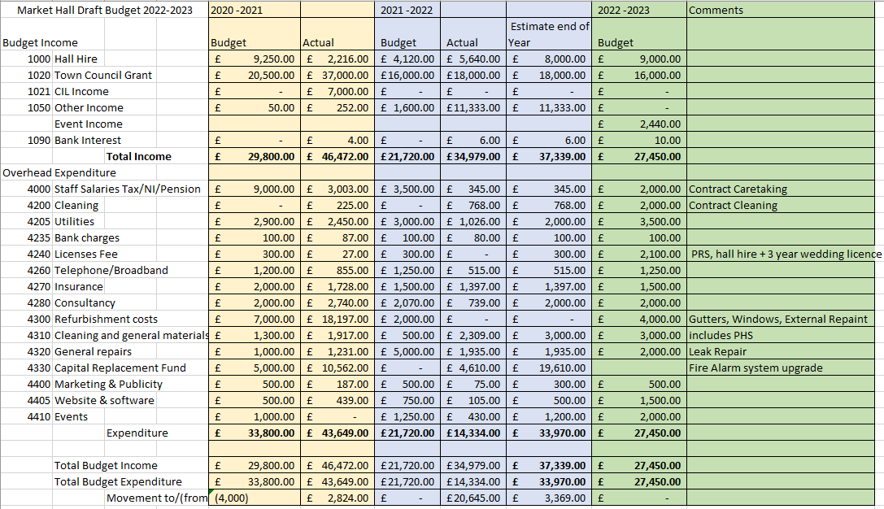

Item 6 - Clerk’s Update

- The emergency call out to fix at the Sax Jazz event cost £144
- Peter King installation of reachable switches £510, costs of emergency works splitting of circuits cost £280.75.
- The projector issues are ongoing. The Cables have been split and Red dune has offered to come down and check projector once the electricians have confirmed the test results.
- The Clerk has had difficulties sorting the Leak out and have asked the Kitchen contractors
to provide a quote
- The Clerk has received one quote to inspect the site and survey for repair or replacement at a cost of £350.00
- Health and safety – fire procedures – evacuation plan.

Item 9 – Bookings Report

The current regular bookings are:
- Town Council meetings,
- IP17 Good Neighbour Scheme, Gather and Grow, Funky Fridays and Line Dancing.
- Active Adults
- ABC Radio (Licence)
- Driving test centre (monthly)
- Carpet Bowls
- keep fit
- U3A
- Music Workshops
- Thursday Evening Belly Dancing

New Bookings received
- Christening, 2 funerals/Memorial Service, New Year’s Eve Party

Bookings and income confirmed to 31st of March 2022
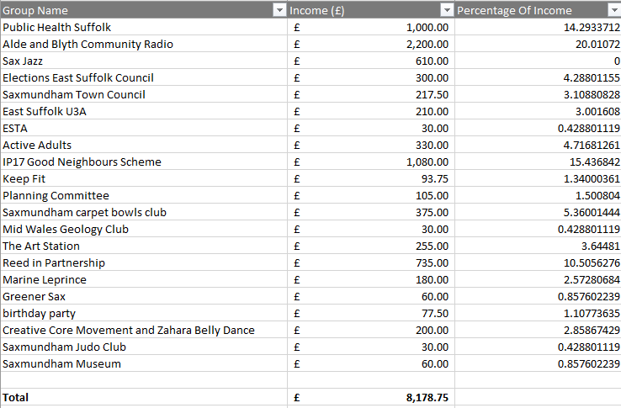

Item 10

Market Hall Programme 2022
Month | What | Costs | Income | Who leads
January

February | Museum Quiz  Wildflower Workshops | 0  O | Rent  Rent | Museum  Environment Co-ordinator
March | Maker’s market |  | 50% of stalls | Art Station
April | HG Wells Time Machine | £150 | 50% of tickets | Clerk
May | Wrestling |  | Percentage of tickets | Clerk
June | Makers Market |  |  | Art Station
July | 750 Festival Weekend  Makers Market |  | Rent  50% of stalls | Town Council  Art Station
August
September | Beer & Folk Festival  Food and Drink weekend  Maker’s Market |  |  | Town Council  Art Station
October | Children’s Events - Puppetry  Market Hall Quiz | £300 |  | Town Council  Town Council
November
December | Christmas Victorian Event  An evening with Dickens & Carols | £150 | 50% of stalls  Ticket Sales | Town Council  Town Council
Events to be added
Music Events
Talks
Literary Evening
Poetry
Comedy
Charity Bingo
Funky Fridays

