Market Hall Trust End of Year Report
2020 -2021
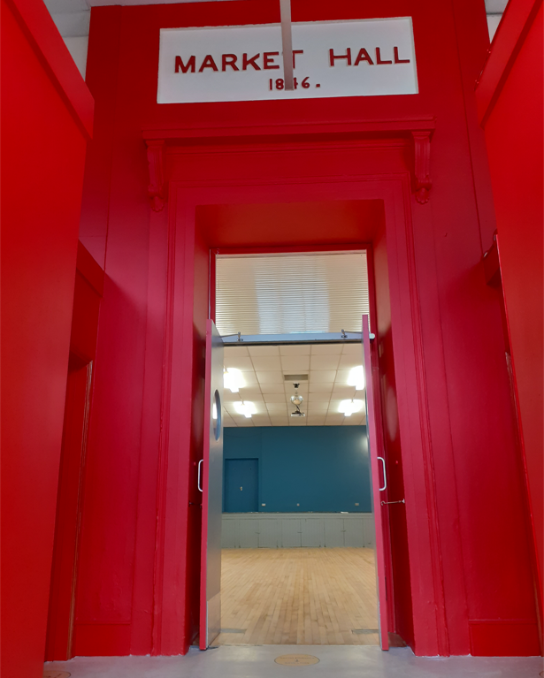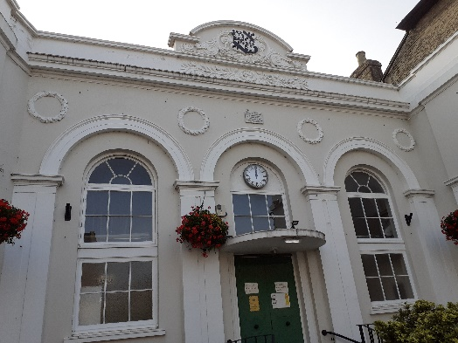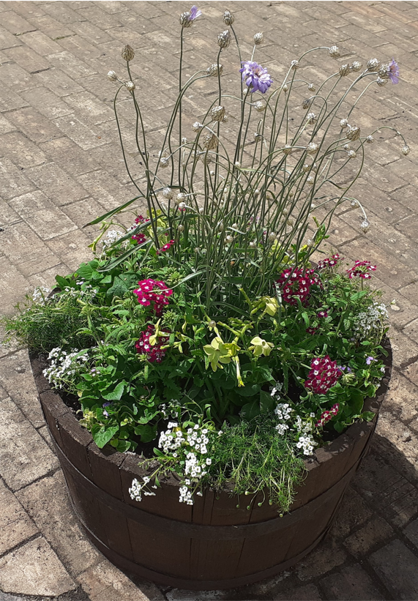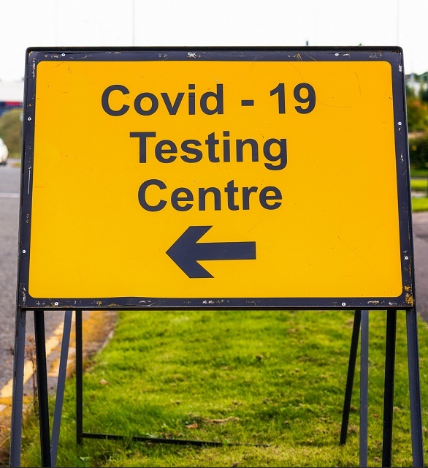

Report on the Activities of the Market Hall
On the 26th of March 2020 the coronavirus restrictions came into place and the hall was closed. During the period of closure, the Market Hall Trustees used this opportunity to improve the facilities and redecorate the main hall and foyer. The electrics were upgraded, the boiler replaced, the floor restored, stage lighting and a new projector were installed. This would not have been possible without the work of the trustees and excellent local tradesman. The Trust would like to say a particular thank you to Rosie Hoare, Ian Scott, Claire Lyth and Carol Cecil who gave their considerable expertise for free as well as Karen Foster and Tim Lock who project managed the works.

Jen Morcom, the Assistant Clerk worked hard to ensure the venue could reopen safely by creating coronavirus cleaning stations and guidance for users. The website was revamped to promote the venue and enable users to make a booking online

The Market Hall was reopened in March as a hub for the coronavirus testing in Saxmundham. This was a welcome boost to funds at a time when other indoor activities were severely restricted. A locally accessible testing centre was helpful to businesses in the Town before lateral flow testing was widely available.

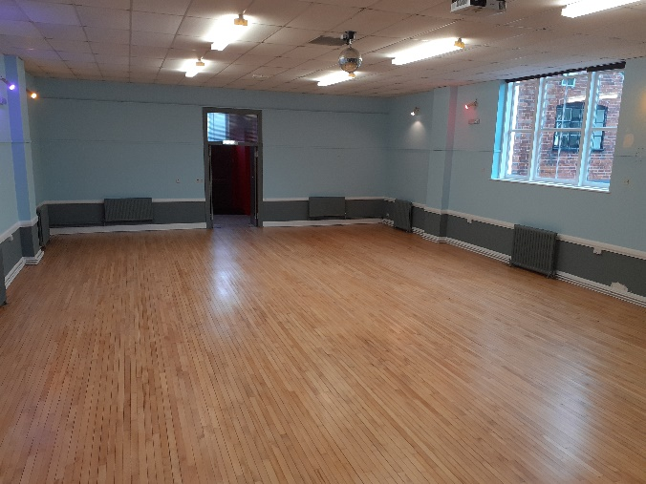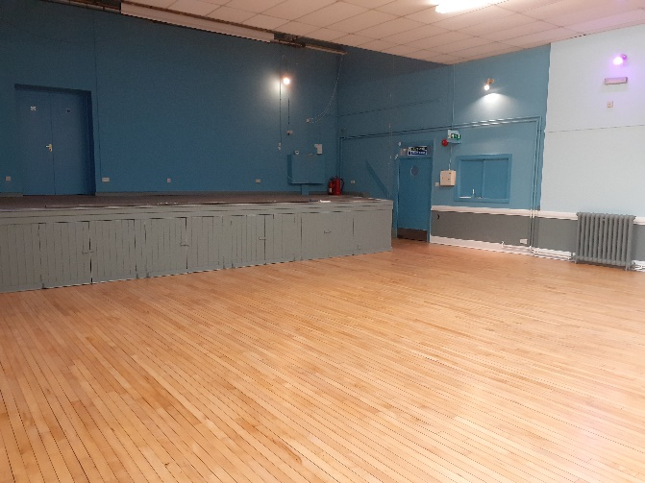
The Newly Refurbished Hall

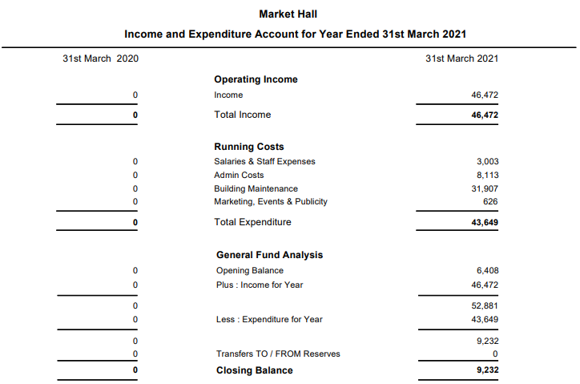

The income for 2020-21 included Covid-19 related grants of £12,500 from East Suffolk District Council. Grant funding from Saxmundham Town Council of £20,500 and a CIL grant of £7000.

