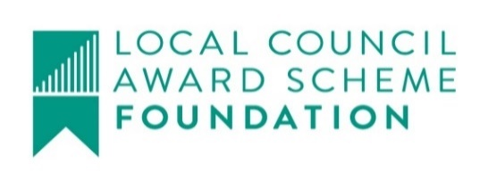
Saxmundham Town Council The Old Police Station, Station Approach, Saxmundham, Suffolk, IP17 1BW, Tel: 01728 604595, VAT Registration No: 571060663 Email: townclerk@saxmundham.org www.saxmundham.org

Report dated: | 3/2/2022
To the: | Town Council
Meeting on: | 14/2/2022
Subject: | Community infra structure (CIL) Purposes and Potential Allocation
Contact/author: | Roz Barnet, Town Clerk

1.0 Summary:
1.1 This report sets out some suggestions for the allocation of CIL
EMR - CIL 19/20 | £ 17,040.00
EMR – CIL 20/21 | £ 30,656.00
EMR - CIL 21/22 | £ 31,309.00
Total | £ 79005.00

2.0 Agreed purposes:
The Town Council agreed seven purposes/priorities for Community Infrastructure Consultation (CIL) spending on the 10th of January 2022:

Purpose 1 - improving access from new housing areas to town centre for pedestrians and cyclists
To consider: improvements to paths from Hopkins Estate to centre; routes from other estates (e.g. to west of town) to town center.
Purpose 2 - enhancing children & young people’s recreational facilities
To consider: improvements to Seaman Avenue and Memorial Field facilities.
Purpose 3 - a more attractive & successful town centre to meet needs of growing population
To consider: environmental improvements such as urban trees; improvements to Fromus Square.
Purpose 4 – improving community, entertainment, and cultural facilities in town
To consider: capital contribution for improvements to Market Hall, Gannon Institute etc.
Purpose 5 – improving facilities for non-fossil fuel transport modes
To consider: create new bicycle storage facilities; electric charging points.
Purpose 6 – developing new or improving existing open or green spaces for the community
To consider: environmental improvements to Memorial Field.
Purpose 7 – developing sports and recreational facilities
To consider: developments to sports and recreational facilities.

3.0 Recommendation for potential Projects per purpose for planning purposes
The potential projects reflect ideas proposed in the Neighbourhood Plan and the Town Council’s Action Plan
 | Potential Projects | Amount
Purpose 1  Improving access from new housing areas to town centre for pedestrians and cyclists | Improvements to paths from Hopkins Estate to centre; routes from other estates (e.g. to west of town) to town center. | £15000
Purpose 2  Enhancing children & young people’s recreational facilities | Improvements to Seaman Avenue and Memorial Field facilities.  Adventure Playground (£2000 already allocated) | £6000
Purpose 3  A more attractive & successful town centre to meet needs of growing population | Environmental improvements such as urban trees; improvements to Fromus Square, parking. | £10000
Purpose 4  Improving community, entertainment, and cultural facilities in town | Capital contribution for improvements to Market Hall, Gannon Institute etc. | £15,000 MH  £10,000 GI  £2000 FC
Purpose 5  Improving facilities for non-fossil fuel transport modes | Create new bicycle storage facilities; electric charging points. | £6,000
Purpose 6  Developing new or improving existing open or green spaces for the community | Memorial Field | £10,000
Purpose 7  developing sports and recreational facilities | Improvements Carlton Park | £5000
 | Total | £79,000

