

**Saxmundham Town Council**

**Minutes of the Meeting of the Market Hall Trustee**

**11 October 2021 Market Hall Saxmundham**

|  |
| --- |
|  |
| Cllr. Di Eastman (Vice Chair) |
| Cllr. John Findlay |
| Cllr. John Fisher  Cllr. Charlotte Hawkins  Cllr. Roger Hedley Lewis  Cllr. James Sandbach  Cllr. Jeremy Smith (Chair) |

**Also present:** Rosalind Barnett (Town Clerk),

|  |  |  |
| --- | --- | --- |
| **6/21MHT** | **Apologies for Absence**  Cllr. Nigel Hiley and Cllr Lock | |
| **7/21MHT** | **Declarations of Interest**  There were no Declarations of Interests. | |
| **8/21MHT** | **Minutes of the Previous Meetings**  **RESOLVED: The Council received and approved the draft minutes of the Market Hall Trust dated 14 of June 2021.** | |
| **9/21MHT** | **Minutes of the Market Hall Committee Meetings**  **RESOLVED: The Council received and noted the minutes of the Market Hall Committee dated**  **20 July 2021 and 27 Sept 2021.** | |
| **10/21MHT** | **Annual Report**  **RESOLVED: The Trust received and approved the Annual Report which included the accounts and report from the internal auditor.** | |
| **11/21 MHT** | **Phase 3 Improvements**  **RESOLVED: The Trust approved the Appointment of DBS projects to complete the kitchen approvements at a cost of £13879.49.**  **RESOLVED: The Trust approved the acceptance of the £10,500 Grant from Saxmundham Town Council.** | |
|  | | |
|  |  |

**The meeting closed at 9.28 pm**

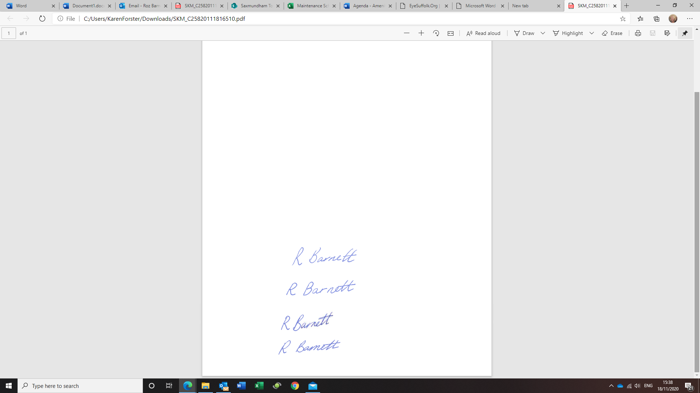

**Roz Barnett**

**Clerk/RFO to Saxmundham Town Council**

**The Town House, Station Approach. Saxmundham, IP17 1BW**