Saxmundham Town Council
MArket Hall Trust 14 FEb 2022

Item 3 – Appendix 1

- Minutes of the Previous Meeting:
To receive and approve the draft minutes from the previous meeting of the 11 October 2021 (Appendix 1)

Minutes of the Meeting of the Market Hall Trustee
11 October 2021 Market Hall Saxmundham
Cllr. Di Eastman (Vice Chair)
Cllr. John Findlay

Cllr. John Fisher
Cllr. Charlotte Hawkins
Cllr. Roger Hedley Lewis
Cllr. James Sandbach
Cllr. Jeremy Smith (Chair)

Also present: Rosalind Barnett (Town Clerk),

6/21MHT | Apologies for Absence  Cllr. Nigel Hiley and Cllr Lock
7/21MHT | Declarations of Interest  There were no Declarations of Interests.
8/21MHT | Minutes of the Previous Meetings  RESOLVED: The Council received and approved the draft minutes of the Market Hall Trust dated 14 of June 2021.
9/21MHT | Minutes of the Market Hall Committee Meetings  RESOLVED: The Council received and noted the minutes of the Market Hall Committee dated  20 July 2021 and 27 Sept 2021.
10/21MHT | Annual Report  RESOLVED: The Trust received and approved the Annual Report which included the accounts and report from the internal auditor.
11/21 MHT | Phase 3 Improvements  RESOLVED: The Trust approved the Appointment of DBS projects to complete the kitchen approvements at a cost of £13879.49.  RESOLVED: The Trust approved the acceptance of the £10,500 Grant from Saxmundham Town Council.
The meeting closed at 9.28 pm
Roz Barnett
Clerk/RFO to Saxmundham Town Council
The Town House, Station Approach. Saxmundham, IP17 1BW

- Minutes of the Previous Management Committee Meetings:
- To receive the minutes from the previous meeting of the 15 December 2021 (Appendix 2)

Minutes of the Meeting of the Market Hall Management Committee (MHC) held at 6.15 pm on 15th December 2021 in Saxmundham Market Hall.

Members of the Committee | Cllr Jeremy Smith (chair) |  | Cllr Tim Lock
 | Cllr Di Eastman |  | Cllr Charlotte Hawkins
 | Cllr John Findlay |  | Rosie Hoare
 | Carole Cecil
Apologies | -
Also present | Roz Barnett – Clerk (TC) |  | Jen Morcom - Assistant Clerk (ATC)

 |  | Action
17/21MHC | Apologies for absence:
 | There were no apologies for absence.
18/21MHC | Pecuniary/non-pecuniary interests.
 | There were no declarations of interest.
19/21MHC | Minutes of the previous meeting.
The time of the meeting held on 27th September 2021 was amended by hand from 7pm to 6pm.
The Committee RESOLVED to approve the minutes including the amendment.
The minutes were signed by the Chair.

20/21MHC | To consider dates for January – March 2022 and note changes to clerking arrangements.
The Town Clerk explained that the Assistant Town Clerk would be attending meetings of the MHC to help with minuting and follow-up work. Because of this it is necessary to move meeting dates to the last Wednesday of the month to fit in with working hours. She proposed that the next to meeting dates should be -_
Wednesday 26th January 2022 at 6.15pm
Wednesday 23rd March 2022 at 6.15pm
The Committee noted and agreed the dates.

The TC presented a short paper outlining staff roles with respect to Market Hall administration.
The Committee noted the administrative arrangements.

21/21MHC | Finance report.
a. | To receive a report on the Market Hall budget April- November 2021.  The Committee noted that much of the underspend to date is due to money set aside for the refurbishment of the kitchen which will be spent in the final quarter.  The Committee also noted that the £4, 610 from the Capital Replacement money has already been spent on new kitchen units, work tops and sinks which will be fitted in January 2022. The sum does not include any further money needed to purchase new equipment.  The Committee noted the current closing balance of £30,476 and the predicted year end position of reserves of £10,976 (£1.7K more than at the start of the year).  The Committee noted the budgetary position and forecast.
b. | To consider the draft budget for 2022-23  The TC explained the slight increase in hall hire income which is based on the Hall’s growing popularity.  There followed a brief discussion about arrangements with ABC Radio and the Committee expressed its willingness for the licence to continue. TC to discuss this with ABC so that the budget estimate can be firmed up in this regard.  The Committee proposed that budget head 4000 (four thousand) should be renamed as the caretaker will be a contractor not an employee.  After further discussion and questions the Committee RESOLVED unanimously to recommend the draft budget to Saxmundham Town Council as Market Hall Trustee. | TC  TC
22/21MHC | Clerk’s update on operational matters.
a. | To receive an update on projector, lighting, and power issues.  The TC explained the ongoing problems relating to the projector and advised that the next step would be to get Red Dune back in now that the cabling problems had been fixed.  The Committee noted her advice and expressed their frustration at the continuing projector problems.  The TC advised that the Market Hall circuits have now been split between several RCDs to avoid a repeat of the overload that occurred during one of the events. Switches for the stage lighting have been lowered, and today’s problems with the electricity in the kitchen have been resolved. Water had entered the fridge socket which has been replaced.
b. | To receive an update on the leak.  The problem regarding a leak from below the Market Hall window has recurred. The TC proposes to remedy this through the installation of a leaded lip under the windowsill which will provide a seal and redirect the water away from the wall. She is in touch with contractors who will do the work.  Cllr Lock expressed his dismay that the problem had not been resolved by the work undertaken by Phil Leon.  The Committee RESOLVED that the work should be done.  TC and Cllr Lock will discuss the matter outside the meeting. | TC/Cllr Lock
 | Cllr Hawkins arrived at 6.50pm followed shortly by Carol Cecil. Both had understood that the meeting would begin at 7pm.
c. | To note caretaking and cleaning arrangements.  The TC explained that Judy Chesterfield is happy to continue in her role as a self-employed cleaner and that a self-employed caretaker is also being sought. The role will be advertised on the Town Council website.  The Committee noted these arrangements.
d. | To consider quote for clock service and repair.  The TC has a quote for £350 plus VAT to repair the Market Hall clock.  The Committee RESOLVED unanimously to accept the quote.
23/21MHC | To receive an update on the kitchen refurbishment
a. | To consider options for a dishwasher.  The TC advised that it will be possible to fit a dishwasher into the kitchen. This will be a new item not yet budgeted for.  The Committee RESOLVED that the TC should get quotes for commercial and domestic dishwashers. | TC
b. | To discuss equipping the new kitchen.  The TC advised that work would begin on the kitchen on 3rd January to rip out the old kitchen units and replace them, resurface the walls and floors and to install a fireproof blind. Work should be complete by the end of January. She asked the Committee to consider whether they would like any new equipment for example a new fridge or fridge freezer.  The Committee RESOLVED that reasonable expenditure on essential new equipment should be considered and that the TC should:  - Get rid of the old cooler/drinks fridge.  - Get prices for a dishwasher.  - Price and advise regarding any other equipment that falls outside the current budget. | TC
24/21MHC | Market Hall improvements phase 3
a | To consider options to toilets and frontage.  The committee considered the two architect’s drawings.  Cllr Lock voiced concerns about drainage should the toilets be located at the back of the Market Hall. He considered that advice would be needed from a suitably qualified surveyor or engineer for both the drainage and the repercussions of cutting the corner off the kitchen.  The Committee RESOLVED unanimously to progress the first of the two drawing which has a storage area at the back of the stage. They would also like the architect to consider only having one male cubicle, moving this nearer the door to the men’s WCs and using the remaining cubicle as a cleaner’s cupboard.  - The TC will discuss all these ideas with the architect and seek his advice on the need for further surveys.  - She will report to the next meeting. | TC
b. | To note the next stages for approvals and planning permissions.  The next steps are as follows:  - TC to discuss the ideas outlined above with the architect.  - TC to engage any surveyors or engineer as advised by the architect.  - Depending on whether any major obstacles are uncovered, the TC will ask the architect to work up a detailed design to be brought to the next meetingwhich may then be in a position to give the go ahead to seek planning permission.  These were noted by the Committee. | TC
25/21MHC | Bookings 2021-2022
a. | The Committee noted the bookings report.
b. | To consider a request from the Judo Club.  The Judo club would like to make regular use of the Market Hall but need a space to store their mats. Keith Cartwright Jones has offered to clear out one end of the under-stage cupboards for storage of the mats. The TC advised that once storage space for IP17 GNS is constructed at the back to the Town House , there will still be space for a further trolley for the spare chairs. A new trolley has been commissioned from Peggs.  The committee RESOLVED agree the proposal as long as there will still be space for the chairs.  The TC will contact Mr Cartwright to make the arrangements. | TC
26/21MHC | Developing the Market Hall as a venue
a | To receive an update on the scheduled events programme to 31 March 2022.  The Committee noted the scheduled events programme.
b. | To consider the draft programme and costs for 2022-23  The Committee noted the ideas and suggested an arts week or arts trail. The chair also felt that some of the proposed events could be tied in with the 750th anniversary of the town’s Market Charter.  The TC explained that although the expectation is that events will make money , there are still some upfront costs. These figures have already been discussed in relation to next year’s budget and the council should be left slightly in profit.
27/21MHC | Fundraising.
a | The Committee RESOLVED to agree the TC’s proposal that she conduct a community consultation using survey monkey to support the Awards for All bid for funding for the events programme.  The TC will send the draft survey to MHC members to pilot the questions, so that it can be publicised and go out over the Christmas period. | TC
b. | The Committee RESOLVED that the process for resubmitting the bid should be:  TC to undertake survey and analyse the results  TC to redraft the bid and recirculate it to MHC members for comment and amendment before resubmission.  The Chair thanked Rosie Hoare for all her work on the events programme to date which everyone has enjoyed immensely.  In the light of the progress underway regarding Market Hall improvements, the Committee agreed Carol Cecil’s proposal that she email former members of the development group to thank them for all their hard work which can now be taken forward by the main Committee. | TC  CC
The next meeting of the MHC will be on 26th January 2022 at 6.15pm

The Meeting ended at 8.05pm

- To receive the minutes from the previous meeting of the 26 January 2022 (Appendix 3)

Minutes of the Meeting of the Market Hall Management Committee (MHC) held at 6 pm on 26th January 2022 at the Fromus Centre.

Members of the Committee | Cllr Jeremy Smith (chair) |  | Cllr Tim Lock
 | Cllr Di Eastman |  | Cllr Charlotte Hawkins
 | Carole Cecil
Apologies | Rosie Hoare - |  | Cllr John Findlay
Also present | Roz Barnett – Clerk (TC) |  | Jen Morcom - Assistant Clerk (ATC)

 |  | Action
28/21MHC | Apologies for absence:
 | Apologies were received from Rosie Hoare and Cllr. Findlay.
29/21MHC | Pecuniary/non-pecuniary interests.
 | There were no declarations of interest.
30/21MHC | Minutes of the previous meeting.
 | The Committee RESOLVED to approve the minutes of the meeting held 15th December 2021.  The minutes were signed by the Chair.  Carole Cecile reported that she had yet to formally wind up the Development working group but that she would do so shortly. | CC
31/21MHC | Finance report
a. | To receive a report on the Market Hall budget April 2021- November 2022.  The TC informed the Committee that an exceptionally high gas bill had been received, which she is investigating. She has already reprogrammed the heating for the Market Hall.  The Committee noted that with an income to date of £38,820 and expenditure of £17,958 there is a current underspend of £20,662. Much of the underspend to date is due to money set aside for the refurbishment of the kitchen. This will be spent shortly as the kitchen is nearing completion.  The TC advised that she expected the budget to balance at year end.  The Committee noted the budgetary position for the current financial year.  The Committee also noted that the budget for 2022-2023 will go before a meeting of the Market Hall Trustee in February. | TC
32/21MHC | Clerk’s update on operational matters.
a. | To receive an update on the projector.  The TC reported that the projector was now working perfectly. The problem was due to the close proximity of the electrical wiring and the cable for the projector. These are now further apart.
b. | To receive an update on clock service and repair.  The TC informed the Committee that repairs had been commissioned but a date for the repair has not yet been fixed.  The Committee noted that a fire drill and review of the Evacuation Plan is overdue.  The Committee agreed that the ATC should invite Committee members to participate in an evacuation on a suitable date. | ATC
33/21MHC | To receive an update on the kitchen refurbishment
a. | To consider arrangements and options for a dishwasher.  The TC had sent out information on domestic and commercial dishwashers. There is a significant difference in price, with commercial dishwashers at £1-2K and high-end domestic dishwashers at £500-£600. She explained that hirers had fedback that they would feel more confident about operating a domestic dishwasher.  The Committee RESOLVED that the TC should purchase a good quality domestic dishwasher.  The ATC will add checks of salt and filter to the weekly safety checks. | TC  ATC
b. | To discuss equipping the new kitchen.  The TC proposed that 100 of each item of crockery and cutlery should be put into the new kitchen and very old items should be thrown away. Items will be topped up annually.  The Committee agreed this idea in principle.  Carole Cecil advised that businesses, e.g. the Bell, may be getting rid of items. Di Eastman advised that Nisbets are good suppliers of catering equipment.  There was a discussion about whether to provide a warmer. The TC advised that there is enough space and available sockets should one be needed.  The Committee RESOLVED to return to this issue should a customer require a warmer. (Nisbet’s can deliver quickly). | TC
34/21MHC | Market Hall improvements phase 3
a | To consider revised options to toilets and frontage.  The TC presented revised drawings from the architect showing the men’s washroom in the current boiler room and women’s washroom in the Webster Room. There are two men’s stalls and two urinals and three women’s stalls as well as the cleaning cupboard.  The storeroom can double as a green room, but there is little leeway in the Market Hall for changing space for performers.  The architect advised that it is best to leave the drawings with the corner shaved off the kitchen for now in order to test whether this would get planning permission. The architect will also advise regarding the need for specialist surveys for drainage, levels etc.  There was a discussion about the café at the front of the building and how this might work.  The Committee RESOLVED to recommend the drawings to the Market Hall Trustee.  Once the drawings are agreed the architect will apply for planning permission. The Council will need to tender for all work before it submits its main Lottery bid as all costs and budgets must be fully evidenced. | TC
35/21MHC | Bookings 2021-2022
a. | To receive a report on bookings  The TC advised that regular spaces in the Market Hall were filling up quickly with several groups wishing to book on Thursday evenings. Clerks are working with hirers to find the best way to fit everyone in and it is expected that regular hirers will settle into a weekly pattern. The Hall is still relatively underused at weekends, but twice-monthly Artisan Markets and a number of events are planned from April.  The Committee requested that the report should be in the form of a calendar in future in order to understand the pattern of use.  The Committee noted the bookings report.  The Committee RESOLVED to invite Steve Palmer (SADCIC) to its next meeting to discuss how to make best use of the available community spaces held by the two organisations. | TC  TC
36/21MHC | Developing the Market Hall as a venue
a | The Committee noted the events programme.  The TC presented the feedback on the community questionnaire regarding use of the Market Hall. The questionnaire had a good response with lots of feedback about the broad range of events and sessions people would like. It will be used to support the bid to ‘Awards for All’ to fund the 22/23 events programme.  The TC will:  - Circulate the draft bid prior to submission  - Circulate key dates for events such as the Museum Quiz Night, Time Machine, Markets and Wrestling. | TC
The next meeting of the MHC will be on 23rd January 2022 at 6.00 pm

The Meeting ended at 7.40 pm

- Budget
  - To receive budget report end of January 2022(Appendix 4)
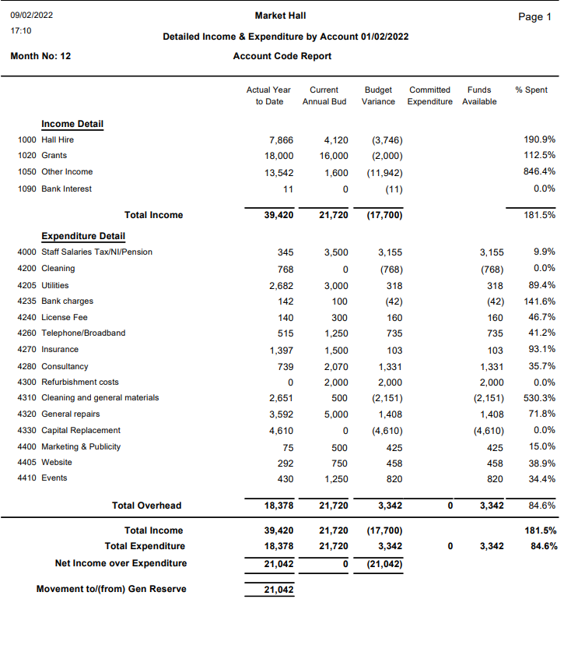
11

  - To agree budget for 2022-2023 (Appendix 5)

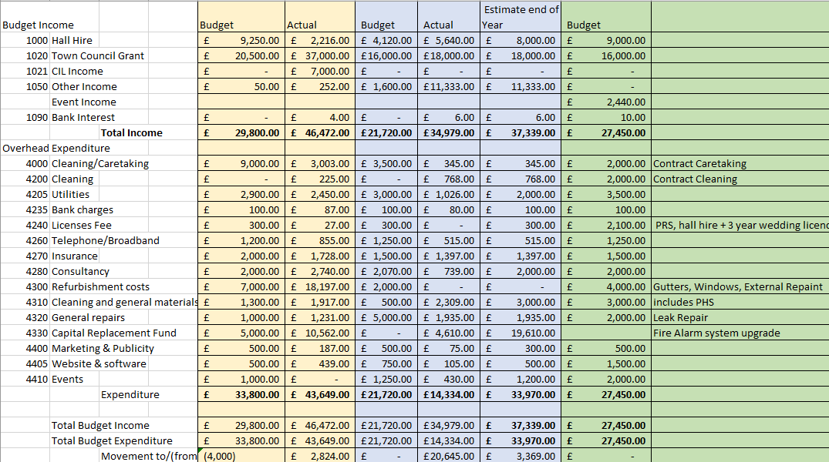

- Market Hall Clock – To consider whether the clock is replaced to commemorate the Jubilee or to install a new electrical mechanism in the existing device.

- Phase 2 Improvements
  - To receive a verbal update on the kitchen refurbishment project.

DBS Projects arrived on site on the 4th of January as agreed and proceeded to strip out the kitchen. They provided the job with a site manager and lead tradesman who provided regular communication with the Clerk throughout the job.

We allowed bookings to continue throughout the works and the tradesmen were very considerate to their needs. The stopped work for the UEA monthly talk and the driving theory test theory booking. There was one booking that had to cancel at short notice as the hall had become dusty, and the cooker had to be moved into the hall for a week while the flooring was installed. We did agree two refunds to regular hirers who we thought had been significantly affected.

Anglia Catering Equipment delivered the kitchen on the 11th of January as agreed the cost of this was £4,610.00. (They are refunding the Council £174 as they failed to deliver the taps).

DBS Projects stripped the kitchen and prepared everything for the fittings. The back wall plaster was flaky and had to scraped and replastered. This was included in the price. There was a problem with the shutter as the wall that is had to affixed to was not structurally strong enough to hold the weight. An additional cost of £340.23 was incurred to creating a supporting frame and making good. This added another 2 days to the schedule. The works would have been completed by the 31 of January but we had another minor hiccup as the handwash sink no longer fitted into its space due to the new wall surfacing. The Clerk arranged for this to be reduced locally at an additional cost of £100. The team are coming back to the Market Hall on the 15 to complete the outstanding items. The final invoice from DBS projects is for 14,119.49

The costs of the equipment and building works current stand at £18,829 which is £329 over the £18,500 agreed for the project.

- Market Hall Improvements Phase 3
  - To consider the recommendations of the Management Committee for toilets and frontage

Item 8 – Phase 3 Recommended Preferred Option for Toilets and Frontage

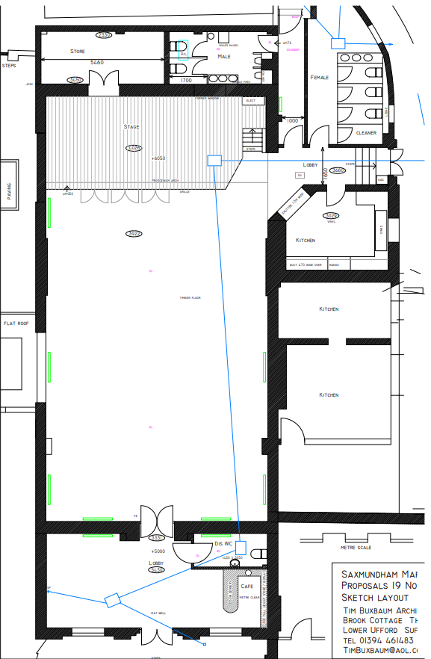

Phase 3 Preferred Option for Frontage
