Roz Barnett
Saxmundham Town Council
Resources Committee 28 February 2022

Item 4 Operational Issues (Appendix 2)
Item no: | 4 a
Report dated: | Updated 24/2/2022
To the: | Resources Committee
Meeting on: | 28 February 2022
Subject: | Health and Safety Consultant.
Contact/author: | Assistant Town Clerk (ATC), email: assistanttownclerk@saxmundham-tc.gov.uk

- Background.
1.1 Saxmundham Town Council agreed to commission a health and safety consultant to act as a dedicated point of contact for officers of the Council and as the legally required Competent Person for Health and Safety on behalf of the Council.

2.0 Tender response
2.1 The Town Council has received eight responses to its invitation to tender. These have been briefly evaluated against the Council’s selection criteria the results of which are summarised below. (The shortlisting criteria are attached at Appendix 1 and the completed spreadsheet has been sent to you electronically.)

Name | Year 1 £ (net of VAT | Year 2 £ (net of VAT) | Year 3 £ (net of VAT) | Total £ (net of VAT) | Did they meet the brief?
Scott Risk Management | £9,250 | £9,000 | £8,137 | £26,387 | Yes
Worknest (Ellis Whittam) | £2,214 plus £273.50 optional costs | £2,214 plus £273.50 optional costs | £2,214 plus £273.50 optional costs | £6,642 plus £820.50 optional costs = £7,462.50 | No - Tender does not adequately address the brief.
OM Group | £2,400 gap analysis, £7,800 basic, £2,000 optional costs | £7,800 basic, approx. £1,000 optional costs | £7,800 basic, £1,000 optional costs | £29,800 | Yes
Wurkplace | £4,430 | £4,430 | £4,430 | £13,290 | Yes – clearly addresses our selection criteria.
HSQE Consultancy | £4,400 | £4,500 | £4,600 | £13,500 | Yes
Pennington Choices | £12,600 | £9,800 | £9,800 | £32,200 | Yes
Virtual Service | £5,192 | £5,192 | £5,192 | £15,576 | Yes
Citation | £2,592 (£216/month) | £2,592 | £2,592 | £7,776 | Yes

3.0 Financial and quality considerations.
3.1 The Town Council has budgeted £3,000/year for all consultants’ fees. Only Worknest and Citation fall within the Council’s budget. Both firms failed to address our tender brief. When both were asked to provide further information, however, only Citation provided the documents needed. Other applicants submitted more comprehensive bids and Wurkplace submitted a particularly clear bid that addressed our brief clearly, concisely, and directly.

3.2 On taking verbal references Worknest received better citations.

4.0 Recommendation.
4.1 That the Council appoint Worknest as the Town Council’s Health and Safety Consultant for a 5-year period at a cost of £2269 for year 1 and £2484 for years 2-5.

5.0 Legal power to make decision.
5.1 Power to enter into contracts. Local Government Act 1972, s.111.

5.2 Power to do anything that will be conducive to or incidental to the discharge of its powers and functions. Local Government Act 1972, s.111.

Item 5 Finance
  - To note payments and receipts and reconciliation reports for January for the Town Council (Appendix 3) 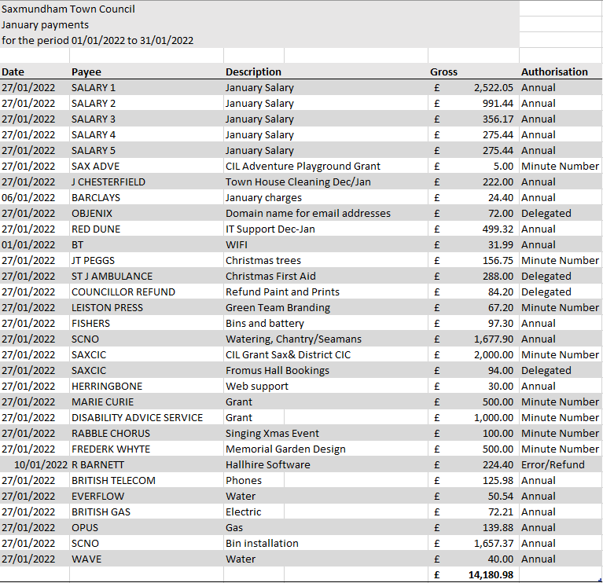
b To note payments and receipts and reconciliation reports for January for the Market Hall (Appendix 4)
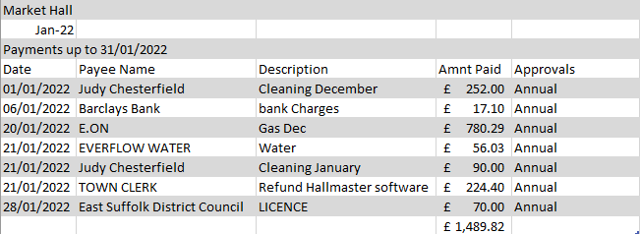
To authorise any February payments outside of the Clerk’s delegated powers for the Town Council and Market Hall (Appendix 5).

c To Approve additional payment of £288 to Red Dune for Software for new laptops.
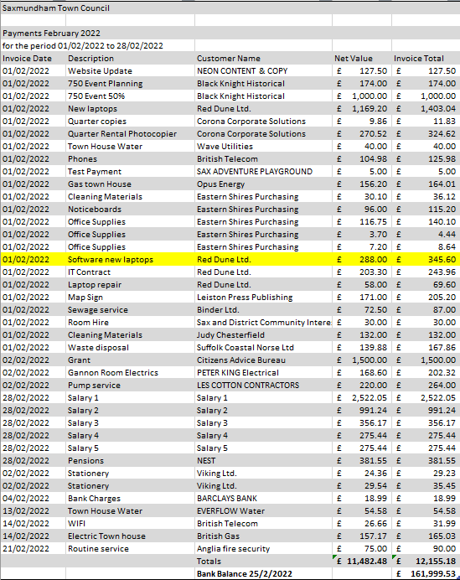

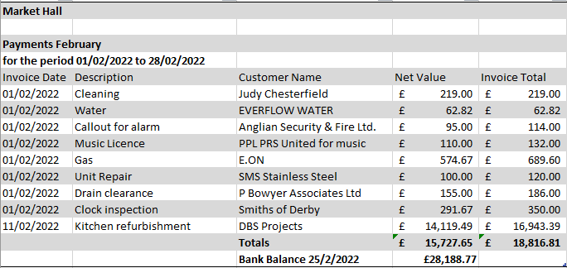

Item 6 a) -Appendix 6- Asset Register with editions 2021-2022

Item | Column1 | Location | Asset Register Value | Insurance Value | Purchased | Ins | Disposed
FROMUS SQUARE
 | War Memorial | Fromus Square | £ 10,810.00 | £ 12,049.00 | Jan-05 | x
CHANTRY RD
 | Chantry Road Play equipment | Chantry Rd play area | £ 9,999.00 | £ 12,000.00 | Mar-15 | x
 | Chantry Road Play Area |  | £ 1.00 |  | Jun-05
 | Fencing at Chantry Road | Chantry Rd play area | £ 7,128.81 | £ 10,000.00 | Dec-14
SEAMAN AVENUE
 | Seaman Ave Play Equipment | Seaman Ave | £ 12,500.00 | £ 59,502.96 | unknown | x
 | Seaman Ave Play Equipment | Seaman Ave | £ 27,958.21 |  | Nov-13 | x
 | Pumping station | Seaman Avenue Playground | £ 6,768.95 | £ 8,000.00 |  | x
 | Swings for Seaman ave | Seaman Ave | £ 13,191.60 |  | Jan-12 | x
 | 1 bench | Seaman Ave | £671.45 |  | Feb-22 | TBA
 | Seaman Avenue Recreation Ground |  | £ 1.00 |  | Mar-05
MEMORIAL FIELD
 | Memorial Field |  | £ 1.00 |  | May-05
 | Portacabin | Memorial Field | £ 24,203.63 | £ 28,714.88 | Dec-15 | x
 | Football posts | Memorial field | £ 2,136.00 | £ 2,380.00 | Apr-13 | x
 | Skate Park play equipment and surfacing | Memorial field | £ 80,677.00 | £ 82,444.07 | Nov-16 | x
 | Picnic bench and benches | Memorial Field | £ 2,846.00 | £ 2,000.00 | Sep-20 | X
 | 2 litter bins (Skate Park) | Memorial Field | £ 700.00 | £ 700.00 | Dec-15 | X
LAND AND BUILDINGS
 | Saxmundham Town Council Offices |  | £ 190,000.00 | £ 114,736.00 |  | x
IT AND EQUIPMENT
 | Computer | STC | £ 770.00 | Contents | Jun-16 | x
 | Monitor | STC | £ 69.70 | Contents
 | Computer (assistant clerk) | STC | £ 317.00 | Contents | Feb-14
 | Computer | STC | £ 500.00 | Contents | May-20
 | Printer | STC | £ 140.00 | Contents | Apr-20
 | Monitor | STC | £ 132.95 | Contents | May-20
 | Monitor | STC | £ 250.00 | Contents | Feb-14
 | Konica Miniolta photocopier | Rental Agreement |  | £ 10,680.06 |  | x
 | Laptop | STC | £ 369.00 | £ 500.00 | Mar-20
 | Laptop | STC | £ 514.80 | £ 514.80 | Nov-20
Around Town
 | Dog Waste Bin | Brook Farm Road | £ 214.00 | £ 1,750.00 |  | x
 | Dog Waste Bin | Felsham Rise | £ 214.00 |  |  | x
 | Dog Waste Bin | Saxon Road | £ 214.00 |  |  | x
 | Dog Waste Bin | Seaman Avenue | £ 214.00 |  |  | x
 | Dog Waste Bin | Deben Road | £ 214.00 |  |  | x
 | Dog Waste Bin | South Entrance | £ 214.00 |  |  | x
 | Dog Waste Bin | Thurlow Close | £ 214.00 |  |  | x
 | Dog Waste Bin | Fromus Green | £ 690.57 |  | Apr-21 | TBA
 | Dog Waste Bin | Boundary Belt | £ 515.00 |  | Sep-22 | TBA
 | Dog Waste Bin | Rendham Rd | £ 690.57 |  | Apr-21 | TBA
 | Dog Waste Bin | Dove Close | £ 125.00
 | Grit Bins | Manor Gardens | £ 150.00 | £ 1,800.00
 | Grit Bins | Alma Place | £ 150.00
 | Grit Bins | Church Road | £ 107.46 |  | Dec-12 | x
 | Grit Bins | Brook Farm | £ 107.46 |  | Dec-12 | x
 | Grit Bins | Seaman Avenue | £ 107.46 |  | Dec-12 | x
 | Grit Bins | Ronald Way | £ 107.46 |  | Dec-12 | x
 | Grit Bins | Brook Farm Road | £ 107.46 |  | Dec-12 | x
 | Grit Bins | Henley Close | £ 107.46 |  | Dec-12 | x
 | Grit Bins | Mill Rise | £ 107.46 |  | Dec-12 | x
 | Grit Bins | Brook Farm Road | £ 107.46 |  | Dec-12 | x
 | Grit Bins | Long Avenue | £ 107.46 |  | Dec-12 | x
 | Grit Bins | Kingfisher Rise | £ 107.46 |  | Dec-12 | x
 | Hanging Baskets x 40 | Around town | £ 400.00 | £ 400.00 | Apr-20
 | Intruplas benches | Chapel Rd and High St | £ 445.15 | £ 495.09
 | Memorial Field Plaque | Memorial Field | £ 345.00 | £ 384.56
 | North Entrance sign | North Entrance | £ 50.00 | £ 1,000.00 |  | x
 | South Entrance sign | South Entrance | £ 1.00 | £ 1,000.00
 | Westcotic SID Sign | Rendham Road | £ 2,625.00 | £ 3,500.00
 | Bus Shelter | Church Hill | £ 3,000.00 | £ 3,000.00
 | Finger Posts | Fromus/The Edge | £ 2,854.00 | £ 2,854.00 | Jun-22 | TBA
STC building
 | 3 Oak Tubs | STC | £ 65.85 | £ 150.00 | Feb-01 | x
 | Desks x 2 | STC | £ 300.00 | contents
 | 2 water heaters | STC | £ 442.20 | £ 442.20 | Jan-21 | x
 | 2 red Gazebos | STC | £0 | £1,000 | Gifted Dec-21 | TBA
VARIOUS
 | Chairmans Medallion x 2 | London Bridge | £ 750.00 | £ 836.02 |  | x
 | Silver Inkstand (long silver) | Museum | £ 7,000.00 | Museum insurers
Market Hall
 | 2 no Teak Benches | Market Hall | £ 824.00 | £ 918.50 |  | x
 | Chairmans Boards | Market Hall | £ 200.00 | £ 222.94 |  | x
 | 3 Oak Tubs | Market Hall | £ 65.85 | £ 150.00 | Feb-01 | x
 | Market Hall rebuild | High Street | £ 1.00 | £ 1,320,000.00 | Oct-20
 | Lighting system | Market hall | £ 3,865.00 | £ 3,865.00 | Dec-20
 | PA system | Memorial Hall | £ 182.50 | £ 244.12 | Dec-20
 | Projector | Market Hall | £ 631.20 | £ 631.20 | Jan-21
 | Replacement boiler | Market Hall | £ 8,997.00 | £ 8,997.00 | May-20
 | Stainless Kitchen Units | Market Hall | £ 5,532.00 | £ 5,532.00 | Nov-22 | TBA
 |  | Total Asset Value | £ 436,127.59 | £ 1,703,394.40

Item 6b Appendix 7 Financial regulations Document hyperlink FRs-amended-May-2022.docx (live.com)
Current Wording
6.3. All payments shall be effected by cheque or other instructions to the Council's bankers, or otherwise in accordance with a decision of the Council or Resources Committee.
6.4. Cheques or orders for authorised payments drawn on the bank account shall be signed by two members of the Council duly authorised by the Council as signatories and accepted by the Bank. A member who is a bank signatory, having a connection by virtue of family or business relationships with the beneficiary of a payment, should not, under normal circumstances, be a signatory to the payment in question.
6.5. To indicate agreement of the details shown on the cheque or order for payment with the counterfoil and the invoice or similar documentation, the signatories shall each also initial the cheque counterfoil.

Revised Wording based on current practice
6.3. All payments shall be affected by electronic payment or other instructions to the Council's bankers, or otherwise in accordance with a decision of the Council or Resources Committee.
6.4. Electronic Payments for authorised payments drawn on the bank account shall be approved by a signatory of the Council. All payments lists should be checked and signed by an authorised signatory of the Council post payment. A member who is a bank signatory, having a connection by virtue of family or business relationships with the beneficiary of a payment, should not, under normal circumstances, be a signatory to the payment in question.
6.5. To indicate agreement of the details shown on the cheque or order for payment with the counterfoil and the invoice or similar documentation, the signatories shall each also initial the cheque counterfoil.
Suggested Wording when we move to Unity Bank
6.3. All payments shall be affected by electronic payment or other instructions to the Council's bankers, or otherwise in accordance with a decision of the Council or Resources Committee.
6.4. Electronic Payments for authorised payments drawn on the bank account shall be approved by two signatories of the Council. A member who is a bank signatory, having a connection by virtue of family or business relationships with the beneficiary of a payment, should not, under normal circumstances, be a signatory to the payment in question.
6.5. To indicate agreement of the details shown on the cheque or order for payment with the counterfoil and the invoice or similar documentation, the signatories shall each also initial the cheque counterfoil.
Annex 1 – BACs Payment Processes
Online Banking Users
- The Town Council in taking advantage of online banking shall establish two classes of user:
CLASS A - user rights only to view balances and create payments.
CLASS B - user rights only to view balances and authorise release of payments.

- The Town Clerk and Finance and Administration Officer shall be CLASS A users.
- The Council’s bank signatories shall be CLASS B users.
- No other users shall be permitted on the council’s online banking system.
- Class A users are not permitted to authorise the release of payments.
Making BACs Payments
- The Finance and Administration Officer shall prepare a schedule of payments using the Rialtas accounting system.
- The Clerk will check the payments list and create within the council’s banking system the payments for approval by two authorised signatures.
- The Finance and Administration Officer shall provide CLASS B users with an approved schedule of payments for reference when authorising payments
- Two CLASS B users shall authorise payments for release. No payment shall be released without two CLASS B users having authorised the payment.

6c Insurance Cover Appendix 8 – The Council are with BHIB

The Council are currently within the 1st year of a 3 Year Long Term Agreement at a cost of £2158.97 Including Insurance Premium Tax (Parish Online Optional). I have sent them a draft of the revised risk register and the additional items will not affect our current premium.

The Gannon Rooms insurance runs out on May 5th and the current premium is £1259.52.

Agenda item 6d – Appendix 9 Risk Register
Item 7b  Subject: | No. | Risk identified | Potential impact  (H/M/L) | Level of risk  (H/M/L) | Management/Control of risk | Review/Assess/Revise
Business continuity |  | Council unable to continue business as a result of an unexpected or tragic event | H | L | All files and recent records are retained at the council’s office. There is a secure, cloud-based IT system for digital records. Paper documents, both current and archived, are filed in the Saxmundham Town House. | Review regular updating of user passwords.  Personnel files are stored in locked, metal filing cabinet.  All other paper-based documentation has been reviewed but historical documentation is yet to be logged and archived appropriately.  Assistant clerk and clerk share information about each other work.
Business continuity |  | Town Clerk temporarily absent or otherwise unable to carry out duties. | H | M | In the event of the clerk being indisposed the assistant town clerk will provide clerical support. An operational plan is in place including temporary clerical support.  Appointment of Finance and Administration Officer to ensure financial continuity | Ensure that both members of staff have reasonable day-to-day experience of all systems to ensure continuity.  Council to revert to using cheques in an emergency.
Business continuity |  | Council records: Loss through damage, fire or theft | H | L | IT system files are backed-up using a cloud-based system. This occurs at file creation and updating. See Business Continuity 1. | Also refer to Business Continuity 1.  Provide an emergency contingency plan.
Business continuity |  | Access to confidential information by non-authorised personnel. | M | L | Only the town clerk, the assistant town clerk, and the IT administrator have access to the IT system. | Password updating procedure in place with our IT support.  Contact IT support if access is required.  See Financial Regulations.  Cabinets/Offices to be locked when Clerk/Assistant Clerk not present.
Business continuity |  | Meeting location adequacy: Health and Safety | H | L | Full Council meetings are normally held in the Market Hall. Committee meetings are normally held either in the Market Hall or Saxmundham Old Police Station. The clerk and assistant town clerk hold keys/access codes to both. The premises are considered satisfactory providing all statutory health and safety obligations are observed. | Statutory health and safety obligations for both the Market Hall and the old police station reviewed and will be continued Relevant documentation retained in STC Office.  Clerk has arranged for Town House door code to be reset.  When the Council has locally based key holders, they may want to consider alarm systems for the buildings.
Freedom of Information Act (FOA) |  | Policy Provision | M | L | The council has a model publication scheme for local Councils in place. The Town Clerk is aware that if a substantial request arrives it may necessitate additional hours of work. The council is able to request a fee if the work will take in excess of 15 hours to complete. The request can be resubmitted in sections to negate the payment of a fee. | Monitor any report and potential impacts made under the FOA.  Review files for any previous information requests.  On receipt of an FOI, the Chair and Vice-Chair should be informed and monitoring of compliance to time to respond should be monitored
Data Protection |  | Failure to comply with GDPR (General Data Protection Regulation) 2018 or later regulations | H | L | Follow good administrative practice for securing personal and GDPR related data | Audit and action sheet completed 2019 officers to review risks on an annual basis.  Ensure all software packages are compliant with GDPR  Clerk and administration staff to receive online update training.
Finance |  | Precept adequacy | H | L | Sound planning and budgeting process to support the annual precept requirement. The process should take account of each committees’ recommendations. The Resources Committee reviews the planned budget in October/November with recommendation/agreement by Full Council each January. | Minute to be made on budget, submission of precept request and receipt of precept payments.  Copy of the approved budget to be sent to all members.
Finance |  | Budgetary control | H | H | The RFO to regularly provide the council with regular updates regarding receipts and expenditure against each budget category. | Part of Financial Standing Orders Section 4. Budgetary Control and Authority to Spend. Financial Regulations reviewed 2020 and will be reviewed reported to Resource Committee & Council annually  Resources Committee to receive regular budget/forecast detailed update. Full council to receive regular updated summary budget sheet.
Finance |  | Insurance adequacy | M | H | Statutory requirement: Employers’ Liability, Public Liability, Fidelity Guarantee. Annual review completed. Part of annual audit. | Asset Register to be reviewed annually or updated more frequently as required.  Market Hall to have a separate asset list.  RFO to report to Council on general adequacy of insurance.
Finance |  | Banking: Adequacy of checking procedure | L | L | The council has agreed Financial Regulations which determine the procedure. Annual independent audit. | Review Financial Regulations annually and as required.  Online banking mandate to be reviewed by Full Council, when necessary.
Finance |  | Cash: Control to prevent loss through theft | H | L | Regular reconciliation of bank statements prepared by RFO. Checked and signed by designated Councillor. Two authorised signatures required for cheques.  Annual internal and external audits completed.  For internet banking payments will be initiated by the clerk and approved by an authorised signature. | Part of Financial Standing Orders. Review as required.  Review procedure for on-line banking and on-line payment authorisation. On-line banking mandate to be reviewed and agreed by Council  Move banking to facilitate 2 councillors approving online payments.  Organise card facility to minimize funds to councillors and officers.
Finance |  | Approval of expenditure: authorisation levels | H | L | Any financial decision must be resolved and clearly recorded prior to any commitment. This usually takes place at Committee meetings.  All income and expenditure must be detailed in quarterly reports presented to the Resources Committee and Full Council.  Financial Regulations have been reviewed and specific limits specified. | Monthly Payment report contains authorisation notes to be completed by Clerk and presented to Full Council.  Internal auditor to randomly sample minute numbers and check financial decisions.  The clerk will send out a copy of the monthly reconciliation and budget report to all councillors on a monthly basis.
Finance |  | Fraud | H | L | Internal procedures are observed. Fidelity Guarantee insurance must be in place. | Monitor adherence to Financial Regulations.  Annual check of fidelity insurance.
Finance |  | VAT & other Taxes | H | L | The council has Financial Regulations which define the requirements for VAT recovery which is completed on a quarterly basis.  PAYE tax & NI paid as defined by HMRC regulations. | Council to review the VAT in relation to the Market Hall before embarking on major refurbishment.
Land and Property |  | Don’t have key documents of ownership and possession. | L | L | Clerk to review all documents and seeing information from Land registry where there are gaps | Council to consider whether to pursue registering any unregistered property/land.
Land and Property |  | Licenses and Leases | L | L | Clerk to review all documents and seeing information from Land registry where there are gaps | Council to consider whether to pursue registering any unregistered property/land
Liability |  | Damage to building assets, street furniture, IT equipment, play equipment and other equipment | M | L | An Asset Register is maintained, and insurance is held at the appropriate level for all items. Regular checks are made on all equipment by the appropriate service providers and members of the council.  Capital Replacement Fund now in place. | An inventory of equipment is required and a central log should be maintained for any items of equipment or documentation which are lent out. This to include a signature by the borrowing party.  See comments on Asset Register and Insurance Cover.
Liability |  | Legal Powers: Illegal activity or payments  Legal powers: Working Parties taking decisions | H  L | L  L | All activity and payments made within the powers of the Town Council (not ultra vires) are to be resolved and clearly recorded in the minutes.  Terms of reference are in place and agreed for Committees and Working parties. | Include details of powers being used by Council in the minutes and papers.
Liability |  | Agendas, minutes and statutory documents: Accuracy and legality and/or non-compliance | L | L | Agendas and minutes are produced in the prescribed method and adhere to legal requirements.  Minutes are approved and signed at the next meeting where possible.  Agendas and minutes are displayed according to legal requirements.  Business conducted at Council meetings should be managed by the Chairman according to Standing Orders.  (Covid -19 has impacted on signatures) | Existing procedures adequate.  Undertake adequate training to ensure adherence to procedure.  Members to adhere to Code of Conduct and Standing Orders.  Review Standing Orders at least annually to ensure relevance.
Liability |  | Public Liability: Risk to third party, property or individuals | H | L | Insurance is in place. Risk assessment of any individual event is undertaken. Separate insurance is taken for one-off events. Health and safety risk assessment, training and instruction routinely completed. | Existing procedures adequate. An annual review of insurance cover to be completed at the start of each financial year.
Council Reputation |  | Conflict of interest  Register of Members’ Interests | L  L | L  L | Councillors have a duty to declare any interest at the start of a meeting or when an interest becomes apparent during a meeting. Councillors with a pecuniary interest must leave the meeting while that item is discussed.  Register of Members’ Interests form to be reviewed at least annually. | Existing procedures are adequate. Reminder to be issued regarding updates to the Interest Register at the start of each financial year.  Members to take individual responsibility to update the register on-line.
Council Reputation |  | Councillors and Staff: Bringing the Council into disrepute | M | L | Councillors understand and receive training on the Code of Conduct. A professional approach is undertaken for all Town Council matters.  An e-mail protocol policy is available. | Members to identify training requirements.  Clerk to issue a reminder covering available training at the start of each financial year.  Review e-mail protocol policy and update as required.
Health & Safety |  | Accident/injury public and staff | H | H | Staff have risk assessments and regularly monitor the Health & Safety risks Councillors have undertaken annual sites visits to record health and safety and Maintenance issues. | The Council are considering appointing an external body to be the competent body for Health and Safety for the Town Council.
COVID-19 |  | Sustained disruptions to service and budget.  Public health risks to staff and public | H | H | Specific risk assessments in place which are constantly reviewed considering government guidance. | Budget to include contingency for responding to unexpected events.  Staff & public welfare to be considered by relevant Committee in the event of a changing situation.
Emergency Plan |  | Sustained disruptions to service and budget.  Public health risks to staff and public | H | L | Council to consider developing Emergency Plan in event | To be reviewed annual to ensure information is UpToDate.

Item 7 Small Grants

- Appendix 10 - Grant request Men’s sheds

Application for a grant to fund the purchase of a bandsaw
Background
The Sax Men’s Shed has been going for nearly three years and has made a good deal of progress in adapting the old garages and kennels despite the covid hiatus. We have acquired a number of very useful workshop machines and hand tools by the generosity of a few people and these have proved invaluable both improving the facilities in the shed and in making the recently completed planters for Sutton Hoo. The planters are shortly to be set in place and form part of the Sutton Hoo Dye Garden.
Requirement
We want to acquire a bandsaw for general use and in making practical items, such as the hedgehog house, for other community groups in and around Saxmundham.
Additionally, it will be used for preparing circular blanks for use with the two woodturning lathes that have been donated. It appears that woodturning will attract the new members than we need to ensure that we can keep going.
At present we have chosen the Charnwood W721 12″ Bandsaw currently priced at £446.00 as it most nearly aligns with our requirements of cutting capacity and accuracy.
We request a grant of that amount to enable us to purchase a bandsaw.
Colin Morley
Treasurer, Saxmundham Men’s Shed

- Appendix 11 Grant request St John’s Church

Love God, Love one another and Love our communities

C/O Carol Cotton 50 St John’s Road Saxmundham IP171BD
Tel: 01728 603221/07714302559

St John’s church would like to take part in the celebrations of the 750 year Town charter. We would appreciate some help with this to the tune of £350.
We propose to have a tent that will run children’s activities, we will be doing craft activities all day with a rest area for parents and a nappy changing area.
We will be running activities for the children as well as having toys and games for them to use. We also plan to bring in a magician and children’s entertainer.
We also plan to give people who visit us a bag with information in about the town and will approach any business that would like to pop something in bag to advertise their business.
Costs: entertainer £350
Art & Craft £100
Printing/bags £150

Total £600

We are therefore asking for a contribution of £350 from Saxmundham Council, the rest will be given by the church.

Item 9 – Appendix 12 Staffing Matters

  - SAXMUNDHAM TOWN COUNCIL
  - Job Description

Job Title: Finance and Admin Officer
Place of work: The Town House, Saxmundham
Hours of work: 10 hours of work per week – (Normally worked Monday and Tuesday)
Salary: (SCP scale 6 point 19)
Pension Option to join the NEST pension scheme
Responsible to: Town Clerk
Objective: The post holder will assist the Town Clerk in the management of the finances for the Town Council, Market Hall and Gannon Rooms as well as completing general administrative activities
Key Tasks:
- To review invoices for payment with the RFO and confirm that the work, goods, or services to which each invoice relates has been received.
- To check invoices for arithmetical accuracy.
- To enter all payments and receipts into Rialtas software by the end of every month.
- To record cash and cheque receipts ensuring they are banked in a timely fashion.
- To attend the monthly Resources Committee and take minutes as required.
- To provide monthly Rialtas reports to the Resources Committee and Town Council.
- To reconcile all payments and receipts on the first week of the month.
- To initiate payments in the absence of the Town Clerk.
- To use the Hallmaster software to issue invoices and track rent payments for the Market Hall and Gannon Rooms.
- To keep an overview of income received through online ticket sales.
- To complete quarterly VAT returns
- To keep financial and related records including contracts.
- To work as part of the Town Council’s administrative team, dealing with general enquiries from members of the public and others.
- To ensure all assigned tasks and duties are completed in a safe manner and comply with safety rules/procedures.
- Be prepared to undertake any other duties as directed by the Town Clerk.

PERSON SPECIFICATION

ESSENTIAL | DESIRABLE
Qualifications & Training  BTEC/diploma/degree or equivalent.  Willingness to undertake Rialtas and | - Accountancy qualification such as ATT/ACCA/ACA or demonstratable relevant experience undertaking a similar role or tasks.  - CILCA qualification
Knowledge and Experience  - Experience of managing budgets/accounts  - Experience of creating and using excel spreadsheets.  - Experience of using accounting software eg Rialtas, Sage or Scribe. | - Competent in Rialtas Omega Accountancy software.  - Experience of working in the public sector.
Skills / Abilities

- Excellent communication and a friendly and welcoming demeanour.
- I.T skills enabling use of word, excel and databases good numeracy, literacy, and presentation skills
- Able to work under pressure

Personal Characteristics  - Methodical and tenacious.  - Be a team player.  - enthusiastic with a willingness to learn. | - Attention to detail and have an ability to proofread communications.

-------------------------------------
  - Saxmundham
  - Town Council
  - is seeking A
  - Finance and Administration Officer
-------------------------------------
Finance and Admin Officer  10 hours of work per week (£13.21 per hour)  Normally worked on a Monday and Tuesday (Could be during the School Day)  Saxmundham Town Council have a part-time vacancy in our small and friendly team for a Finance and Administration Officer.  We are looking for an individual that can undertake the financial administration duties of the Town Council.  The Council would like to recruit an individual with excellent IT skills and experience of using accounting software packages. | The closing date for this vacancy is Friday 25th of March 2022.  Please contact the Town Clerk for full details of the post and an application form  Email townclerk@saxmundham-tc.gov.uk  Tel 01728 604595
\

