Roz Barnett
Saxmundham Town Council
Town Council 14 February 2022

Item 7 123/21TC Minutes of Previous meetings
Appendix 2

Minutes of the Meeting of the Market Hall Management Committee (MHC) held at 6 pm on 26th January 2022 at the Fromus Centre.

Members of the Committee | Cllr Jeremy Smith (chair) |  | Cllr Tim Lock
 | Cllr Di Eastman |  | Cllr Charlotte Hawkins
 | Carole Cecil
Apologies | Rosie Hoare - |  | Cllr John Findlay
Also present | Roz Barnett – Clerk (TC) |  | Jen Morcom - Assistant Clerk (ATC)

 |  | Action
28/21MHC | Apologies for absence:
 | Apologies were received from Rosie Hoare and Cllr. Findlay.
29/21MHC | Pecuniary/non-pecuniary interests.
 | There were no declarations of interest.
30/21MHC | Minutes of the previous meeting.
 | The Committee RESOLVED to approve the minutes of the meeting held 15th December 2021.  The minutes were signed by the Chair.  Carole Cecile reported that she had yet to formally wind up the Development working group but that she would do so shortly. | CC
31/21MHC | Finance report
a. | To receive a report on the Market Hall budget April 2021- November 2022.  The TC informed the Committee that an exceptionally high gas bill had been received, which she is investigating. She has already reprogrammed the heating for the Market Hall.  The Committee noted that with an income to date of £38,820 and expenditure of £17,958 there is a current underspend of £20,662. Much of the underspend to date is due to money set aside for the refurbishment of the kitchen. This will be spent shortly as the kitchen is nearing completion.  The TC advised that she expected the budget to balance at year end.  The Committee noted the budgetary position for the current financial year.  The Committee also noted that the budget for 2022-2023 will go before a meeting of the Market Hall Trustee in February. | TC
32/21MHC | Clerk’s update on operational matters.
a. | To receive an update on the projector.  The TC reported that the projector was now working perfectly. The problem was due to the close proximity of the electrical wiring and the cable for the projector. These are now further apart.
b. | To receive an update on clock service and repair.  The TC informed the Committee that repairs had been commissioned but a date for the repair has not yet been fixed.  The Committee noted that a fire drill and review of the Evacuation Plan is overdue.  The Committee agreed that the ATC should invite Committee members to participate in an evacuation on a suitable date. | ATC
33/21MHC | To receive an update on the kitchen refurbishment
a. | To consider arrangements and options for a dishwasher.  The TC had sent out information on domestic and commercial dishwashers. There is a significant difference in price, with commercial dishwashers at £1-2K and high-end domestic dishwashers at £500-£600. She explained that hirers had fedback that they would feel more confident about operating a domestic dishwasher.  The Committee RESOLVED that the TC should purchase a good quality domestic dishwasher.  The ATC will add checks of salt and filter to the weekly safety checks. | TC  ATC
b. | To discuss equipping the new kitchen.  The TC proposed that 100 of each item of crockery and cutlery should be put into the new kitchen and very old items should be thrown away. Items will be topped up annually.  The Committee agreed this idea in principle.  Carole Cecil advised that businesses, e.g. the Bell, may be getting rid of items. Di Eastman advised that Nisbets are good suppliers of catering equipment.  There was a discussion about whether to provide a warmer. The TC advised that there is enough space and available sockets should one be needed.  The Committee RESOLVED to return to this issue should a customer require a warmer. (Nisbet’s can deliver quickly). | TC
34/21MHC | Market Hall improvements phase 3
a | To consider revised options to toilets and frontage.  The TC presented revised drawings from the architect showing the men’s washroom in the current boiler room and women’s washroom in the Webster Room. There are two men’s stalls and two urinals and three women’s stalls as well as the cleaning cupboard.  The storeroom can double as a green room, but there is little leeway in the Market Hall for changing space for performers.  The architect advised that it is best to leave the drawings with the corner shaved off the kitchen for now in order to test whether this would get planning permission. The architect will also advise regarding the need for specialist surveys for drainage, levels etc.  There was a discussion about the café at the front of the building and how this might work.  The Committee RESOLVED to recommend the drawings to the Market Hall Trustee.  Once the drawings are agreed the architect will apply for planning permission. The Council will need to tender for all work before it submits its main Lottery bid as all costs and budgets must be fully evidenced. | TC
35/21MHC | Bookings 2021-2022
a. | To receive a report on bookings  The TC advised that regular spaces in the Market Hall were filling up quickly with several groups wishing to book on Thursday evenings. Clerks are working with hirers to find the best way to fit everyone in and it is expected that regular hirers will settle into a weekly pattern. The Hall is still relatively underused at weekends, but twice-monthly Artisan Markets and a number of events are planned from April.  The Committee requested that the report should be in the form of a calendar in future in order to understand the pattern of use.  The Committee noted the bookings report.  The Committee RESOLVED to invite Steve Palmer (SADCIC) to its next meeting to discuss how to make best use of the available community spaces held by the two organisations. | TC  TC
36/21MHC | Developing the Market Hall as a venue
a | The Committee noted the events programme.  The TC presented the feedback on the community questionnaire regarding use of the Market Hall. The questionnaire had a good response with lots of feedback about the broad range of events and sessions people would like. It will be used to support the bid to ‘Awards for All’ to fund the 22/23 events programme.  The TC will:  - Circulate the draft bid prior to submission  - Circulate key dates for events such as the Museum Quiz Night, Time Machine, Markets and Wrestling. | TC
The next meeting of the MHC will be on 23rd January 2022 at 6.00 pm

The Meeting ended at 7.40 pm

Appendix 3

Minutes of the Resource Committee Meeting Monday, 31 January 2022 at 2pm
In the Market Hall

Committee Members:
Councillor Di Eastman
Councillor John Findlay (Chair)
Councillor John Fisher
Apologies: Councillor Nigel Hiley, Councillor Jeremy Smith
Also Present: Rosalind Barnett (Town Clerk)
Public Forum: There were no members of the public present.
Please note all documents related to these minutes can be found in the committee pack http://www.saxmundham.org/council/template1-3/
170/21R | Apologies for Absence  Apologies were received from Councillor Nigel Hiley and Councillor Jeremy Smith
171/21R | Declarations of Interest  Cllr Eastman declared a non-pecuniary interest in item 174/21R as she is a trustee of IP17 Good Neighbour Scheme.
172/21R | Minutes of the Previous Meeting  RESOLVED: The minutes of the 29 November 2021 were adopted as a true and accurate record.
173/21R | Operational Issues  - Phone & WIFI contract renewal  The Clerk explained that the current contracts were up for renewal and asked councillors for their views on potential providers and the specification.  RESOLVED: The Clerk will request quotes based on the current specification.  - Energy usage and contracts  The Clerk reported that the agency that had secured the energy contract with SSE have confirmed that the company would not honour the agreements signed in January 2021. The agency reported that this has happened on numerous occasions as companies cannot afford to honour these agreements due to the substantial price hikes. The Clerk presented four new quotes for renewal energy from, SSE, Smartest Energy, E-on and Yu Energy. The Committee noted that Smartest Energy was the cheapest supplier and that their electric tariff represents a saving of £1444.40 and that the gas a saving of £1592.98 from EON’s standard rate.  RESOLVED: The Committee agreed to move the supply for electric and gas to Smartest Energy.  - Health and Safety consultant  The Clerk explained that the Council had received 8 applications for the Town Council’s Health and Safety tender.  RESOLVED: Councillor Fisher and Councillor Eastman agreed to review the three lowest priced tenders that met the Town Council’s specification and bring back recommendations to the next Resources Committee.
174/21R | - Property Licenses  - To consider arrangements for the IP17 Good Neighbour Scheme (GNS)Licence.  The Clerk reported that the arrangements for shared usage of the Town House with the IP17 GNS was still working well. The Town Council are now looking to formalise these arrangements through an annual renewable licence. The Clerk had reviewed the utility bills for the building and the square footage that IP17 GNS were occupying. She proposed a £750 annual fixed charge as contribution to the utility bills and cleaning. This had been discussed with the trustees and they were happy to proceed on this basis.  RESOLVED: That the Town Clerk issues an annual licence to IP17 Good Neighbours Scheme for the usage of the offices at the Town House at a cost of £750 per annum.  - To consider arrangements for the Youth Booth Licence.  The Committee discussed the costs of running the Youth Booth this year which had been around £3000. This included £1851 for 18 months of electricity, £749 external decoration, and £200 for emptying of the septic tank. The Clerk reported that CYDS have paid for the internal decoration and reequipped the building. It was noted that CYDS have been excellent tenants and contributed to improvements on the Memorial Field and events in the Town. In next year’s budget there is £2000 for Youth Booth Maintenance and £3000 for Youth Activities which will cover the costs listed in the current licence. Councillors asked the Clerk to change the budget line to Youth Booth so it could be used to cover utilities.  RESOLVED: That the Town Clerk issues an annual licence to on the same terms to Young People Taking Action (CYDS) for the usage of the Youth Booth.  The Clerk asked the Committee to note that she would be using her delegated powers to purchase land registry documents for Town Council owned land and for property where it is in the Council’s interests to ascertain ownership.
175/21R | Finance  - RESOLVED: That the Committee noted and ratified the payments for November/December for the Town Council.  - RESOLVED: That the Committee noted and ratified the payments and receipts for November/December for the Market Hall.  - The Committee received the January payments list and noted that there were no additional approvals required.  Councillor Eastman reported that she had signed the bank reconciliation statements up to December 31, 2021.
176/21R | End of year Arrangements  The Committee noted the activities that needed to be completed before the end of the financial year.  RESOLVED: That the Committee agreed to sign up for a 3-year contract for end of year services from Rialtas to secure a 7% discount to reduce annual cost down from £600 to £558.
165/21R | Small Grants  Councillors discussed the grant applications received and agreed that the CAB provide a service to the people of Saxmundham and that rising cost of living would be significantly impacting residents.  RESOLVED: That the Committee agreed £1500 grant for the Citizens Advice Service.

Meeting finished 2.51 pm
Roz Barnett Clerk/RFO

Appendix A: January Payments
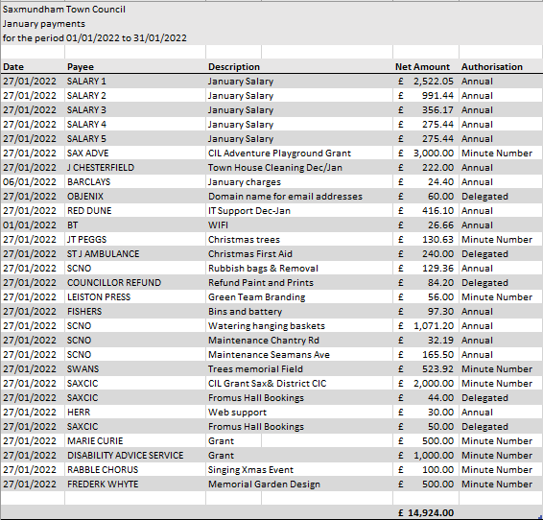
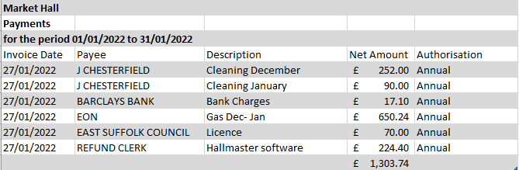

Appendix 4

Minutes of the Meeting of the Planning & Development Control Committee
6pm on 2nd February 2022 by ZOOM.

Councillors:
Cllr. John Fisher (Chair) |  | Cllr. Roger Hedley-Lewis
Also Present: Jenny Morcom,(Assistant Town Clerk (ATC).

120/21PD | Apologies for absence  Cllr Hiley sent his apologies.
121/21PD | Pecuniary/Non-Pecuniary Interests  None declared.
122/21PD | Minutes of the meeting held 19th January 2022 and 12th January 2022  The Committee was inquorate so the minutes of the meeting held 19th January will be considered at the next meeting. There were no amendments to the minutes.
123/21PD | Open Forum  No members of the public had joined the meeting.
124/21PD | Planning Applications  The Committee members present agreed to recommend that the Town Council approve application DC/22/0011/FUL: a single storey rear extension to Fairfield, 7 North Entrance as it is an improvement to the property. As the committee is inquorate the ATC will seek ratification from all Town Councillors by email.
125/21PD | Recent Planning Decisions.  The Committee noted the following decision by East Suffolk council;  DC/5135/CLP 15 Felsham Rise, IP17 1EZ Certificate of lawful use sought to extend sitting room into the garage Permitted
126/21PD | The next meeting will be held on 9th February 2022 at 6pm.

The meeting closed at 6.20 p.m.

Jennifer Morcom, Assistant Clerk to Saxmundham Town Council
The Town House, Station Approach
Saxmundham, IP17 1BW

Appendix 5 – Town Council Payments January 2022
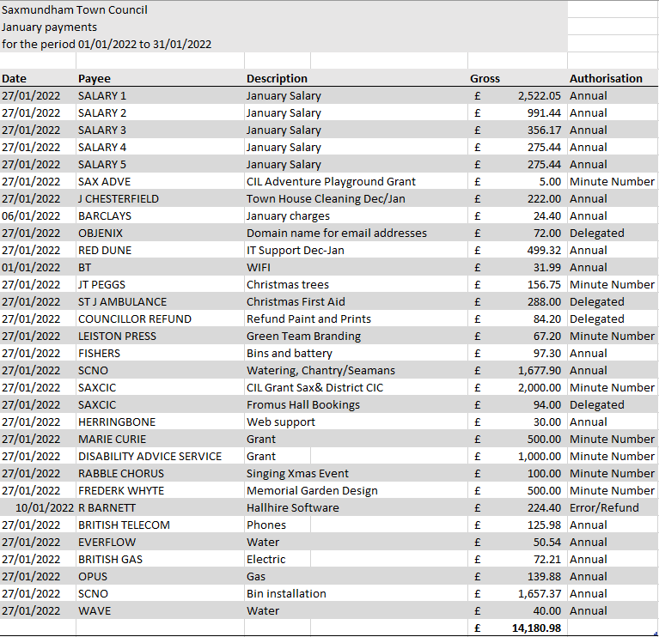

Appendix 6 – Market Hall Payments January 2022
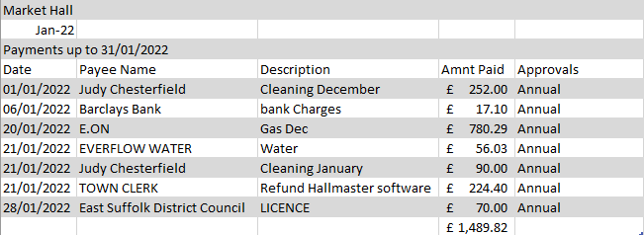

Appendix 8 – Community Infrastructure Levy
Community Infrastructure (CIL) - To consider potential projects and allocation of Community Infra Structure Fund.
Report dated: | 3/2/2022
To the: | Town Council
Meeting on: | 14/2/2022
Subject: | Community infra structure (CIL) Purposes and Potential Allocation
Contact/author: | Roz Barnet, Town Clerk

1.0 Summary:
1.1 This report sets out some suggestions for the allocation of CIL
EMR - CIL 19/20 | £ 17,040.00
EMR – CIL 20/21 | £ 30,656.00
EMR - CIL 21/22 | £ 31,309.00
Total | £ 79005.00

2.0 Agreed purposes:
The Town Council agreed seven purposes/priorities for Community Infrastructure Consultation (CIL) spending on the 10th of January 2022:

Purpose 1 - improving access from new housing areas to town centre for pedestrians and cyclists
To consider: improvements to paths from Hopkins Estate to centre; routes from other estates (e.g. to west of town) to town center.
Purpose 2 - enhancing children & young people’s recreational facilities
To consider: improvements to Seaman Avenue and Memorial Field facilities.
Purpose 3 - a more attractive & successful town centre to meet needs of growing population
To consider: environmental improvements such as urban trees; improvements to Fromus Square.
Purpose 4 – improving community, entertainment, and cultural facilities in town
To consider: capital contribution for improvements to Market Hall, Gannon Institute etc.
Purpose 5 – improving facilities for non-fossil fuel transport modes
To consider: create new bicycle storage facilities; electric charging points.
Purpose 6 – developing new or improving existing open or green spaces for the community
To consider: environmental improvements to Memorial Field.
Purpose 7 – developing sports and recreational facilities
To consider: developments to sports and recreational facilities.

3.0 Recommendation for potential Projects per purpose for planning purposes
The potential projects reflect ideas proposed in the Neighbourhood Plan and the Town Council’s Action Plan
 | Potential Projects | Amount
Purpose 1  Improving access from new housing areas to town centre for pedestrians and cyclists | Improvements to paths from Hopkins Estate to centre; routes from other estates (e.g. to west of town) to town center. | £15000
Purpose 2  Enhancing children & young people’s recreational facilities | Improvements to Seaman Avenue and Memorial Field facilities.  Adventure Playground (£2000 already allocated) | £6000
Purpose 3  A more attractive & successful town centre to meet needs of growing population | Environmental improvements such as urban trees; improvements to Fromus Square, parking. | £10000
Purpose 4  Improving community, entertainment, and cultural facilities in town | Capital contribution for improvements to Market Hall, Gannon Institute etc. | £15,000 MH  £10,000 GI  £2000 FC
Purpose 5  Improving facilities for non-fossil fuel transport modes | Create new bicycle storage facilities; electric charging points. | £6,000
Purpose 6  Developing new or improving existing open or green spaces for the community | Memorial Field | £10,000
Purpose 7  developing sports and recreational facilities | Improvements Carlton Park | £5000
 | Total | £79,000

Appendix 9 – Electrical Charging Points
To consider the recommendation from members of the Amenities Committee to defer the installation of charging points at the Town House.

The County Council decided not to fund the installation of charging points at the Saxmundham Town House as they have installed 6 chargers at the Fromus Centre.
The Committee considered the costs of installing the chargers and decided that the potential cost of £5,500 for installation was excessive. The Committee felt that the benefits to the Town would not warrant the expenditure especially as there are charging points already available in the Town. The Committee did not think the potential revenue would be sufficient to offset the costs.

Recommendation: that Full Council defer this project until the County Council are prepared to put more funding into the program.

Below shows the costs of the installation based on the specification provided by the County Council
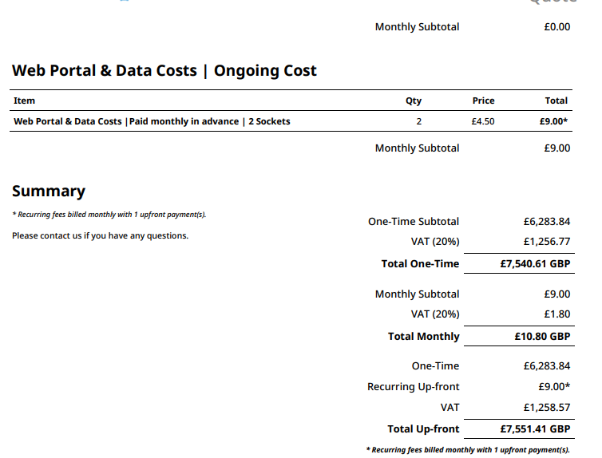

Appendix 10 – SaxFest request for funding of £15000

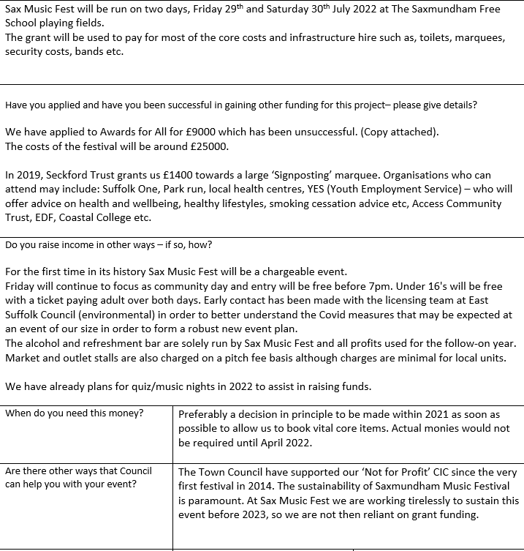

Appendix 11 – 750 celebrations

Outline Programme & Draft Budget

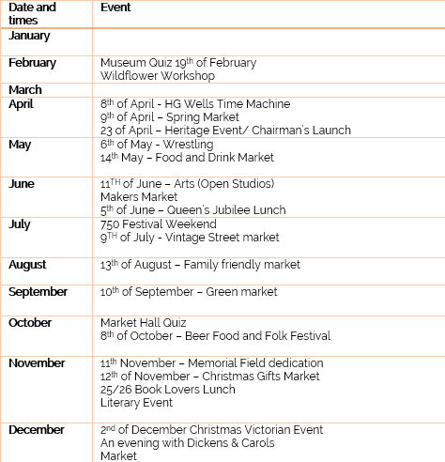

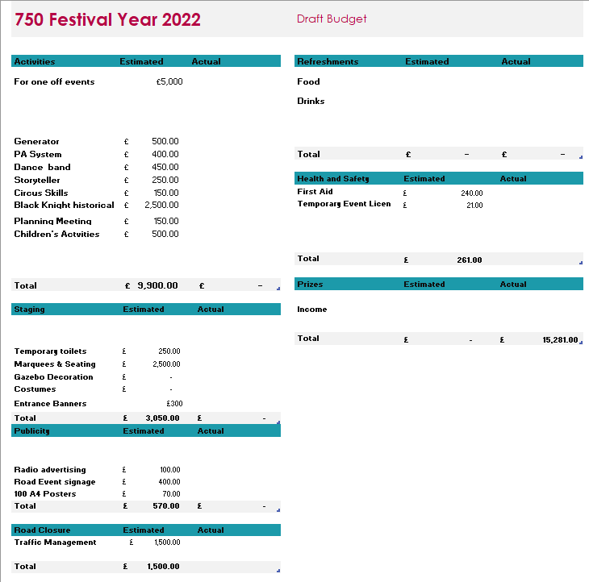

Appendix 12 – 750 celebrations

Saxmundham Town Council
Meeting on Monday 14th February 2022
Item No.:
Report by: Jeremy Smith, Chair
Date of report: 11 February 2022
Queen’s Head public house and restaurant, High Street – identification as Asset of Community Value
1. Under the Localism Act 2011, parish councils and certain community organisations are able to identify and nominate ‘assets’ in their area as being of community value. Provided that the nomination meets the legal requirements, the district council (East Suffolk Council in our case) must list it accordingly.
An Asset of Community Value (ACV) is defined as: A building or other land is an asset of community value if its main use has recently been or is presently used to further the social wellbeing or social interests of the local community and could do so in the future.
In recent years, many such assets have been listed, including e.g. village shops and public houses that have played an important role in the life of their community.
2. The government’s guidance note on ACVs explains:
“These provisions give communities a right to identify a building or other land that they believe to be of importance to their community’s social well-being. The aim is that, if the asset comes up for sale, then they will be given a fair chance to make a bid to buy it on the open market. If the nominated asset meets the definition of an asset of community value, the local authority will list it. The owner will have a right to an internal review by the council, and a right of appeal to an independent tribunal against the result of the internal review. Nothing further will happen unless and until the owner decides to dispose of the asset, either through a freehold sale, or the grant or assignment of a lease, granted for at least twenty-five years. A range of important types of disposal will be exempted from the provisions... Unless an exemption applies, the owner will only be able to dispose of the asset after a specified window has expired. The first part of this window is an interim period, which will allow community interest groups to express a written intention to bid. If none do so in this period, the owner is free to sell their asset. If a community interest group does express an intention to bid during this interim period, then the full window will operate. After that, the owner is again free to sell to whomever they choose, and no further window can be triggered for a protected period.”
3. As councillors will be aware, the Queen’s Head public house, with Chinese restaurant, on Saxmundham High Street has been closed for all or most of the COVID pandemic period, and remains closed with no sign of re-emergence into active economic life. Its last Facebook entry is for September 2020. It has over many decades played an important role in the life of Saxmundham’s community, and benefits from rear parking and outside area for its clientele. With the White Hart now being used for other economic purposes, the Queen’s Head is the last High Street / town centre public house remaining, and could in future continue to perform its long-standing role as an important role as community social facility in the High street, and help to reinvigorate the town centre community life and local economy.
4. The intentions of the owners (including any lease-holders) remain at this point unclear, but there is evidently a possibility that the premises may be marketed for other potential purposes, and its role as public house lost. In order to enable the possibility of a community bid in the event of a proposed disposal, I recommend that Saxmundham Town Council in principle agrees to identify the Queen’s Head public house, High Street, Saxmundham, as an asset of community Value.
5. The Assets of Community Value (England) Regulations 2012 state:
“6. A community nomination [which includes parish council] must include the following matters—
(a) a description of the nominated land including its proposed boundaries;
(b) a statement of all the information which the nominator has with regard to—
(i) the names of current occupants of the land, and
(ii) the names and current or last-known addresses of all those holding a freehold or leasehold estate in the land;
(c) the nominator’s reasons for thinking that the responsible authority should conclude that the land is of community value; and
(d) evidence that the nominator is eligible to make a community nomination.”
6. According to East Suffolk Council’s website, “East Suffolk Council require nominators to discuss their application with the relevant Communities Officer prior to submission.” For Saxmundham, the officer is Ms Zoe Botten.
ESC have also produced a short leaflet on ACVs and the nomination process:
https://www.eastsuffolk.gov.uk/assets/Community/right-to-bid/Nominating-community-assets-guidance-notes.pdf
Recommendations:
(a) that the Council in principle agrees to identify the Queen’s Head public house and restaurant, High Street, Saxmundham, as an asset of community value, having regard to its long record (including recent past) in providing facilities and services that further the social well-being and interests of the local community;
(b) authorises the Town Clerk to take urgent steps towards implementation of a formal nomination, including preparation of the required information, and contact with the Communities Officer, and to report back to the next meeting of the Council.

