Roz Barnett
Saxmundham Town Council
Town Council 10 January 2022

Item 7 123/21TC Minutes of Previous meetings
Appendix 2

Minutes of the Meeting of the Market Hall Management Committee (MHC) held at 6.15 pm on 15th December 2021 in Saxmundham Market Hall.

Members of the Committee | Cllr Jeremy Smith (chair) |  | Cllr Tim Lock
 | Cllr Di Eastman |  | Cllr Charlotte Hawkins
 | Cllr John Findlay |  | Rosie Hoare
 | Carole Cecil
Apologies | -
Also present | Roz Barnett – Clerk (TC) |  | Jen Morcom - Assistant Clerk (ATC)

 |  | Action
17/21MHC | Apologies for absence:
 | There were no apologies for absence.
18/21MHC | Pecuniary/non-pecuniary interests.
 | There were no declarations of interest.
19/21MHC | Minutes of the previous meeting.
The time of the meeting held on 27th September 2021 was amended by hand from 7pm to 6pm.
The Committee RESOLVED to approve the minutes including the amendment.
The minutes were signed by the Chair.

20/21MHC | To consider dates for January – March 2022 and note changes to clerking arrangements.
The Town Clerk explained that the Assistant Town Clerk would be attending meetings of the MHC to help with minuting and follow-up work. Because of this it is necessary to move meeting dates to the last Wednesday of the month to fit in with working hours. She proposed that the next to meeting dates should be -_
Wednesday 26th January 2022 at 6.15pm
Wednesday 23rd March 2022 at 6.15pm
The Committee noted and agreed the dates.

The TC presented a short paper outlining staff roles with respect to Market Hall administration.
The Committee noted the administrative arrangements.

21/21MHC | Finance report.
a. | To receive a report on the Market Hall budget April- November 2021.  The Committee noted that much of the underspend to date is due to money set aside for the refurbishment of the kitchen which will be spent in the final quarter.  The Committee also noted that the £4, 610 from the Capital Replacement money has already been spent on new kitchen units, work tops and sinks which will be fitted in January 2022. The sum does not include any further money needed to purchase new equipment.  The Committee noted the current closing balance of £30,476 and the predicted year end position of reserves of £10,976 (£1.7K more than at the start of the year).  The Committee noted the budgetary position and forecast.
b. | To consider the draft budget for 2022-23  The TC explained the slight increase in hall hire income which is based on the Hall’s growing popularity.  There followed a brief discussion about arrangements with ABC Radio and the Committee expressed its willingness for the licence to continue. TC to discuss this with ABC so that the budget estimate can be firmed up in this regard.  The Committee proposed that budget head 4000 (four thousand) should be renamed as the caretaker will be a contractor not an employee.  After further discussion and questions the Committee RESOLVED unanimously to recommend the draft budget to Saxmundham Town Council as Market Hall Trustee. | TC  TC
22/21MHC | Clerk’s update on operational matters.
a. | To receive an update on projector, lighting, and power issues.  The TC explained the ongoing problems relating to the projector and advised that the next step would be to get Red Dune back in now that the cabling problems had been fixed.  The Committee noted her advice and expressed their frustration at the continuing projector problems.  The TC advised that the Market Hall circuits have now been split between several RCDs to avoid a repeat of the overload that occurred during one of the events. Switches for the stage lighting have been lowered, and today’s problems with the electricity in the kitchen have been resolved. Water had entered the fridge socket which has been replaced.
b. | To receive an update on the leak.  The problem regarding a leak from below the Market Hall window has recurred. The TC proposes to remedy this through the installation of a leaded lip under the windowsill which will provide a seal and redirect the water away from the wall. She is in touch with contractors who will do the work.  Cllr Lock expressed his dismay that the problem had not been resolved by the work undertaken by Phil Leon.  The Committee RESOLVED that the work should be done.  TC and Cllr Lock will discuss the matter outside the meeting. | TC/Cllr Lock
 | Cllr Hawkins arrived at 6.50pm followed shortly by Carol Cecil. Both had understood that the meeting would begin at 7pm.
c. | To note caretaking and cleaning arrangements.  The TC explained that Judy Chesterfield is happy to continue in her role as a self-employed cleaner and that a self-employed caretaker is also being sought. The role will be advertised on the Town Council website.  The Committee noted these arrangements.
d. | To consider quote for clock service and repair.  The TC has a quote for £350 plus VAT to repair the Market Hall clock.  The Committee RESOLVED unanimously to accept the quote.
23/21MHC | To receive an update on the kitchen refurbishment
a. | To consider options for a dishwasher.  The TC advised that it will be possible to fit a dishwasher into the kitchen. This will be a new item not yet budgeted for.  The Committee RESOLVED that the TC should get quotes for commercial and domestic dishwashers. | TC
b. | To discuss equipping the new kitchen.  The TC advised that work would begin on the kitchen on 3rd January to rip out the old kitchen units and replace them, resurface the walls and floors and to install a fireproof blind. Work should be complete by the end of January. She asked the Committee to consider whether they would like any new equipment for example a new fridge or fridge freezer.  The Committee RESOLVED that reasonable expenditure on essential new equipment should be considered and that the TC should:  - Get rid of the old cooler/drinks fridge.  - Get prices for a dishwasher.  - Price and advise regarding any other equipment that falls outside the current budget. | TC
24/21MHC | Market Hall improvements phase 3
a | To consider options to toilets and frontage.  The committee considered the two architect’s drawings.  Cllr Lock voiced concerns about drainage should the toilets be located at the back of the Market Hall. He considered that advice would be needed from a suitably qualified surveyor or engineer for both the drainage and the repercussions of cutting the corner off the kitchen.  The Committee RESOLVED unanimously to progress the first of the two drawing which has a storage area at the back of the stage. They would also like the architect to consider only having one male cubicle, moving this nearer the door to the men’s WCs and using the remaining cubicle as a cleaner’s cupboard.  - The TC will discuss all these ideas with the architect and seek his advice on the need for further surveys.  - She will report to the next meeting. | TC
b. | To note the next stages for approvals and planning permissions.  The next steps are as follows:  - TC to discuss the ideas outlined above with the architect.  - TC to engage any surveyors or engineer as advised by the architect.  - Depending on whether any major obstacles are uncovered, the TC will ask the architect to work up a detailed design to be brought to the next meetingwhich may then be in a position to give the go ahead to seek planning permission.  These were noted by the Committee. | TC
25/21MHC | Bookings 2021-2022
a. | The Committee noted the bookings report.
b. | To consider a request from the Judo Club.  The Judo club would like to make regular use of the Market Hall but need a space to store their mats. Keith Cartwright Jones has offered to clear out one end of the under-stage cupboards for storage of the mats. The TC advised that once storage space for IP17 GNS is constructed at the back to the Town House , there will still be space for a further trolley for the spare chairs. A new trolley has been commissioned from Peggs.  The committee RESOLVED agree the proposal as long as there will still be space for the chairs.  The TC will contact Mr Cartwright to make the arrangements. | TC
26/21MHC | Developing the Market Hall as a venue
a | To receive an update on the scheduled events programme to 31 March 2022.  The Committee noted the scheduled events programme.
b. | To consider the draft programme and costs for 2022-23  The Committee noted the ideas and suggested an arts week or arts trail. The chair also felt that some of the proposed events could be tied in with the 750th anniversary of the town’s Market Charter.  The TC explained that although the expectation is that events will make money , there are still some upfront costs. These figures have already been discussed in relation to next year’s budget and the council should be left slightly in profit.
27/21MHC | Fundraising.
a | The Committee RESOLVED to agree the TC’s proposal that she conduct a community consultation using survey monkey to support the Awards for All bid for funding for the events programme.  The TC will send the draft survey to MHC members to pilot the questions, so that it can be publicised and go out over the Christmas period. | TC
b. | The Committee RESOLVED that the process for resubmitting the bid should be:  TC to undertake survey and analyse the results  TC to redraft the bid and recirculate it to MHC members for comment and amendment before resubmission.  The Chair thanked Rosie Hoare for all her work on the events programme to date which everyone has enjoyed immensely.  In the light of the progress underway regarding Market Hall improvements, the Committee agreed Carol Cecil’s proposal that she email former members of the development group to thank them for all their hard work which can now be taken forward by the main Committee. | TC  CC
The next meeting of the MHC will be on 26th January 2022 at 6.15pm

The Meeting ended at 8.05pm

Appendix 3

Minutes of the Meeting of the Planning & Development Control Committee
6pm on 1st December 2021 in the Town House.

Councillors:
Cllr. John Fisher (Chair) |  | Cllr. Roger Hedley-Lewis
Cllr Nigel Hiley

Also Present: Jenny Morcom,(Assistant Town Clerk (ATC).

90/21PD | Apologies for absence  There were no apologies for absence.  It was noted that Cllr Hawkins had resigned from the Committee due to time pressures. The Committee wished to record its thanks to Cllr Hawkins for all her work and good advice.  The Committee asked the Assistant Clerk to ensure that there would be an opportunity to discuss co-option of another Councillor to the Planning Committee at the next meeting of the Town Council.  ATC to action
91/21PD | Pecuniary/Non-Pecuniary Interests  None declared.
92/21PD | Minutes of the meeting held 17th November 2021  It was unanimously RESOLVED to approve the minutes of the meeting held on 17th November 2021. The minutes were signed by the Chair.
93/21PD | Open Forum  No members of the public had joined the meeting.
94/21PD | Planning Applications  DC/21/5135/CLP was noted.  The town council has not been asked to comment on this as it is a n application for a certificate of lawful use rather than a planning application. Cllr Fisher explained that the application was likely to be an attempt by new owners to regularise past works (the extension of the kitchen into the garage) which should have had planning permission.  ATC to check with East Suffolk that this is the correct interpretation.
95/21PD | Recent Planning Decisions.  The Committee noted that there have been no planning decisions since its last meeting.
96/PD21 | To note and discuss how to respond to East Suffolk Planning Policy consultations  - Sustainable Construction Supplementary Planning Document, consultation period: Monday 1st November to 5pm on Monday 13th December 2021.  Cllr Hiley explained that the document was extremely useful and did not suggest any comments to be made by the Town Council. He explained that the document had inspired him to research a number of good practice documents and initiatives that might form the basis of a proposal, for ratification by the Town Council, of a set of questions/requests to ask of all applications for major developments (or ask the planning authority to ask). For instance:-  - What measures have been/will be taken to reduce the energy demand associated with your proposed development beyond the minimum required by Building Regulations?  - What measures have been/will be taken to limit carbon consumed through the implementation and construction process e.g. by reusing on-site materials or sourcing materials locally?.  - What measures have been/will be taken to use renewable or low carbon energy sources?  - What measures have been/will be taken to ensure building design and layout has been optimised to improve energy efficiency beyond minimum requirements in Part L of the building Regulations?  - What measures have been/will be taken to reduce the potential impacts of flooding associated with the proposed development?  - What measures have been/will be taken to reduce water stress associated with your proposed development e.g. water retention and minimisation measures?  Cllr Hiley agreed to draft a brief discussion document for the next Planning Committee meeting.  - Affordable Housing Supplementary Planning Document, consultation period: Monday 1st November to 5pm on Monday 13th December 2021.  The Committee noted the short summary paper prepared by the ATC and RESOLVED to recommend that the Town council need not make comments.  - Cycling and Walking Strategy, consultation period: Monday 1st November to 5pm on Monday 10th January 2022.  There was a quick discussion about the need for maps alongside cycles routes, and the encouragement of safe cycling.  Cllr Fisher agreed to draft some ideas for the next Planning Committee meeting.  ,  - Draft East Suffolk Community Infrastructure Levy (CIL) Charging Schedule and Draft East Suffolk CIL Instalment Policy, consultation period: Thursday 11th November to 5pm Thursday 23rd December 2021  The Committee RESOLVED to recommend that the Town Council need not comment on the document. Cllr Fisher will also seek an update from East Suffolk as to whether S.106 will be sought in the case of the Garden Neighbourhood.  The Planning Committee noted the consultations and agreed to discuss these more fully at its next meeting.
97/PD21 | The next meeting will be held on 22nd December 2021 at 6pm in the Town House

The meeting closed at 7.45 p.m.

Jennifer Morcom, Assistant Clerk to Saxmundham Town Council
The Town House, Station Approach
Saxmundham, IP17 1BW

Appendix 3 continued

Minutes of the Meeting of the Planning & Development Control Committee
6pm on 22nd December 2021 in the Town House.

Councillors:
Cllr. John Fisher (Chair) |  | Cllr. Roger Hedley-Lewis
Cllr Nigel Hiley

Also Present: Jenny Morcom,(Assistant Town Clerk (ATC).

98/21PD | Apologies for absence  There were no apologies for absence.
99/21PD | Pecuniary/Non-Pecuniary Interests  None declared.  It was noted that Application DC/21/5358/FUL was from a serving member of the Town Council.
100/21PD | Minutes of the meeting held 1st December 2021  It was unanimously RESOLVED to approve the minutes of the meeting held on 1st December 2021. The minutes were signed by the Chair.
101/21PD | Open Forum  No members of the public had joined the meeting.
102/21PD | Planning Applications  DC/21/5398/FUL: Single storey rear extension at Hope Cottage, North Entrance. This is a retrospective application for work completed in 2015 by the previous owner.  It was unanimously RESOLVED that the Committee had no objections to the application.  DC/21/5265/FUL: 4x8m swimming pool at 32 South Entrance.  It was unanimously RESOLVED that the Committee had no objections to the application.
103/21PD | Recent Planning Decisions.  The Committee noted that there have been no planning decisions since its last meeting.
104/PD21 | To note and discuss how to respond to East Suffolk Planning Policy consultations  - Cycling and Walking Strategy, consultation period: Monday 1st November to 5pm on Monday 10th January 2022.  It was unanimously RESOLVED that the Committee felt that safe cycling between Benhall and Saxmundham should be a priority. ATC to make the comment on behalf of the Council.  - Draft East Suffolk Community Infrastructure Levy (CIL) Charging Schedule and Draft East Suffolk CIL Instalment Policy, consultation period: Thursday 11th November to 5pm Thursday 23rd December 2021  Cllr Fisher reported that there was no further information as to whether East Suffolk will seek S.106 monies in the case of the Garden Neighbourhood.
97/PD21 | The next meeting will be held on 15th January 2022
The meeting closed at 6.35 p.m.
Jennifer Morcom, Assistant Clerk to Saxmundham Town Council

Appendix 4
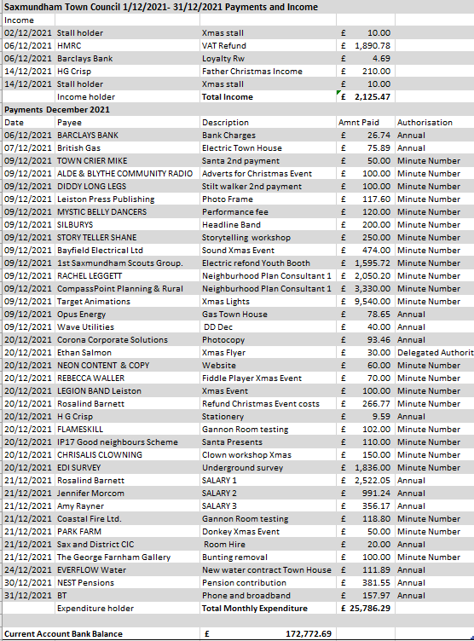
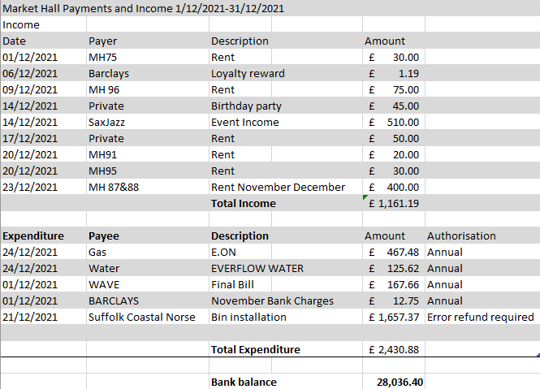

Appendix 8 – Small Grants

