Roz Barnett
Saxmundham Town Council
Amenities Committee 17January 2022

Item 4 Updates from the Clerk
  - Men’s Sheds have painted their door and put up the new sign
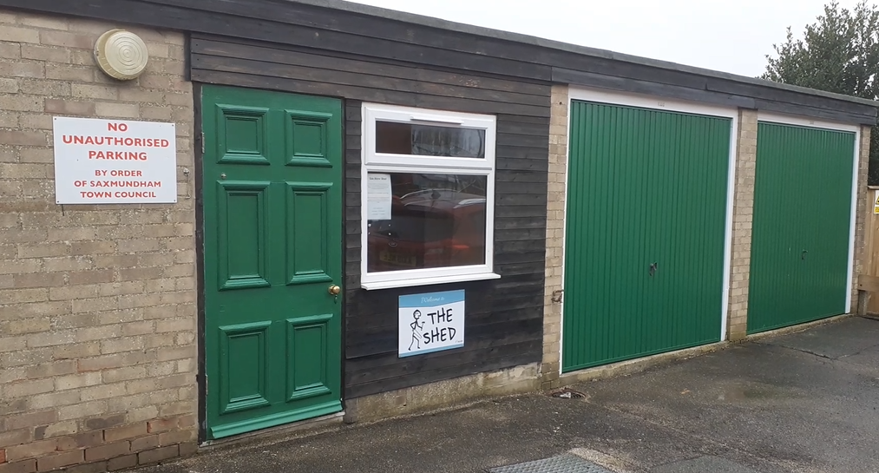
  - The underground survey at the Memorial Field has been completed and copies ordered.
  - The Clerk has made an expression of interest for a talking bench to be located on Fromus Green or the Memorial Field.
  - The Clerk has chased the Seaman’s Avenue benches and they will both be removed, and one replaced in the next three weeks.
  - The Clerk has written to the County Council about the Heritage Street Lighting.
  - The new playpark signs have finally been installed.

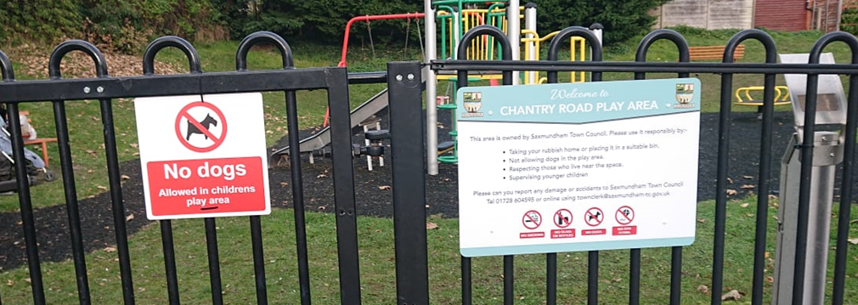

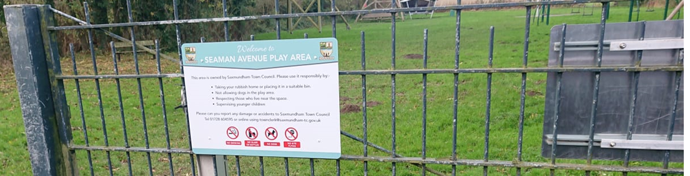

Item 5 - Report from the Environmental Co-ordinator
- Approximately 20 volunteer participants from the community on our new year litter pick on the 3rd Jan. Next one is Sunday 6th Feb 10am Seaman Avenue, we aim to concentrate on the litter in the hedges.
- Geraldine and I have applied for funding for more picker gear from East Suffolk.
- Myself, John and Roger marked out services and tree planting sites on Friday 7th Jan in preparation for planting fruit trees.
- Sunday 9th Jan myself two Green Team volunteers, six Saxmundham 1st Scouts, the scout leader and two parents planted 15 trees.
- Monday 10th Jan myself John and Looby/Stewart and Roger planted the last 5 trees.
- Still awaiting sites for the three entrance trees (temporarily healed in in my garden) to be planted before the end of March.
- Next on my list: mole hills, play park actions and clearing the willow prunings highways left from the Rendham Rd ditch at MF. Woodland trust trees coming in March. Scouts are keen to help again.
- Roger is chasing permission for planting the Oak tree from East Suffolk.
- Info regarding the Town Council 2022, 750 trees target and the above tree planting going out in Feb Saxmundham news.
- I have applied for a trial of the cargo ebike scheme for March.
.

Item 8 – Electrical charging points

Annual fixed running cost £300 plus variable charges

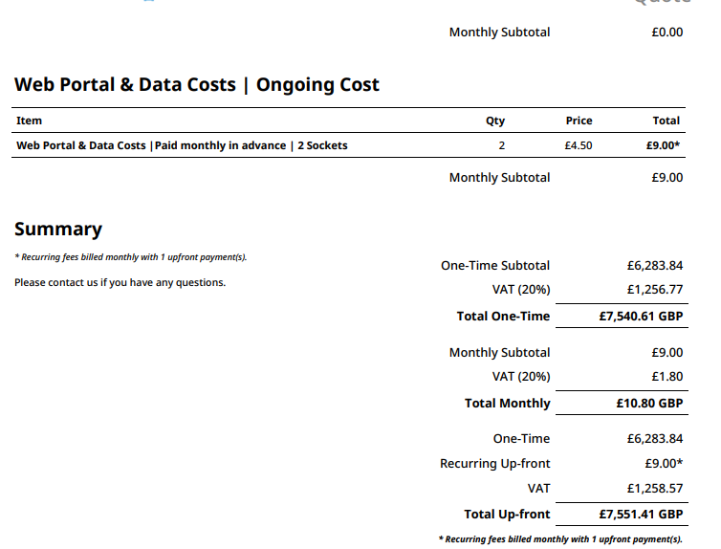

Item 9 – ROSPA Reports

Please note we have now installed ROSPA approved signage on all sites, including no kite flying. Amy has suggested that we need another sign installing on Seaman Avenue, for the approach from the Youth Booth.
The Clerk has authorised minor repairs with Norse

Chantry Rd – Items for action
- Chain Link Fencing damaged access to sheds and railway
- Litter Bin replacement
- Entrapment risk with existing bench
- Bolts thread requires covering or cutting back.
Memorial Field Skatepark – No items for action

Seamans Avenue items for Action
- Gate mechanism need adjustment
- Benches replaced/repaired
- Cable way double track - Traveler guard missing, modify to ensure sufficient ground clearance
- Replace all chain bushes on basket swing tighten fixtures
- Install basketball court signage
- Replace toddler swings

