Saxmundham Town Council

Minutes of the Meeting of Saxmundham Town Council
7.00pm Monday April 11, 2022, Market Hall, Saxmundham

In Attendance – Councillors
Councillors: Di Eastman (Vice Chair), John Findlay, John Fisher, Charlotte Hawkins, Roger Hedley Lewis, Nigel Hiley Tim Lock, James Sandbach, Jeremy Smith (Chair).

Also present: Roz Barnett (Town Clerk), Richard Smith (County Councillor).

Open Forum:
Dr Havard sent his apologies as he was unable to complete the scheduled presentation on the new health centre because of testing positive for Covid 19.

A young person asked the Town Council whether they would consider developing a Youth Council for the Town. The Chair thanked him and suggested that he put his ideas in writing to the Council for their consideration. It was noted that the Town Council would need to ensure any Youth Council or youth involvement activities are run appropriately and safely which may mean procuring specialist advice.

172/21TC | Apologies and Approval of absence.  None Received.
173/21TC | Declarations of interest and considerations of requests for dispensations.  Cllr Di Eastman declared a non-pecuniary interest as she is a Trustee of IP17 Good Neighbour Scheme.  Councillors Sandbach Hiley and Hedley Lewis declared a non-pecuniary interest in item 163/21TC as they are Trustees of the Gannon Institute.
174/21TC | Minutes of the Previous Town Council meeting.  RESOLVED: It was unanimously resolved to accept the minutes of the meeting held on 14 March 2022 with a change to correct the date on page 6.
175/21TC | County Councillor Report.  County Councillor Richard Smith reported that he had submitted a letter of support for one stop shop health centre proposed for Saxmundham. He also gave a brief update on the Sizewell C developments and his dismay at the recent statements made by the Minister which might be seen as prejudging the outcome. He reiterated that if the development goes ahead that he would act as spokesperson for the community and would seek maximum compensation for the Town.  He was delighted to report that he will pay the full amount for a clock for the Market Hall in commemoration of the Queen’s Platinum Jubilee.  Questions were raised about what the County Council are doing to help families with the cost-of-living crisis and whether there will be a further roll-out of the solar panel scheme.  It was noted that the old Fromus Centre site development team had consulted with the Town Council and Greener Sax on the future of the Saxmundham Community Garden.
176/21TC | District Councillor Report  Councillor Fisher expressed his concerns that the Minister’s statements on the Sizewell C development could be considered a predetermination and would open the doors to a judicial review.  Councillor Fisher explained that East Suffolk council taxpayers will receive a £150 automatic tax rebate to help them with the cost-of-living crisis.  He also stated that East Suffolk are running a campaign to encourage residents to recycle glass.  He reported that the feedback from the Community Governance Review will be considered by a working group which is being set up for the purpose.
177/21TC | Chair’s Report.  Councillor Smith explained that he had submitted the Town Council’s paper on the proposed changes to Saxmundham’s parish boundary to East Suffolk Council. He added that the maps had been discussed with Benhall Parish who had agreed with the Saxmundham proposal.  The Chair reported that the Town Council is now carrying two vacancies, which have been advertised locally.  The Chair informed Council that he had attended a Sea Link Virtual Briefing from National Grid officials regarding the proposed high voltage undersea electricity link between Suffolk and Kent.  The Chair invited Councillors to the 750 Launch event on the 23rd of April which is being run in partnership with the museum. He also asked Councillors to promote the Jubilee Event planned for the 5th of June in the Market Place  The Chair shared the news that the Clerk will be leaving Saxmundham to take up a post at Bungay Town Council.
178/21TC | Minutes of the previous committee meetings.  - The Council received and noted the draft minutes of the Amenities Committee held on the 28 March 2022.  Councillor Lock updated the Council on the Memorial Field project and explained that the Committee were expecting the plans for the Memorial Field entrance from the garden designer imminently. He also mentioned that the volunteers who are developing the Saxmundham Memorial Trail have researched over 30 casualties and recorded the poignant details of their lives. He was pleased to inform the Council that the primary school children that designed the trail markers and had been presented with certificates and prizes for their work.  In addition, he wanted to record the Council’s thanks to David Smith from DS Memorials who has donated a memorial stone and has offered to engrave it free of charge.  - The Council received and noted the draft minutes of the Resources Committee held on the 1 April 2022  - The Council received and noted the draft minutes of the Planning and Development Control Committee meetings held on the 3rd and 15th of March 2022  The Chair asked that the committee’s minutes also include Town Council recommendations under the item on ‘recent planning decisions’.
179/21TC | Financial matters.  - RESOLVED: That the Town Council received and ratified the payments and receipts for the Town Council up to the 31st of March 2022. (Appendix A)  - RESOLVED: That the Town Council received and ratified the payments and receipts for the Market Hall up to the 31st of March 2022. (Appendix B)  - The Council received and noted the draft year end budget report to the 31st of March 2022 for the Town Council, which showed a projected healthy outturn due to additional income received during the year.  The Clerk sent out a report on the public works loan boards which showed an outstanding balance of £71,494 and that it will be fully paid in the 2025/26 financial year.  The Clerk reported the Town Council balances as of the 31st of March 2022:  Cambridge Account £110,091  Barclays Current Account is £122,862.44  - The Council received and noted the budget report to the 31st of March 2022 for the Market Hall. The Clerk reported that the Market Hall was showing a projected healthy outturn due to higher than anticipated income from Market Hall lettings.
180/21TC | Neighbourhood Plan  - The Council considered the feedback from the public and the revised Neighbourhood Plan for submission  RESOLVED: The Town Council agreed the revised Neighbourhood Plan Draft for submission to East Suffolk Council  - To consider the Consultation Statement  RESOLVED: The Town Council agreed the Consultation Statement  - To consider the Basic Conditions Statement  RESOLVED: The Town Council agreed the Basic Condition Statement  The Chair paid tribute to the members of the steering group and thanked them for their contribution.  Councillor Eastman reported that she had met with the East Suffolk Council and Greater Anglia to discuss ideas for the merging the two carparks.
181/21TC | Induction and Training Policy for Councillors - To consider the draft induction and training policy for Councillors (Appendix 9).  RESOLVED: The Town Council agreed to adopt the induction and training policy for Councillors.
182/21TC | Meeting Schedule - To Agree Meeting schedule for 2022-2023 (Appendix 10)  RESOLVED: The Town Council agreed to adopt the Meeting schedule for 2022-2023.  The Council agreed to hold the Annual Town Meeting on Friday the 27th of May.
183/21TC | Gannon Rooms – To receive a Report and consider the next steps forward  The Council noted that the Charity Commission records have been updated and the Town Council is now the sole Trustee for the Gannon Institute charity. The Clerk was in consequence authorised to remove the three individual trustees.  The Council noted that the Clerk has now filed the 2020/21 Charity Commission annual report.  RESOLVED: The Council agreed to quarterly meetings of the Gannon Institute Trust.  RESOLVED: The Council agreed to set up the Institute’s accounts for 2021/2022 on the Rialtas System at a cost of £350.  RESOLVED: The Council agreed to advertise the North Room to solicit expressions of interests however any decisions on the selection of the tenant would have to be made at a meeting of the Trust  RESOLVED: The Council agreed to seek quotes from architects to draft the specification for improvements and act as project manager for further works in a 3-phase approach in order that the Trust can make an appropriate selection  - Phase 1 – Heating, basic redecoration, DDA compliant access and essential internal works to re-open the building. e.g., fire detection, alarm, emergency lighting and ring main  - Phase 2 – Replacement and reconfiguration of the toilets and reception area.  - Phase 3 – External refurbishment including the cupolas.
184/21TC | Environment and Climate Change  - Councillor Hiley presented the updated Environment and Climate Change Action Plan. The Council agreed that the Environment and Climate Change Working Group would continue monitoring the plan and initiating projects.  RESOLVED: The Council agreed the updated Environment and Climate Change Action Plan  - Councillor Hiley outlined the exciting plans for the September Green Market and consultation event planned for the 10th September 2022  RESOLVED: The Council agreed to a budget of £1000 for the event.
185/21TC | Correspondence  The Council discussed the request for CCTV, and they agreed to consult with Businesses about the possible installation of CCTV in the Town Centre in the first instance.  The Council discussed the concerns of wasted energy at the Market Hall, and this was referred to the Market Hall Committee.  It was agreed that Stocks could use the Memorial Field for the funfair, but measures needed to be taken to avoid the difficulties experienced the previous year.  The Council agreed to sign the Sizewell C letter to the business secretary but suggested amendments to the proposed document.
186/21TC | Reports from Councillor Representatives on other Organisations.  Citizens Advice Bureau - Councillor Sandbach reported that Citizens Advice Leiston, Saxmundham and District have merged with Citizens Advice Felixstowe and District and Citizens Advice Northeast Suffolk to create Citizens Advice East Suffolk.  Footpath warden – Councillor Fisher reported that Mill Lane footpath continues to be in a poor state.  IP17 Good Neighbour Scheme – Councillor Eastman reported that they had received a sum of money from a legacy trust fund 50% for the use of IP17 GNS projects and 50% to be used for health related projects in the community. She also informed Council that she had visited Deben Community Farm which delivers therapeutic activities for young people and adults  Sizewell A & B & C – Councillor Hiley and Sandbach reported that they had met with the Sizewell Community Team and the slides from the meeting had been circulated to Councillors. They advised the Council that there are sizeable pots of money for community projects and that it is important that Saxmundham benefits from any legacy funding.
187/21TC | Staffing Matters  - The Council noted the resignation of the Town Clerk and that she will be leaving Saxmundham in June.  - RESOLVED: The Council agreed the job description, person specification and advert for the Town Clerk position.
188/21TC | RESOLVED: a Motion to Exclude the Public under the Public Bodies (admission to meetings) Act 1960 on the grounds that publicity would be prejudicial to public interest by reasons of the confidential nature of the following business being transacted.
189/21TC | Staffing Matters  Councillors discussed the staffing structure and agreed that they could afford to proceed with a full-time Clerk and the Finance Officer. It was agreed that the Council will discuss interim arrangements if required at the next meeting.  RESOLVED: That the Town Council proceeds with the appointment of the Finance and Administration Officer.  RESOLVED: That the new Finance Officer and Town Clerk be added to the Bank signature mandate on appointment.

Meeting ended at 9.57pm
Roz Barnett, 26/04/2022 Clerk to Saxmundham Town Council
Appendix A - Town Council Payments March 2022
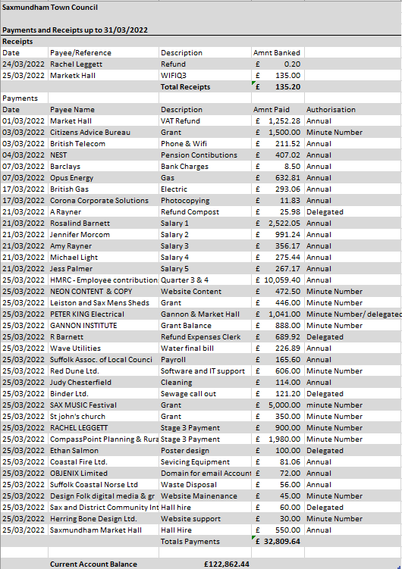

Appendix B - Market Hall Payments March 2022
