Saxmundham Town Council

Minutes of the Meeting of Saxmundham Town Council
7.00pm Monday March 14, 2022, Market Hall, Saxmundham

In Attendance – Councillors
Councillor Di Eastman (Vice Chair) |  | Councillor Nigel Hiley
Councillor John Findlay |  | Councillor Tim Lock (Arrived 7.14)
Councillor John Fisher |  | Councillor Jeremy Smith (Chair)
Councillor Roger Hedley Lewis |  | Councillor Charlotte Hawkins
Apologies Councillor James Sandbach

Also present: Roz Barnett (Town Clerk)

Open Forum: Clare Palmier delivered a short presentation on the work of the Art Station. She explained that the Art Station now operates from the old telephone exchange and is home to eight independent creative studios. They also have meeting and exhibition space which has already hosted three exhibitions and dance workshops. The Art Station run educational and inclusive art projects that combat social isolation and bring people together. Clare asked that arts and culture be prominent within planning documents due to the powerful contribution that creatives bring to the regeneration and economic development of the Town Centre.

The Chair thanked the Art Station for their important contribution to the cultural life of the Town.

One minute’s silence for the people of Ukraine was held before the meeting commenced.

152/21TC | Apologies and Approval of absence.  Apologies were received from Councillor James Sandbach.  It was noted that Councillor Rose Webster had not attended or sent apologies for a period of six consecutive months and therefore will cease to be a member of the Town Council.  The Clerk agreed to notify East Suffolk of the vacancy.  RESOLVED: The Town Council approved the absence of Councillor Sandbach and noted the new Councillor vacancy.
153/21TC | Declarations of interest and considerations of requests for dispensations.  Cllr Di Eastman declared a non-pecuniary interest as she is a Trustee of IP17 Good Neighbour Scheme.  Councillor Hiley declared a non-pecuniary interest 165/21TC as he is involved in Sax Music Fest.  Councillors Hiley and Hedley Lewis declared a non-pecuniary interest in item 163/21TC as they are Trustees of the Gannon Institute.
154/21TC | Minutes of the Previous Town Council meeting.  RESOLVED: It was unanimously resolved to accept the minutes of the meeting held on 14 February 2022.
155/21TC | County Councillor Report. None received
156/21TC | District Councillor Report.  Councillor J Fisher reported that East Suffolk Council has published its budget proposals, opting for a 2.89% increase for 2022 after freezing Council Tax levels during Covid-19 last year. This will equate to £4.95 increase for a Band D property
157/21TC | Chair’s Report.  Councillor Smith opened his report warning Councillors that East Suffolk Covid-19 rates have been increasing and the Council were monitoring this situation carefully.  He explained that he was excited about the 750th Anniversary Festival and invited councillors to attend the 23rd of April heritage launch event. This event will feature a pop-up museum in the afternoon and an evening history talk including refreshments.  He was pleased to report that the Neighbourhood Plan is progressing well, and the steering group were carefully considering the consultation feedback. He expressed concern however that East Suffolk Council (ESC) and Babergh/Mid Suffolk District were not giving proper regard to existing Neighbourhood Plans. Framlingham and Thurston have recently challenged their respective district planning authorities who had agreed to development contrary to their adopted Neighbourhood Plans.  It was agreed that the Chair should write to ESC in support of Framlingham, urging them to respect the legal status of Neighbourhood Plans.  The Town Council noted the tragic events unfolding in Ukraine and in an act of solidarity with the Ukrainian people agreed to support the business led initiative of flying of Ukrainian flags in the High Street.
158/21TC | Community Governance Review –  Councillor J Smith presented a report on the Community Governance Review and the Council discussed potential changes to the Saxmundham boundary.  Resolved:  - The Town Council agreed to support in principle a change in the parish boundary between Saxmundham and Benhall, so that the proposed new South Saxmundham Garden Neighbourhood and related development would fall within Saxmundham Parish, based on the map shown as Option 2 Appendix A.  - The Town Council agreed to submit the report to East Suffolk Council as their submission to the consultation on the Community Governance Review, while indicating that they may wish to discuss the proposals with Benhall Parish Council and may, if appropriate, make a further submission following such discussion.  - The Town Council agreed to send this report to Benhall Parish Council, which meets next on 30th March.  - The Town Council agreed to publicise the points set out in this report and invite any views from Saxmundham residents and businesses.
159/21TC | Carlton Park Industrial Estate Development Proposal Council Position  The Town Council, having received a presentation on behalf of the applicant, and listened to objections and concerns from residents agree the following position statement on the Carlton Park Industrial Estate Development Proposal  The Town Council:  (1) notes that the Local Plan defines the site of the Industrial Estate including the present proposed extension as an Employment Area (Policy SCLP12.36) which  “comprises some 8ha of employment land. 3ha of land remains vacant. The site contains lawful uses within Use Classes B1, B2 and B8. Proposals for development of B1, B2 and B8 uses will be permitted subject to the following criteria:  - Proposals for further development of the site should be accompanied by a site-specific Flood Risk Assessment;  - An investigation into any potential contamination of the site should be undertaken prior to the submission of a planning application;  - Where appropriate, measures should be taken to assess and manage any heritage assets on the site; and  - Proposals that generate a significant amount of traffic movements from the site will be required to provide a Transport Assessment, assessing the impact of the proposal on the local highway network.”  (2) notes that the Local Plan policy also recognizes that it is “the largest employment site close to Saxmundham and well related to the local transport network, encouragement will be given to those uses which have a high employee to floorspace ratio.”  (3) supports the development in principle (on the basis that all of the above policy requirements are met), in particular on the basis that it is likely to provide a significant number of new employment opportunities for local people, but subject to the following points being properly addressed,  (4) underlines the importance of ensuring that transport to and from the site is strictly regulated and avoids HGV and other commercial transport through Saxmundham,  (5) emphasises the importance of effective and attractive green buffer zone between the site and nearby residential occupiers, also for noise reduction purposes,  (6) further emphasises the necessity of high-quality design of buildings and landscaping within the new development, taking account of the views from St Peter’s Church and the wider area around Carlton Park  (7) considers it necessary that there be excellent cycle and pedestrian links to and from the site to Saxmundham and Kelsale and Carlton, to minimise local motor travel,  (8) endorses the desirability of maximising uses that have a high employee to floorspace ratio, for example, including small start-up units,  (9) insists that any café or retail outlets on the site be strictly controlled and limited as to times of operating, to ensure that they are genuinely a facility principally for those working at the site or visiting it for work purposes, and do not generate nuisance or disturbance.  Concerns were expressed about the impact of the catering outlets on Town Centre businesses and the Council expressed the opinion that it would be preferable that these are not located on the frontage. It was agreed that this be included in the covering letter.  RESOLVED: That the Town Council adopt the position statement as detailed above on the Carlton Park Industrial Estate Development and submit the comments to East Suffolk Planning Department.
160/21TC | Minutes of the previous committee meetings.  - The Council received and noted the draft minutes of the Amenities Committee held on the 21 February 2022.  Councillor Lock asked the Council to note that the Amenities Committee would be considering the location of Allotment land at the request of the Chair of the Environment and Climate Change Working Group.  - The Council received and noted the draft minutes of the Resources Committee held on the 28 February 2022  - The Council received and noted the draft minutes of the Planning and Development Control Committee meetings held on the 3rd and 15th of March 2022
161/21TC | Financial matters.  - RESOLVED: That the Town Council received and ratified the payments and receipts for the Town Council. (Appendix A)  - RESOLVED: That the Town Council received and ratified the payments and receipts for the Market Hall up to 28th of February 2022. (Appendix B)  - The Council received and noted the budget report to the 28th of February 2022 for the Town Council, which showed a projected healthy outturn due to additional income received during the year.  - The Council received and noted the budget report to the 28th of February 2022 for the Market Hall, which also showed a projected healthy outturn due to additional hire income and the Adnam’s Grant.
162/21TC | End of year arrangements  - Resolved: The Council received and approved the Asset Register dated March 2022.  - Councillors discussed the amendments to the financial regulations. It was agreed to remove the phrase ‘up to’ and refer to the appendix on BACS payments in the main text.  Resolved: The Council received and approved the proposed amendments to the financial regulations with the minor changes stated above.  - RESOLVED: The Town Council reviewed and approved the Risk Register.
163/21TC | Community Infrastructure Levy (CIL) –  The Council discussed the potential projects and allocation of the Community Infrastructure Levy.  It was agreed to set up a working group consisting of Councillors T Lock, R Hedley Lewis, J Smith, and D Eastman to discuss the potential projects. Councillors stressed the importance of setting aside enough funding for agreed projects particularly the Gannon Rooms.  RESOLVED: That the Town Council agreed to set up a small working group to explore the development of projects for CIL funding.
164/21TC | To consider Grant Request  Councillors noted that the Sax Community Music Festival was now going ahead due to securing funds from other sources. The Clerk was authorised to make £5000 grant payment from the Events Budget for immediate Costs. This will leave the balance of £4000 to be paid in 2022/2023.  RESOLVED: The Town Council agreed to make £5000 grant payment for the Sax Community Music Festival.
165/21TC | Celebrate the Queen’s Platinum Jubilee  The Clerk reported that plans are in place for the Jubilee event planned for Sunday the 5th of June 12:30 to 4:30. She was pleased to inform the Council that the IP17 Good Neighbour Scheme had agreed to organise the food for the community lunch. She explained that the event will take place in the Marketplace with a stage, live entertainment, and activities for the children. Community groups and individuals can book tables at a cost of £12 or bring their own chairs and attend for free. Councillor Eastman raised the question whether the Town Council should buy a commemorative item for attendees at the event.  RESOLVED: That the Council agreed the indicative budget of £2000 for the jubilee event and agreed the oversight of the spending of the budget given to the Clerk and Chair of the Events Working Group.
166/21TC | Communications  - The Council received and discussed the draft Communications Policy that had been prepared By the Communications Working Group with help from the Town Centre Coordinator. Councillors welcomed the ‘can do approach’ and hoped that it would lead to more positive publicity for the Town. The Clerk was asked to make some minor amendments to the formatting, to remove the word ‘elected’ before ‘councillor’, and to amend the document so that only officers were required to use email signature.  RESOLVED: The Council received and approved the Communications Policy with the agreed minor changes  - The Chair and Clerk have worked with Archant to develop a supplement to be published early June. The paper supplement will cost £750, and there is an additional charge of £200 for an online promotion campaign.  RESOLVED: The Council agreed £950 for the supplement for the 750 celebrations to promote the heritage of the Town  - The Council noted that the Town Guide publication will now be produced in September.
167/21TC | Correspondence  IP17 Good Neighbours Scheme have nominated a Young Person to carry the Torch in the Suffolk relay.  The Council noted the development of a Saxmundham Woodland Creation Scheme to the South of the Town and agreed in principle support for the scheme which will create open access land and a link between Benhall and Saxmundham.
168/21TC | Reports from Councillor representatives on other organisations.  Councillor Eastman reported that the footpath bridges damaged in the storms have been repaired and replaced.  Councillor Fisher reported that ESTA is having a public meeting in Woodbridge.  Councillor Hiley reported that the one stop shop is progressing and suggested that Dr Havard be invited to the next meeting.
169/21TC | RESOLVED: a Motion to Exclude the Public under the Public Bodies (admission to meetings) Act 1960 on the grounds that publicity would be prejudicial to public interest by reasons of the confidential nature of the following business being transacted.
170/21TC | Staffing Matters  - Councillors discussed the proposed new structure and that included the post of the Finance and Administration Officer. Councillor Eastman explained that this post had been introduced because the risk register had highlighted the need for an additional officer to be involved in the financial operations. In order for this addition to be cost neutral the Clerk had agreed to reduce her hours.  RESOLVED: That the Town Clerk reduce her hours to 30 hours a week to fund the post of Finance and Administration Officer.  - Councillors discussed and agreed the job description and advert for the Finance and Administration Officer. The Clerk stated that it would advertised online using SALC, FaceBook and Indeed. Posters would also be displayed on the Town Noticeboards.  RESOLVED: The Town Council approved the Job description and advert and agreed that that the Finance and Administration Officer be advertised for 10 hours a week (SCP scale 6 point 19).

Meeting ended at 9.33pm
Roz Barnett, 28/03/2022 Clerk to Saxmundham Town Council
Appendix A - Town Council and Market Hall Payments February 2022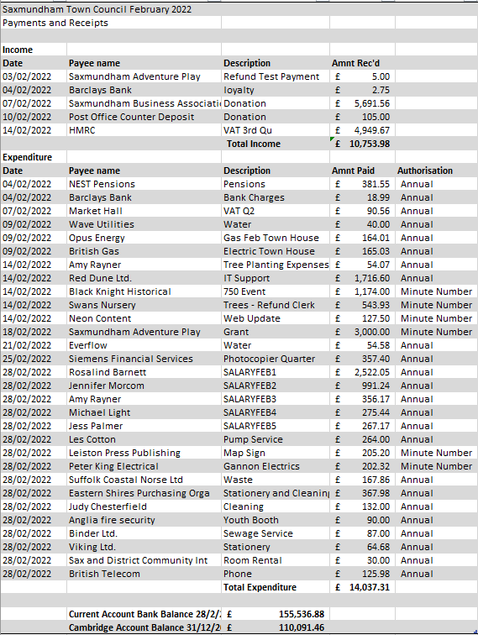

Appendix B - Market Hall Payments February 2022
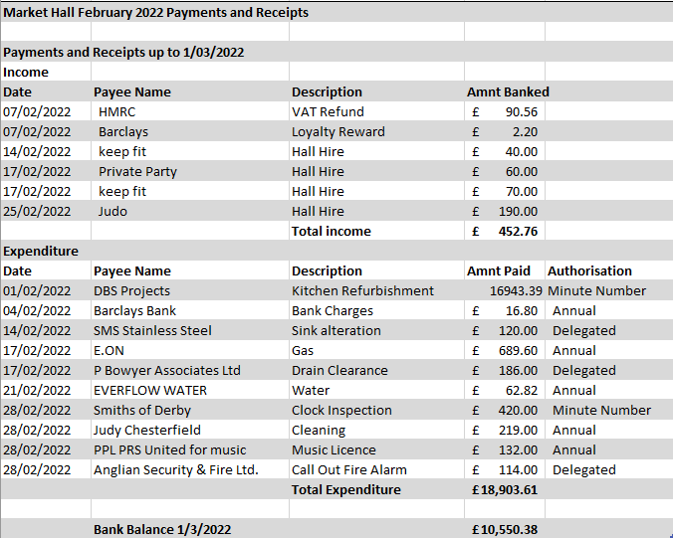

Appendix C – Proposed Revised Boundary

