Roz Barnett
Saxmundham Town Council
Resources Committee 1 April 2022

- Finance
  - To note payments and receipts and reconciliation reports for February for the Town Council (Appendix 2)
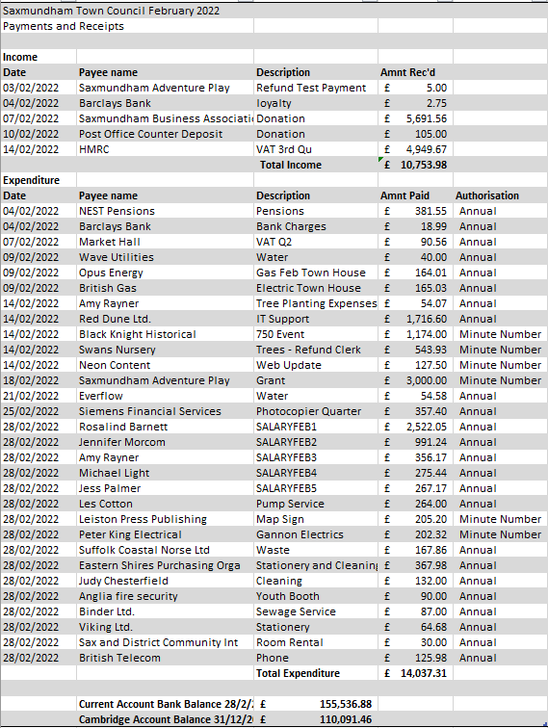

  - To note payments and receipts and reconciliation reports for February for the Market Hall (Appendix 3) 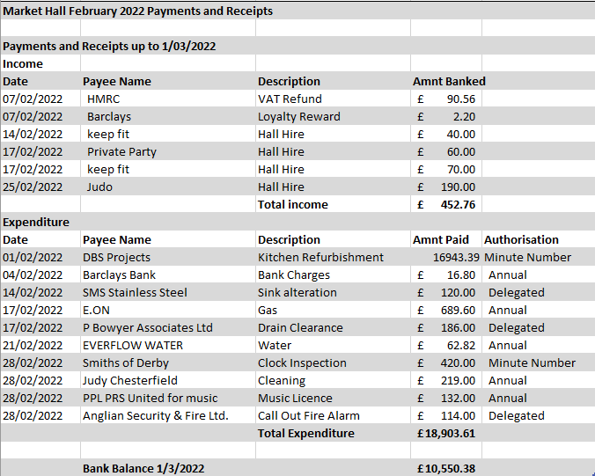

  - To note March payments and authorise any payments outside of the Clerk’s delegated powers for the Town Council and Market Hall (Appendix 4).
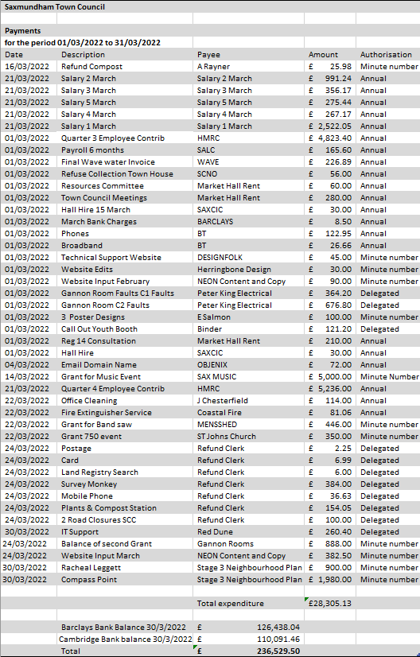

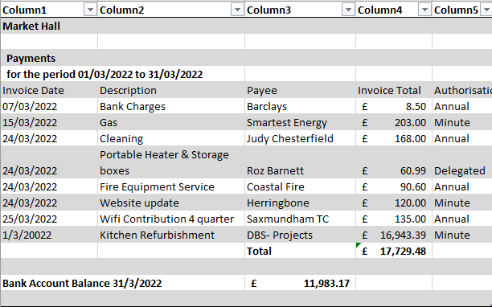

  - To receive provisional end of year financial reports for Town Council & Market Hall (Appendix 5).

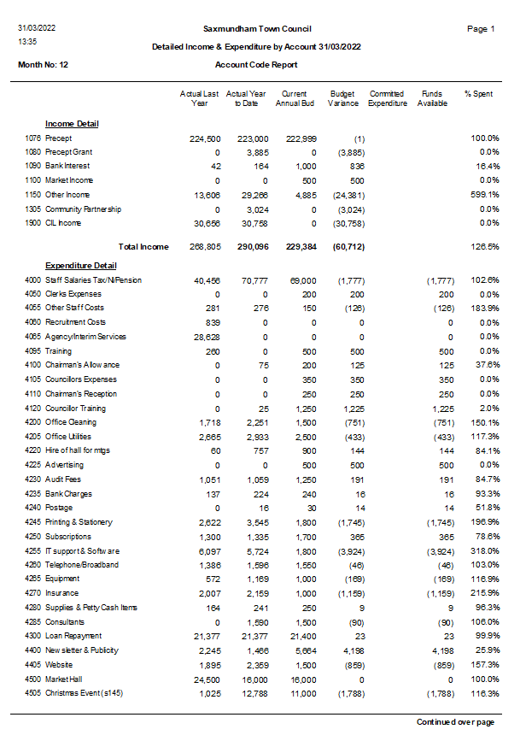
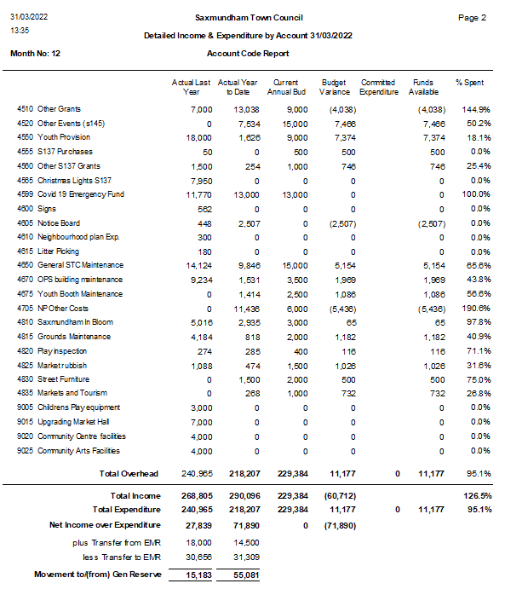
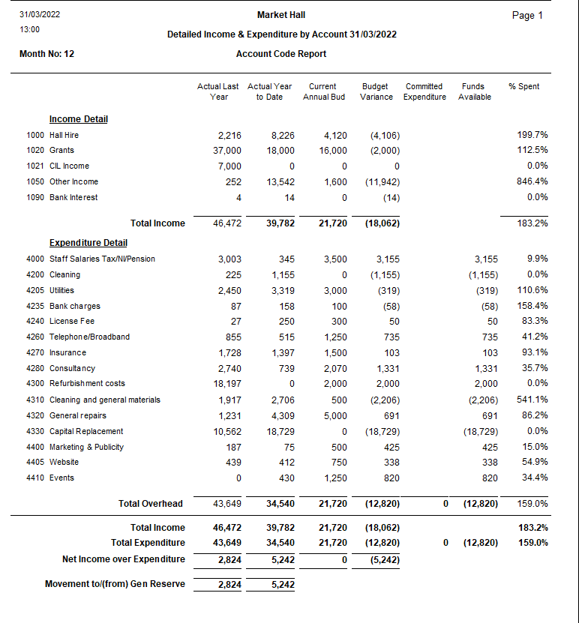

  - To note end of Year CIL report 2021-2022(Appendix 6).
