Roz Barnett

Saxmundham Town Council

Town Council 24 MAy 2021

**Agenda item 5a - Appendix 1 Committee and Working Group Structure**

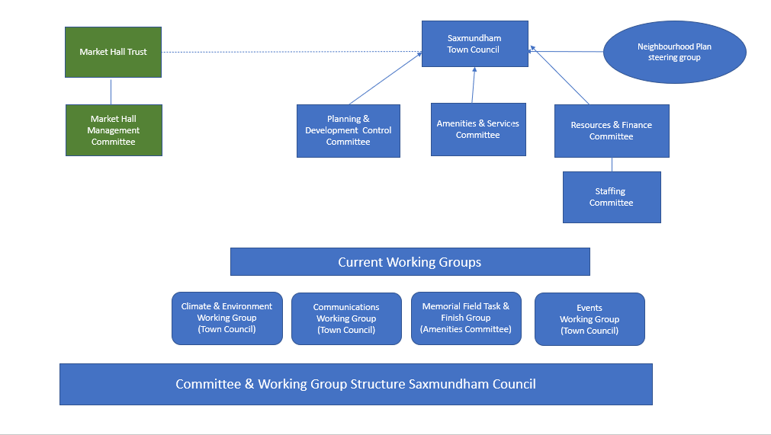

**Agenda item 5b - Appendix 2 Terms of Reference Committees & Working Groups**

**Amenities & Services Committee**

**Prime Objectives**

To deal with all matters of general grounds, premises, amenities, and services with Saxmundham over which the Council has control or influence.

The Market Hall is excluded unless then Market Hall Trustees or Management committee requests assistance.

**Membership and Frequency of Meetings**

The Committee comprises 5 voting members of the Town Council. The Quorum for this Committee shall be 3 members.

Members of the public may be asked to report on an item to this committee or to join this committee as a non-voting representative.

The Amenities and Services Committee will meet every 6 weeks as required based on the business to discuss.

**Delegated Business**

The Committee has delegated authority to deal with matters relating to and/or under its control to conclusion, including spending within the its approved budget:

* Notice boards
* Benches
* Dog Bins and Waste Bins
* Christmas Lights
* Memorial Field
* Sax In Bloom
* Grounds, hedges, ditches and similar
* Market
* OPS building & its environs maintenance
* Skate Park
* Play areas and equipment
* War memorial
* Any other appropriate items as deemed by Full Council
* Signage

Regarding issues relating to services and amenities not owned nor controlled by the Council but that affect the public domain such as below, this committee has delegated authority to make proposals and representations on behalf of Council.

* Highways, footpaths, and pavements
* Parking
* Railway & Railway station
* Street furniture and signage

Any proposed unbudgeted expenditure, in excess of £250, will require approval at the Resources Committee or Full Council.

**Planning & Development Control Committee**

**Prime Objectives**

To deal with all matters of planning such as planning applications, planning application decisions and enforcement issues, and respond appropriately and in a timely manner to the District Council or any other interested parties.

This Committee is not responsible for any strategic planning issues in terms of Neighbourhood or Local plan.

**Membership and Frequency of Meetings**

The Committee comprises 5 voting members of the Town Council. The Quorum for this Committee shall be 3 members.

Members of the public may be asked to report on an item to this committee or to join this committee as a non-voting representative.

The Planning and Development Control Committee will meet fortnightly as required based on the business to discuss.

**Delegated Business**

The Committee has delegated authority to deal with the following matters to conclusion:

* Consider and give views, on behalf of the Town Council, on planning applications sent for consultation by the relevant district council or any other authority so empowered to do
* Consider the decisions of the local planning authorities in respect of local planning applications.
* Consider any planning appeals, planning appeal decisions and planning enforcement cases.
* Consider and give views on any street naming issues or consultations.
* Produce and publish any information for the public in connection with planning matters, within legal powers.
* To work with the Neighbourhood Plan Steering Group as required
* Consider any other matters referred to the Committee by the Town Council.

Any proposed unbudgeted expenditure, in excess of £250, will require approval at the Resources Committee or Full Council.

**Resources & Finance Committee**

**Prime Objectives**

To manage the Council’s budget and finances effectively, to ensure that good financial practice is followed, and that the Council’s resources are effectively deployed. To ensure the good management of all personnel matters for the Council, including performance management, and training and development for staff and councillors

**Membership and Frequency of Meetings**

The Committee comprises 6 voting members of the Town Council. The Quorum for this Committee shall be 3 members.

Members of the public may be asked to report on an item to this committee.

The Resources Committee will meet monthly as required based on the business to discuss.

**Delegated Business**

The Committee has delegated authority and responsibility to deal with the following matters to conclusion, in line with the agreed budget:

FINANCIAL ITEMS

* Consider and give views on the Budget and Precept for the following municipal year and recommend to Council.
* Regularly review the financial status of Council, referencing expenses and income in conjunction with the Budget. To make recommendations to Council on virement of budget.
* To approve expenditure up to £5000.
* To review Banking arrangements and make recommendations to Council.
* To review all statutory compliance.

LEGAL, STATUTORY and STRATEGIC ITEMS

* To consider legal policies and make recommendations to Council.
* To consider and make recommendations to Council on key financial policies including Insurance, Asset register, Financial Regulations, Risk Managements and Internal Controls.
* To decide the development of facilities in areas such as IT and Technology.
* To consider and make recommendations to Council regarding future projects bringing resources to the Town.
* To consider any item as deemed appropriate by Council.

STAFFING MATTERS

The Committee will have delegated responsibility to:

* Consider and determine the staffing structure and review and oversee the appointment of staff.
* Review and monitor contracts and salary pay scales.
* To consider the recommendations from the Staffing Sub-committee.
* To consider and review employment related policies.
* To consider and decide on programmes of training and development for Staff and Councillors

Staffing Sub-Committee

**Prime Objectives**

To consider grievance or disciplinary matters (not including any appeal therefrom) referred and to manage the Clerk.

**Membership and Frequency of Meetings**

The Sub-Committee comprises 4 voting members of the Town Council.

The Sub-Committee reports to the Resource Committee.

The Quorum for this Committee shall be 3 members.

The Staffing Sub-committee will meet as required based on the business to discuss.

**Delegated Business**

The Sub-Committee has delegated authority and responsibility to deal with the following matters to conclusion:

* To consider grievance or disciplinary matters for all staff in accordance with the council’s grievance and disciplinary policies.
* To manage, supervise and appraise the Clerk, administer leave requests, record and monitor absence from work.
* To recommend to the Resource committee any actions regarding the Clerk’s performance and to recommend salary and benefit levels for the Clerk.
* To consider any other item that Resource Committee or Full Council deem appropriate.

**Agenda item 5c - Appendix 3 Members of Committees**

|  |  |  |  |  |  |
| --- | --- | --- | --- | --- | --- |
|  | **Resources** | **Planning & Development** | **Amenities & Services** | **Market Hall Management** | **Staffing Sub-committee** |
| **Cllr. D Eastman** | **X** |  | **X** | **X** | **X** |
| **Cllr. J Findlay** | **X** |  |  | **X** | **X** |
| **Cllr. J Fisher** | **X** | **X** |  |  | **X** |
| **Cllr. C Hawkins** |  | **X** | **X** | **X** |  |
| **Cllr. R Hedley Lewis** |  | **X** | **X** |  |  |
| **Cllr. N Hiley** | **X** | **X** |  |  |  |
| **Cllr. T Lock** |  |  | **X** | **X** |  |
| **Cllr. J Sandbach** | **X** |  | **X** |  |  |
| **Cllr. J Smith** | **X** |  |  | **X** |  |

**Agenda item 5d - Appendix 3 Members of Working Groups**

|  |  |  |  |  |
| --- | --- | --- | --- | --- |
|  | **Climate & Environment Working Group** | **Communications Working Group** | **Memorial Field Working Group** | **Events Working Group** |
| **Cllr. D Eastman** |  | **X** | **X** | **X** |
| **Cllr. J Findlay** |  |  |  |  |
| **Cllr. J Fisher** |  |  |  |  |
| **Cllr. C Hawkins** |  | **X** | **X** |  |
| **Cllr. R Hedley Lewis** |  |  | **X** |  |
| **Cllr. N Hiley** | **X** |  |  |  |
| **Cllr. T Lock** |  |  |  |  |
| **Cllr. J Sandbach** |  | **X** |  | **X** |
| **Cllr. J Smith** |  | **X** |  | **X** |

**Agenda item 5f - Appendix 5 Town Representatives of other Organisations**

|  |  |  |  |  |  |  |  |  |  |
| --- | --- | --- | --- | --- | --- | --- | --- | --- | --- |
|  | **CAB** | **Community Partnership** | **ESTA** | **Footpath warden** | **Neighbourhood**  **Plan** | **Patient**  **Participation Group** | **SALC** | **Sizewell**  **A, B &C** | **Tree**  **warden** |
| **Cllr. D Eastman** |  | **X** |  |  | **X** |  |  |  |  |
| **Cllr. J Findlay** |  |  |  |  |  |  |  |  |  |
| **Cllr. J Fisher** |  |  |  | **X** |  |  |  |  | **X** |
| **Cllr. C Hawkins** |  |  |  |  |  |  |  |  |  |
| **Cllr. R Hedley Lewis** |  |  |  |  |  |  |  |  |  |
| **Cllr. N Hiley** |  |  | **X** |  |  | **X** |  | **X** |  |
| **Cllr. T Lock** |  |  |  |  | **X** |  |  |  |  |
| **Cllr. J Sandbach** | **X** |  |  |  |  |  |  | **X** |  |
| **Cllr. J Smith** |  |  |  |  | **X** |  |  |  |  |

**Agenda item 7 - Appendix 6 Minutes 12 April 2021**



**Saxmundham Town Council**

**Minutes of the Meeting of the Saxmundham Town Council**

**7.00 pm 12 April 2021 by Video Conference**

**In Attendance - Councillors:**

Councillor Di Eastman (Vice-Chair)

Councillor John Findlay

Councillor John Fisher

Councillor Charlotte Hawkins

Councillor Nigel Hiley

Councillor Tim Lock (Arrived 7.21)

Councillor. Jeremy Smith (Chair)

**Also present:** Rosalind Barnett (Town Clerk),

**Open Forum:**  Amy Rayner attended the meeting and stated that she wished to support the motion on the Climate and Ecological and Emergency Bill. She expressed her hope that the Council will adopt the motion and set an example in the wider community. She also asked the Council whether they have a biodiversity strategy.

|  |  |
| --- | --- |
| 1  155/20TC | **Apologies and Approval of Absence**  County Councillor Richard Smith sent apologies. |
| 2  156/20TC | **Declarations of Interest and Consideration of Requests for Dispensations**  Councillor D Eastman ­­declared a non-pecuniary interest in item 167/20TC as she is a trustee of IP17 Good Neighbours Scheme. |
| 3  157/20TC | **Minutes of the Previous Meeting Town Council Meeting**  **RESOLVED: It was unanimously resolved to accept the minutes of the meeting held on the 8 March 2021.** |
| 4  158/20TC | **County Councillor Report**  No report received. |
| 5  159/20TC | **District Councillor’s Report**  District Councillor J Fisher informed councillors that he had no specific new matterto report. |
| 6  160/20TC | **Chair’s Report** Councillor J Smith expressed the Town Council’s condolences to the Royal Family at the news of the death of His Royal Highness Prince Philip, Duke of Edinburgh. The Town websites and Facebook page were updated to express the Town Council’s sadness but Covid 19 restrictions and the wishes of the Royal Family meant that a condolence book was not provided. Cllr Smith explained that a meeting had been planned with the Strategic Transport Officer for Suffolk County Council to discuss the traffic and pedestrian issues for Saxmundham. The purpose of this initial meeting is to establish a relationship with him and his team with a view to inviting them to meet with members of the Neighbourhood Plan Steering Group and take forward some of the ideas for the Town Centre.  Cllr Smith stated that he hoped to bring Councillors together for an informal meeting in the summer to look at Strategic planning for the Council. |
| 7  161/20TC | **Minutes of the Previous Committee Meetings:**   1. The draft minutes of the Resources Committee held on the 22March were received and noted. 2. The draft minutes of the Market Hall Management Committee held on the 15 March were received and noted. The Chair reported that the Committee are planning to restart the events programme in the summer and are working on the kitchen refurbishment for which estimates are coming in that exceed the foreseen budget. 3. The draft minutes of the Amenities & Services Committee held on the 29 March were received and noted. The Clerk reported that Councillor Hedley Lewis and Councillor Hawkins had completed the planting of the trees with the ‘Station Adopters’. |
| 8  162/20TC | **Economic Development**  Councillor Smith proposed that the Council adopt the Saxmundham Town Centre Action Plan which had been circulated as a draft to all Councillors and the Neighbourhood Steering Group for their comments. The plan prepared by East Suffolk District Council in consultation with the Town Council sets out a programme of activities to support businesses in the Town and development for the Town Centre.  **RESOLVED That the Saxmundham Town Centre Action Plan be adopted. (Councillors however were given a further 48 hours to review and comment on the final version recently circulated, which included a number of detailed amendments).**   1. The Clerk reported on the first virtual Business Network meeting and although only five Businesses attended there was a good discussion about ways to help the High Street. The businesses welcomed the ‘Egg Trail’ and the community bunting project as ways of encouraging people to visit the Town. They also were positive about the new website and suggested a short one-hour virtual monthly meeting. The Businesses made a request for a Town Manager/Coordinator post to help promote and look after the town centre in liaison with businesses. Councillors supported the idea of the development of this post and tasked Clerk and Chair to develop a proposal using the guidance of the East Suffolk District Council Business Support Team. |
| 9  163/20TC | **Financial Matters**   1. The Chair reported a comfortable surplus for end of the financial year for the Town Council on its income and expenditure account, and asked councillors to note the balances.   Town Council End of Year Bank Balance 2020 – 2021 **£ 114,715.54 (this does not include the deposit account at the Cambridge Building Society)**  Market Hall End of Year Bank Balance 2020 – 2021 **£ 3,739.86**  He explained that the accounts are distorted as they show the Community Infrastructure Levy (CIL) income and expenditure.  The Clerk advised that the CIL income and expenditure must be shown in the accounts however in the coming year, the CIL income will show but will be immediately transferred into the Earmarked CIL Reserves and any CIL expenditure will come from Earmarked CIL Reserves.  The Chair requested a separate report on the reserves including the CIL reserve.   1. Councillors noted the circulated payments and receipts up to the 31st of March 2021. 2. The Clerk asked for the approval of the payments of £270 to Frederic Whyte for planting design advice and Dubois Plants of £865 for plants for the station. These payments were agreed. |
| 10  164/20TC | **Christmas Lights**   1. Councillors noted that the Christmas lights contract has come to an end. 2. Councillors expressed support for the Town lights, and agreed to consult with residents and local businesses to hear their views on future lighting.. One issue to decide would be the length of any future contract, e.g. 2 or 3 years. 3. Councillors suggested that the small trees be included in the new scheme. The Chair suggested that the legal powers pertaining to entertainment and attraction of visitors were appropriate for the Christmas lights display and events. |
| 165/20TC | **Neighbourhood Plan**   1. Councillors noted the written progress report on the Neighbourhood Plan prepared by the Chair. 2. **Appointment of consultants: RESOLVED Councillors agreed to the appointment of the Rachael Leggett and Andrea Long as consultants to work with the Neighbourhood Plan Steering Group to produce the Neighbourhood Plan at a foreseen cost for the whole process of around £11,000. The Council agreed expenditure of up to £3000 from its resources with this rest of the funding for the contract coming from a grant application to Locality.** |
| 166/20TC | **Youth Booth** –  Councillors discussed the extension for an additional year for the current licence to CYDS for the use of the Youth Booth. The Clerk was asked to update the licence and secure access to the toilets and water for Town Council activities at the Memorial Field.  **RESOLVED Councillors agreed to an additional one year licence to CYDS for the use of the Youth Booth.** |
| 167/20TC | **IP17 Good Neighbours Scheme**  Councillor Eastman presented a report on the agreement for the support grant for IP17 Good Neighbours Scheme.  **RESOLVED: Councillors agreed the written agreement as prepared by IP17 Good Neighbour Scheme. It was agreed that the grant would be paid on the confirmation that the contract of employment is signed off.** (Councillor Eastman abstained from the vote) |
| 168/20TC | Cllr Hiley proposed the Motion (set out at Appendix A) on the Climate and Ecological and Emergency Bill. Councillors discussed the issues raised and suggested that the Council develops practical ideas that can be implemented locally to improve the environment. The Working Group on the Environment has been agreed before the pandemic, and members will be appointed at the at the Annual Meeting of the Council. Councillors unanimously supported the motion.  **RESOLVED The Council unanimously agreed the motion, which includes the following :**   1. **Support the Climate and Ecological Emergency Bill** 2. **Inform the local media of this decision.** 3. **Write to our local MP, asking them to support the Bill; and** 4. **Write to the** [**CEE Bill Alliance**](http://www.ceebill.uk)**, the organisers of the campaign for the Bill, expressing its support (campaign@ceebill.uk).** |
| 169/20TC | **Appointment to Committee**  Councillor Hedley Lewis was formally appointed to the Amenities Committee. |
| 170/20TC | **Town Council Meetings and Annual Town Meeting**  **The Town Clerk reported on the difficult legal position for all parish councils due to the ending on 7th May of the temporary statutory powers to hold meetings by digital means during the pandemic, but before Stage 3 of the government’s post-lockdown opening was reached, at earliest on 17th May.**   1. Councillors agreed to convene the Annual Town Meeting on the 18th May which will be held at the Market Hall. 2. Councillors noted the annual meeting calendar and that virtual and public meetings are not permitted from the 7-17 May 2021. Councillors agreed to change the date of the Annual meeting of the Town Council to the 24 May.   **RESOLVED: That the Clerk is given temporary delegated authority to make decisions on the Council’s behalf whilst the legality of holding Council meetings is in question. The Clerk will consult with all councillors if the situation arises where any use of this delegated authority may be required.** |
| 171/20TC | **Events Working Group**  Councillors discussed arrangements and the membership of working group to develop an events programme for the Town. Councillor Eastman, Sandbach and Smith agreed to be on the Group.  **RESOLVED Councillors agreed to the setting up of a working group to organise events for the Town.** |
| 172/20 | **Town Centre Decoration**  Councillors received the paper on ideas for decorating the Town Centre. Councillor Hedley Lewis suggested that we contact community groups to get further help on the bunting project.  **RESOLVED Councillors agreed to allocating £1500 from the events budget for decorations for the Town Centre. The delegation of the decisions within this budget would be to the Clerk in liaison with Councillor Findlay and Councillor Eastman.** |
| 173 | **Reports from Councillor Representatives on Community Organisations**  *IP17 GNS* - Councillor Eastman reported that the Easter Egg Trail is going very well.  *Patient Participation Group* – Councillor Hiley reported that an informal meeting was held and the very successful effort of the Saxmundham vaccination roll out programme was noted and the plans for a new health centre were discussed. It was suggested that Town Council invite the Doctor to talk to Councillors about the plans for the Health Centre.  *Sizewell* - Councillor Hiley reported that the Planning Inspectorate have held the two-day preliminary hearing. A lot of interesting reports were raised, and the next decision will be whether there will be a delay in the consultation process to allow for face-to-face meetings. |
| 173/20TC | **Correspondence**  Councillors noted the Correspondence list. Councillors informed the Clerk that there is no active Neighbourhood Watch Scheme in Saxmundham. The Clerk reported that she had received a complaint about signage on the pavements and asked for Councillors’ views. |

The meeting closed at (9.14) p.m.

Roz Barnett

Clerk/RFO to Saxmundham Town Council

Station Approach

Saxmundham, IP17 1BW

**Annex A**

**Motion to Support the Climate and Ecological Emergency Bill**

**Introduction**

Humans have already caused irreversible climate change, the impacts of which are being felt in the UK and around the world. Global temperatures have increased by 1 degree Celsius from pre-industrial levels. Atmospheric CO2 levels are above 400 parts per million (ppm) and continue to rise. This far exceeds the 350 ppm deemed to be a safe level for humanity.

Without more significant and sustained action, the world is set to exceed the Paris Agreement’s 1.5°C limit between 2030 and 2040. Therefore, the current UK target of net zero by 2050 is not satisfactory. It is too little too late.

The increase in harm caused by a rise of 2°C rather than 1.5°C is significant. This is described by the Intergovernmental Panel on Climate Change’s Special Report on Global Warming of 1.5°C published in October 2018. According to the IPCC, limiting heating to 1.5°C may still be possible with ambitious action from national and sub-national authorities, civil society, the private sector and local communities. The costs of failing to address this crisis will far outstrip the investments required to prevent it. Investing now will bring many benefits in the form of good jobs, breathable cities and thriving communities.

Further information is available at: https://www.ceebill.uk/

**The Council notes that**

1. This council has declared a climate and ecological emergency;
2. There is a Bill before Parliament—the Climate and Ecological Emergency Bill (published as the “Climate and Ecology Bill”)—according to which the Government must develop an emergency strategy that:
3. requires that the UK plays its fair and proper role in reducing greenhouse gas emissions consistent with limiting global temperature increase to 1.5 degrees C above pre-industrial temperatures;
4. ensures that all the UK’s consumption emissions are accounted for;
5. includes emissions from aviation and shipping;
6. protects and restores biodiverse habitats along overseas supply chains;
7. restores and regenerates the UK’s depleted soils, wildlife habitats and species populations to healthy and robust states, maximising their capacity to absorb CO2 and their resistance to climate heating;
8. sets up an independent Citizens’ Assembly, representative of the UK’s population, to engage with Parliament and Government and help develop the emergency strategy.
9. **Council therefore resolves to:**

(i) Support the Climate and Ecological Emergency Bill

(ii) Inform the local media of this decision;

(iii) Write to our local MP, asking them to support the Bill; and

(iv) Write to the [CEE Bill Alliance](http://www.ceebill.uk), the organisers of the campaign for the Bill, expressing its support (campaign@ceebill.uk).

**Agenda item 9a - Appendix 7 Minutes Resources Committee 26 April**



**Saxmundham Town Council** ,

**Minutes of the Resource Committee Meeting 26 April 2021 at 2pm**

**by Video Conference**

**Committee Members:**

Councillor. Di Eastman

Councillor. John Findlay (Chair)

Councillor John Fisher

Councillor. Nigel Hiley

Councillor. Jeremy Smith

**Also Present**: Rosalind Barnett (Town Clerk)

|  |  |
| --- | --- |
| **88/20R** | **Apologies for Absence**  No apologies were received. |
| **89/20R** | **Declarations of Interest**  Councillor Eastman declared a non-pecuniary interest as she is a trustee of the IP17 Good Neighbours Scheme. |
| **90/20R** | **Minutes of the Previous Meeting**  It was unanimously **RESOLVED: To accept the minutes of the 22 March 2021.** |
| **91/20R** | **Public Forum**  There were no members of the public present. |
| **92/20R** | **Finance**   1. Councillors noted the payments receipts and reconciliation for March. 2. **RESOLVED:** **Councillors approved the payments for the Town Council that had been circulated with the addition of two late payments C Richards for caretaking activities (£75) and J Chesterfield for cleaning activities £124. (Appendix A)**   **The Clerk asked the Committee to note the receipt of additional CIL Income of £30757 for April.**   1. **RESOLVED: Councillors agreed the payments for the Market Hall that had been circulated with the addition of two late payments C Richards for caretaking activities (£118.75) and J Chesterfield for Cleaning activities (£24) (Appendix B)** 2. The Chair noted the positive outcome in this year’s budget. He commented that the CIL income was still showing in the accounts and distorting the budget position. The Clerk advised that she had received advice that CIL must be shown in the accounts. However, the CIL income and expenditure should be coded to earmarked reserves.   Councillors noted the report and asked for separate reports one on the Town Council’s Budget without CIL and a separate report on CIL |
| **93/20R** | **Financial Regulations – Payments**  Councillors discussed the paper on payments and after discussion made the following decisions.   1. **RESOLVED: Councillors agreed that payments report to Council should be taken directly from the Rialtas software.** 2. **ReSOLVED: to recommend to the Town Council that the RFO shall prepare and submit a complete schedule of actual payments to the Town Council for retrospective ratification each month.** 3. **ReSOLVED: to recommend to the Town Council that to allow for the change above that the financial regulations are amended to:**   ***The RFO shall prepare and submit a schedule of payments to the Council for each month of the year and payments made shall be retrospectively ratified by the Council. (Where there is clear authorisation of the payment and sufficient funds in the budget the Clerk will make any payments). All invoices for payment shall be examined, verified and certified by the RFO to confirm that the work, goods or services to which each invoice relates has been received, carried out, examined and represents expenditure previously approved by the Council. Where the invoice exceeds the authorised expenditure by up to 20%, the Clerk will seek an additional approval from the chair of the Resources Committee. Where the excess amount exceeds the authorised expenditure by more than 20% the RFO will seek Committee approval.***   1. **ReSOLVED: to recommend to the Town Council that an amendment be made to the Financial Regulations to raise the expenditure threshold to £1000 for the requirement of three estimates.** (The Clerk however would be expected to always seek best value in all contract works as stated in the financial regulations). 2. **RESOLVED: Councillors agreed the annual pre-approved payment list (Appendix C)** |
| **94/20R** | **Year End Issues**   1. Councillors noted that there was a reported VAT underclaim of £175. 97 for the Market Hall (for the final quarter of 2019-2020). The Clerk advised that she had consulted with previous clerks and checked the records but had not been able to see what the claim related to and therefore it was difficult to pursue.   **ReSOLVED: to recommend to the Town Council that the Council agrees not to pursue the underclaim.**   1. Councillors discussed the risk registerand noted that some additional work would be required on the mitigation of risks especially about the instigation of bank electronic payments. It was agreed however that the document should be sent to the Town Council for approval.   **ReSOLVED: to recommend to the Town Council that the Council adopts the Risk Register**.   1. Councillors discussed the internal control statement and asked Councillor Eastman and the Clerk to complete the internal control document before the May Town Council meeting.   **ReSOLVED: to recommend to the Town Council that the Council approves the internal control statement and arrangements.** |
| **95/20R** | **Operational Issues**   1. The Clerk explained that she had reviewed the waste management contract for the Market with the traders and the Assistant Clerk and suggested that the disposal could move to fortnightly collection which would reduce the costs to £559.42. **resolved:** **that the Clerk make the reduction to the Market waste management contract.** 2. The Clerk explained that the new website would need ongoing technical support and the staff would require training on the maintenance of the site.   **RESOLVED: that Herring Bone Design be contracted for 20 hours of support at £60 per hour for 2021-2022. It was agreed not seek additional estimates for website support this year as Herringbone were given the contract for the website design and should be held responsible for any revisions.**   1. The Clerk gave a report in the increased costs around IT arrangements and alerted councillors that there will be an overspend in the budget line 4255.     **RESOLVED: That the payments listed were approved expenditure and the probably overspend was noted.** |
| **96/20R** | **Staffing Matters**   1. Councillors considered the paper on the Assistant Clerk’s hours and agreed with the revised workload that a slight increase in hours was required.   **RESOLVED: that the Assistant Clerk Hours will be increased to 22.5 hours from the 1st of June.**   1. It was agreed to defer the appraisal scheme guidance discussion. 2. The Clerk reported that the post had been advertised and there has been interest. The Closing date is set for the 13th of May with interviews scheduled for the 20th of May. |
| **97/20R** | **Small Grants**  Councillors discussed the grant application and supported the idea of the Community Cinema event. Councillors asked that the Clerk to review the grants programme with a view to advertising it to the whole community.   1. **RESOLVED: That a grant of £500 was agreed to St John’s Church for a Community Film Event.** |
| **98/20R** | **RESOLVED that Pursuant to Section 1 (2) of the Public Bodies (Admission to Meetings) Act 1960 the public and press be excluded from the meeting on the grounds that publicity would be prejudicial to the public interest by reasons of the confidential nature of the business to be transacted** |
| **99/20R** | **IP17 Good Neighbours Scheme (GNS)**  Councillor Eastman reported that the employment contract was about to be finalised. It was agreed that the Clerk should pay 50% of the grant when Councillor Eastman had confirmed the contract had been signed. |

Meeting finished 3.58 pm

**Roz Barnett Clerk/RFO**

**Appendix A**

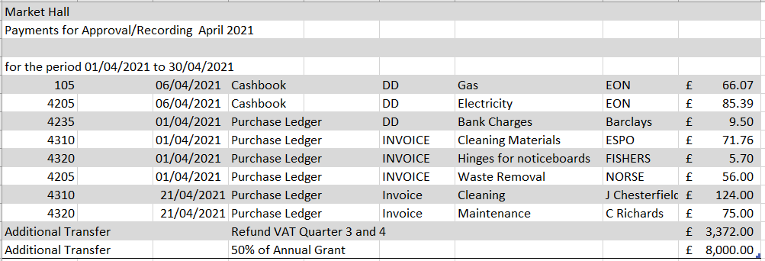**Appendix B**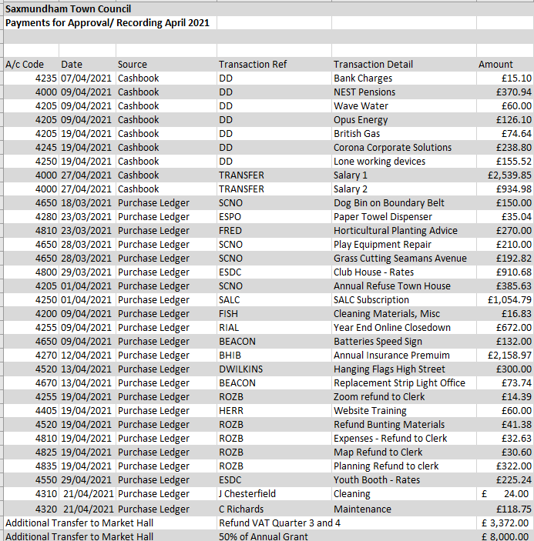

**Appendix C**

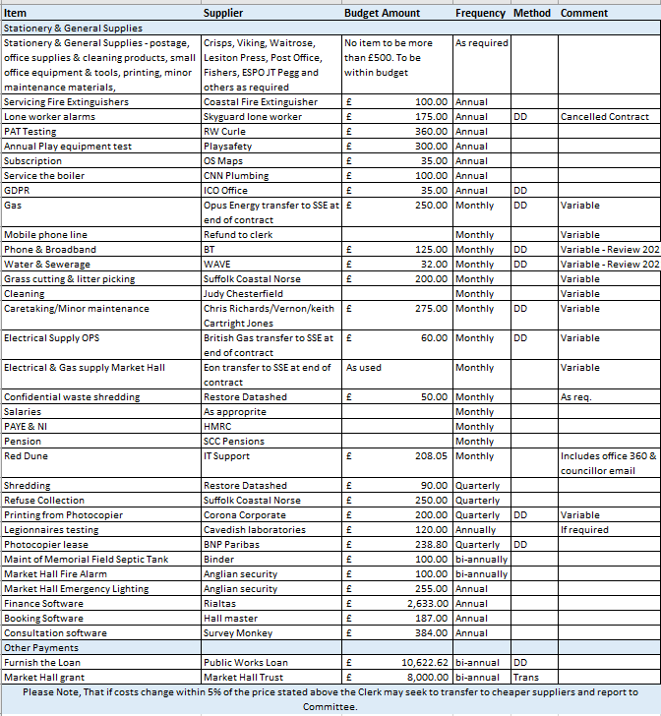

**Item 9b Appendix 8 – Minutes of the Market Hall Management Committee 26 April 2021**



**Saxmundham Town Council** ,

**Minutes of the Meeting of the Market Hall Management Committee**

**7.00 PM 5 May 2021 by Video Conference**

**Members of the Committee:**

Carole Cecil

Councillor Di Eastman

Councillor John Findlay

Councillor Charlotte Hawkins

Rosie Hoare

Councillor. Tim Lock

Councillor. Jeremy Smith (Chair)

**Also Present:**

Roz Barnett (Clerk)

|  |  |
| --- | --- |
| **62/20MHC** | **Apologies for absence**  No apologies for absence were received. |
| **63/20MHC** | **Pecuniary/Non-Pecuniary Interests**  There were no Declarations of Interests. |
| **64/20MHC** | **Minutes of the last meeting**  **It was RESOLVED to accept the minutes of the previous meeting held on the 15th of March 2021.** |
| **65/20MHC** | **Finance Reports**   1. The Committee received the end of year position report for 2020-2021. Appendix A 2. The Committee received the report on the Market Hall Budget 2021-2022. Appendix B |
| **66/20MHC** | **Market Hall Improvements Phase 1**   1. The Clerk reported that the lighting bars and lights have been installed and that the underfloor storage rail has been ordered. 2. **RESOLVED: The Committee approved the install of a cabinet for the Broadband and the projector controls at a cost of £300.18.** |
| **67/20MHC** | **Market Hall Improvements Phase 2**   1. The Committee discussed the revised costs for the kitchen refit and asked the Clerk to seek some additional quotes for one contractor to do all the works. Councillor Lock warned that there could be additional costs once the Fire Risk Assessment Report is received. 2. The Committee noted that the works will cost more than the available funds. It was agreed to ask the Resources Committee to identify additional Council funding for the kitchen refit (£5000- £10,000). 3. It was agreed that the Clerk would apply for a grant of £2500 for a grant from the Adnams Trust towards the kitchen appliances. |
| **68/20HHC** | **Market Hall Improvements Phase 3**   1. The Committee formally agreed in principle that they would explore:  * Two different options of the installation of three glass apertures at the frontage. * Two options drawings for the toilets. One option to be based on the design suggested by the theatre designer and the second for the men’s toilets on a mezzanine above the disabled and women’s toilets (to create a larger entrance foyer area).  1. **Resolved: That Tim Buxbaum be appointed as the architect to the project and be commissioned to develop the options drawings, costs, and planning consent fees at a cost of up to £1500.** 2. It was agreed that the Clerk would make initial approaches to the Lottery Heritage Fund with a view to submitting an expressing an interest. It was noted that the capital works would best be completed early 2023 to allow for the events programme for the 750th programme of activities. |
| **69/20MHC** | **Bookings 2021- 2022**   1. The Committee noted that the risk assessment has been revised and agreed that the limit for the reopening should be 30 in line with government guidance. 2. The Clerk advised that organisations are keen to use the Market Hall. The Committee noted the report on bookings which currently predicts income of £4455. The Clerk stated that additional interest had been received for a parent and toddler group, Friday night bingo and a monthly driving test theory centre. It was suggested that the bingo night be limited to two Fridays a month. |
| **70/20MHC** | **Developing the Market Hall as a venue**   1. The Chair welcomed ideas from all the committee members for Events for the Market Hall Programme. Suggestions came forward for talks, puppetry, poetry, comedy and sales. The Clerk and Chair agreed to circulate information about any potential events to the Committee.   Rosie Hoare reported that she has pencilled in dates with the bands for the 2021 programme.   * 21 August - Swing Machine * 10 October - Blues Bluffers/Ska Band * 20 November - Operlele cabaret night * December– Horn Factory to be confirmed.   **Resolved: The Committee agreed to use the £1000 Events budget to support the events programme (Especially if numbers are limited by the government). It was agreed to delegate the day-to-day decision making on the Events Budget to the Clerk in consultation with the Chair of the Committee.**     1. **RESOLVED: that the Clerk books the HG Wells production for £150 per performance plus 50% of the Box Office.** |
| **71/20MHC** | **Alde and Blythe Community Radio**  The Chair informed the Committee that the Radio station have signed the licence and is now broadcasting on Friday, Saturday and Sunday. |
|  |  |

**The meeting closed at 8.28pm.**

**Roz Barnett**

**Clerk to Saxmundham Town Council,**

**Appendix A**

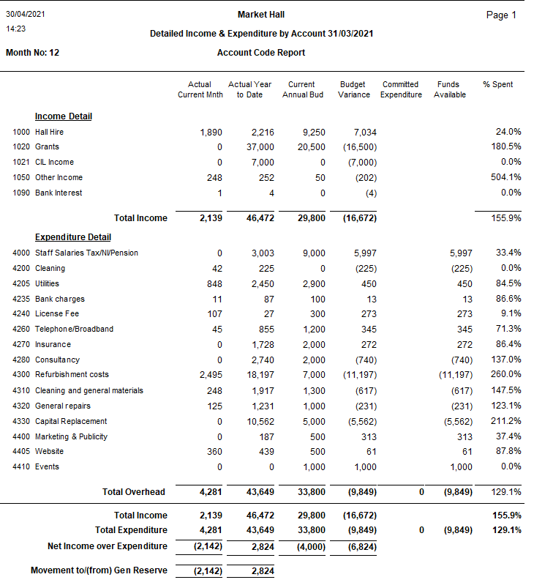

**Appendix B**

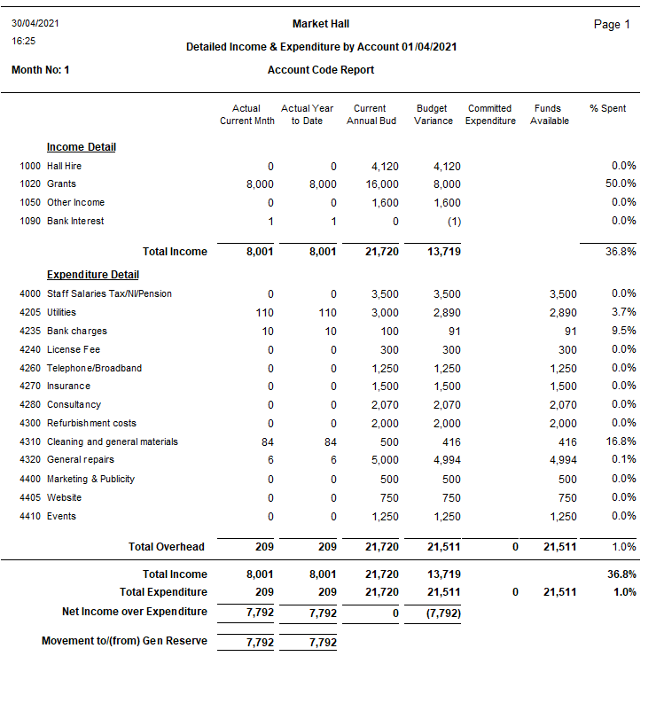

**Item 9c Appendix 9 – Minutes of the Amenities and Services Committee 19 April 2021**



**Saxmundham Town Council** ,

**Minutes of the Meeting of the Amenities & Services Committee**

**6.30 PM 28 April 2021 by Video Conference**

**Councillors:**

Councillor D. Eastman

Councillor C. Hawkins

Councillor R Hedley Lewis

Councillor T. Lock (Chair)

Councillor James Sandbach (Arrived 6.50pm)

**Also Present: Roz Barnett (**Town Clerk)

|  |  |
| --- | --- |
| **64/20AS** | **Apologies for Absence**  No apologies were received. |
| **65/20AS** | **Pecuniary/Non-Pecuniary Interests**  There were no Declarations of Interests. |
| **66/20AS** | **Minutes of the Previous Meeting**  **It was unanimously RESOLVED to approve the minutes of the meeting held on the 29 March 2021.** These minutes will be signed by the Committee Chair at the earliest opportunity. |
| **67/20AS** | **Clerk Update**  The Clerk informed the Committee of recent developments:   1. Repairs to the IP17 Good Neighbours Scheme office lighting was completed at a cost of £180. The existing light fittings were replaced with energy efficient LED fitments. This was completed under the Clerks delegated powers in consultation with the Committee Chair. 2. The Clerk explained that the station plants were scheduled to arrive and asked if there was anyone available to help with the planting. Councillors suggested that the Clerk investigates the installation of an outdoor tap. 3. A local company has offered to restore the war memorial. It was agreed to accept the offer and allow the Clerk to authorise spending on materials. 4. The Clerk had received the costs for the grass cutting for 2021-2022, £662 for the Memorial field and £128.75 for Chantry Rd. It was agreed to stay with Norse and keep the mowed paths at Memorial Field. |
| **68/20AS** | **Memorial Landscape Project**   1. The working group recommended that t a topographical survey of the Memorial Field and Seaman Avenue Play area be completed. It was agreed that the Clerk would progress this and arrange for quotes. Councillor Lock offered to send the details of some local companies.   The group suggested that applications for funding could be made to Tesco’s, Adnams, Award for All and possibly request some CIL money.   1. The working group also suggested contacting play companies and asking them for design ideas for the improvements to Seaman’s Avenue Play Area. It was agreed the Clerk would invite some companies for their ideas. 2. The Councillors asked that the trees be staked on the Memorial Park. The Clerk agreed to chase the contractor for quotes. |
| **69/20AS** | **Youth Booth**   1. Councillors noted that the Clerk had approached 5 companies for quotes to paint the Youth Booth and discussed the two quotes received. It was decided to go with the company that had recently completed the painting at the Market Hall as the Council were pleased with his work. The Committee suggested that the building be painted in anti-graffiti paint in the esixting colour. **RESOLVED: that the Clerk award the contract to Phil Leon at a cost of £600 labour plus paint materials.** 2. It was agreed that the Clerk would ask CYDS to design the Youth Booth Sign and that the Council will pay the costs of the production. |
| **70/20AS** | **Saxmundham Walking Trail**  Councillors agreed the route for the walking trail and suggested it be called the ‘Fromus Walking Trail.’ The Clerk was asked to consult with East Suffolk and ensure that the County Council Rights of Way Team approve the route. Once these approvals have been confirmed the Clerk will order the signs and stickers. |
| **71/20AS** | **Bins Requests**  The Committee considered the request for a bin on Rendham Rd beside the bench. It was agreed to consult with East Suffolk with a view to ordering a mixed-use bin at a cost of £515. |
| **72/20AS** | **Signage**   * Councillors agreed the wording of the Play Park signage for Seaman Avenue and Chantry Rd. * The Clerk reported that East Suffolk had provided free dog waste signage and stickers. The Clerk was asked to investigate whether all the bins were mixed use and get costs for the Keep Britain Tidy ‘Watching You’ signage. |
| **73/20AS** | **Flagpole**  Councillors discussed the idea and costs of a flagpole in the Town either at the Town House or the Market Hall. It was decided not to pursue it in the immediate future and wait to see what recommendations come from the Neighbourhood Plan steering Group about the Town Centre. |
| **74/20AS** | **Saxmundham in Bloom**   * The Councillors agreed to keep the current mowing regime which leaves some areas uncut. It was also agreed to wait until the Environment Co-ordinator is appointed to develop a cohesive strategy for all the sites in Town. * Councillors agreed to develop a plan for the planting for the North and South Entrance. * The Clerk warned the Council that there might be additional costs for the testing of the lampposts. * It was agreed that the Clerk would get costs for autumn bulb planting. * It was agreed to develop a plan for the 2022 planting scheme in the Summer of 2021. |
| **75/20AS** | **Annual Plan**  Councillors agreed to develop an annual Plan for the Committee. |
| **76/20AS** | **Correspondence**  There was no additional correspondence received. |
|  |  |

**The meeting closed at 7.33 p.m.**

**Roz Barnett**

**Clerk to Saxmundham Town Council, Old Police Station, Approach Road, Saxmundham, IP17 1BW**

**Tel: 01728 604595**

**Item 9d Appendix 10 – Minutes of the Planning & Development Control Committee 14 & 28 April 2021**



**Saxmundham Town Council**

**Council ,**

**Minutes of the Meeting of the Planning & Development Control Committee**

**6.00 PM 14th April 2021 by Video Conference**

**Councillors:** Cllr. J. Fisher (Chair) Cllr. C. Hawkins Cllr. N. Hiley

**Also Present:**  J. Morcom (Assistant Town Clerk (ATC))

|  |  |
| --- | --- |
| **1/21PD** | **Apologies for absence**  None have been received. |
| **2/21PD** | **Pecuniary/Non-Pecuniary Interests**  None declared at this point. |
| **3/21PD** | **Minutes of the Previous Meeting held 22nd February 2021**  **It was unanimously RESOLVED to approve the minutes of the meeting held 22nd February 2021.** These will be signed when the Chairperson is able to come to the office. |
| **4/21PD** | **Open Forum**  No members of the public had joined the meeting. |
| **5/21PD** | **Planning Applications**  DC/21/1255/ADN: Fingerpost close to junction of Market Place and high St. This is the town council’s own application.  **The Committee noted the application.** |
| **6/21PD** | **Recent Planning Decisions.**  The Committee noted the decision to permit DC/20/4835/FUL, alterations to the rear windows of 34 Church St. |
| **7/21PD** | **To discuss and recommend a response to East Suffolk planning protocol survey from Theberton and Eastbridge Parish Council.**  This is a survey seeking support for criticism of East Suffolk’s planning protocols.  **Cllr Fisher declared a non-pecuniary interest in the item as he is an East Suffolk councillor.** This rendered that Planning Committee inquorate and, therefore, unable to recommend a response to the Town Clerk.  **The Committee suggested that the Town Clerk contact individual councillors about the survey. ATC to discuss the matter with the Clerk.** |
| **8/21PD** | **To note, and, if appropriate, to recommend responses to East Suffolk consultation documents**  8a. East Suffolk Community Infrastructure Levy charging Schedule:  **It was unanimously RESOLVED that the ATC should respond regarding the Committee’s concerns that CIL rates would not be fixed for large strategic sites and may be zero, with no guarantee that S.106 would be used to deliver community infrastructure instead.**  8b. Sustainable construction Supplementary Planning Document;  **It was unanimously RESOLVED that the ATC should respond regarding the Committee’s concerns that the document does not mention wildlife friendly design.**  Cllr Hawkins left the meeting at 6.50pm because of internet problems. |
| **9/21PD** | **To discuss/report back any concerns on energy projects**  9a Sizewell C:  Cllr Hiley reported that he had attended the preliminary meetings with the Planning Inspector and the timetable was under review. He had also reported back to the Full Council.  9b. Off-shore windfarms:  The Committee noted the timeline. |
|  | **The next meeting of the Planning and Development Control Committee will be at 6pm on Monday 28th April 2021.** |

**The meeting closed at 7 p.m.**

**Jennifer Morcom, Assistant Clerk to Saxmundham Town Council**

**The Town House, Station Approach**

**Saxmundham, IP17 1BW**



**Saxmundham Town Council ,**

**Minutes of the Meeting of the Planning & Development Control Committee**

**6.00 PM 28thth April 2021 by Video Conference**

**Councillors:** Cllr. J. Fisher (Chair) Cllr. C. Hawkins Cllr. N. Hiley

**Also Present:**  J. Morcom (Assistant Town Clerk (ATC))

|  |  |
| --- | --- |
| **10/21PD** | **Apologies for absence**  None have been received. |
| **11/21PD** | **Pecuniary/Non-Pecuniary Interests**  None declared at this point. |
| **12/21PD** | **Minutes of the Previous Meeting held 14th April 2021**  **It was unanimously RESOLVED to approve the minutes of the meeting held 22nd February 2021.** These will be signed when the Chairperson is able to come to the office.  The ATC fed back that no councillors had responded with regard to the questionnaire from Theberton and Eastbridge.  East Suffolk had telephoned in response to Town Council (STC) comments about the lack of specification of CIL on major sites and STC’s point that this should at least be qualified with an expectation of S.106. East Suffolk intend to arrange a ZOOM meeting with STC and Benhall sometime in May. |
| **13/21PD** | **Open Forum**  No members of the public had joined the meeting. |
| **14/21PD** | **Planning Applications**  DC/21/0317/FUL: Saxmundham Free School, amendments to plans for new teaching block.  The Committee were concerned, despite broadly supporting the application, that they could not easily understand what had been changed on the new set of plans. In particular they would like to know how the designers had responded to concerns about privacy from the residents of Lincoln Avenue. A design and access statement would have helped a great deal in this case.  **The Committee resolved that the ATC should make these points in the response to East Suffolk.**  DC/21/1797/FUL: BT siting two storage containers in land to the rear of 48 High Street.  Although the Committee had no major objection to the siting of the containers, they were concerned that they may be unsightly, and would like them to be landscaped with either a green wall or planting around the fencing. They would also like to know what the containers are to be used for. |
| **15/21PD** | **Recent Planning Decisions. - none** |
|  | **The next meeting of the Planning and Development Control Committee will be at 6pm on Wednesday 12th May 2021. TBC** |

**The meeting closed at 6.28 p.m.**

**Jennifer Morcom, Assistant Clerk to Saxmundham Town Council**

**The Town House, Station Approach**

**Saxmundham, IP17 1BW**

**Item 10a Appendix 11 – Payments and Receipts April 30 2021**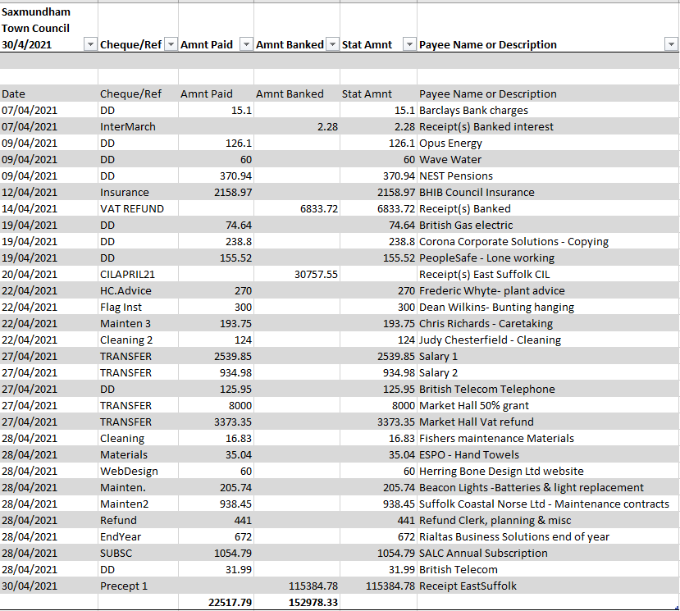

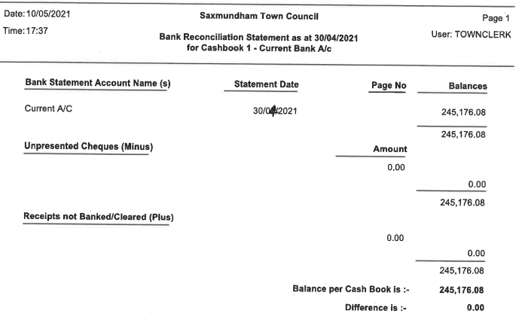

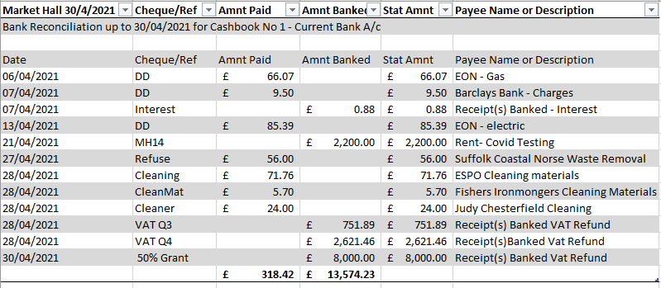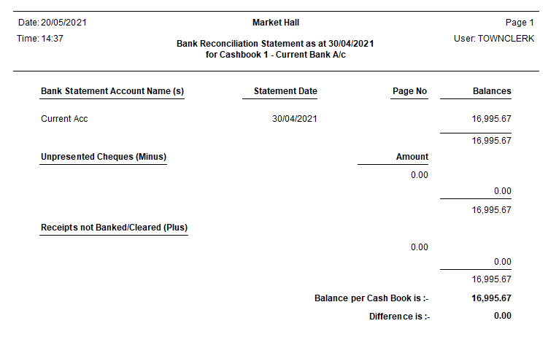

**Item 10 b Appendix 12 – April Financial Reports** 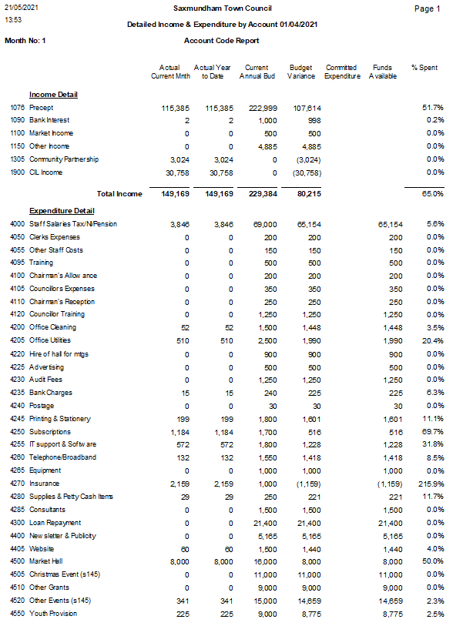m 4e – 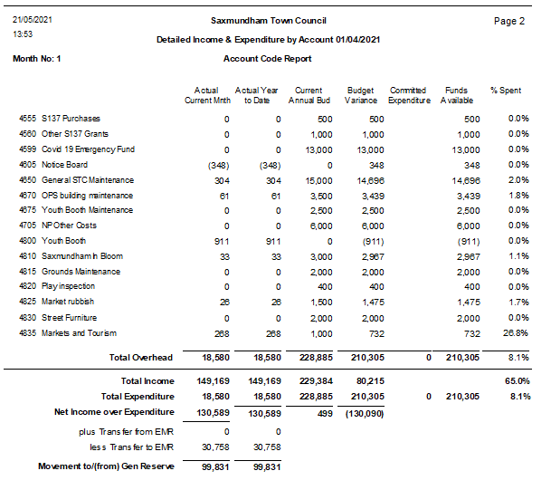

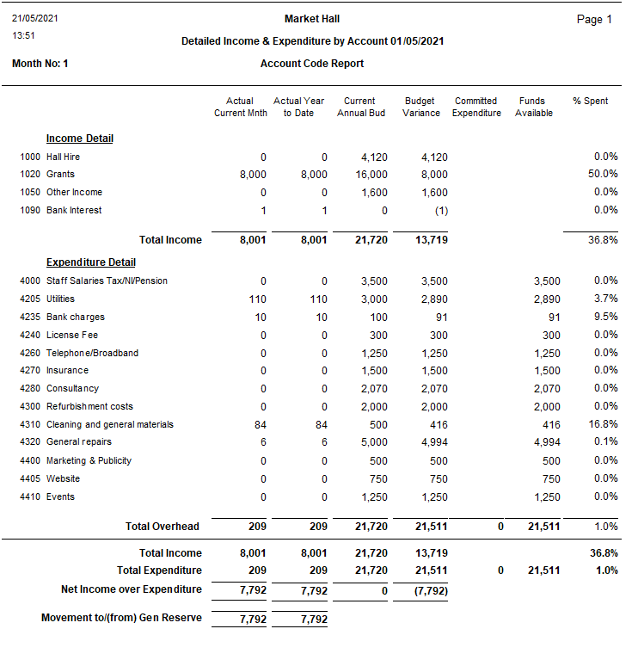

**Agenda item 11 – Appendix 13 Payments Report**

1. **Summary.**

**Issue 1**

In reviewing the end of year paperwork, the Clerk has found that between the records of payments approved and the actual payments made there are several discrepancies. This is because the list of payments for approval that are taken to the Resources Committee are a snapshot in time. There maybe direct debit payments or payments that are made at the end of the month that get omitted from the payment list which means that the Town Council are not being presented with the full information.

The payment list for approval is also being prepared outside of the Rialtas software system so there is also an issue of not looking at the actual data that is being inputted into the programme and this creates the opportunity for error.

**Issue 2**

For efficiency, within a larger council payment may need to be made throughout the month. The reasons why this is important are: -

* To prevent unnecessary delays into operations while waiting for Committee meetings.
* Some smaller suppliers require quick payment (Especially due to Covid-19).
* There is not a petty cash system so timely reimbursement is important.
* If the Council works with businesses and community organisations, to deliver events, payments will need to be made timely.

Custom and practice in Town Councils is that normally the clerk would make a payment without the payment being authorised by committee in these circumstances:

* There was money in the budget,
* It had been duly authorised at a committee or was within the delegated authorisation of expenditure.
* Payment was made in consultation with the relevant chairs and reported back to Council at the first possible opportunity.
* SALC has advised that the auditors would not normally pick up whether a payment has been authorised if the expenditure had been clearly authorised but making payments within the month is not allowed within the existing financial regulations and an amendment would be required.

**Issue 3**

Sometimes the Clerk is expecting an invoice that must be paid by a certain date but may not yet have received the invoice or the works completed. This is a particular issue at the end of the financial year. This means that some payment may be listed when the works have been completed but the invoice not yet received.

**Issue 4**

**The current financial regulations state the clerk is required to seek 3 estimates for expenditure over £100.**

h) When it is to enter into a contract of less than £25,000 in value for the supply of goods or materials or for the execution of works or specialist services other than such goods, materials, works or specialist services as are excepted as set out in paragraph (a) the Clerk or RFO shall obtain 3 quotations (priced descriptions of the proposed supply); where the value is below [£3,000] and above [£100] the Clerk or RFO shall strive to obtain 3 estimates. Otherwise, Regulation 10.3 above shall apply.

**2.0 Options**

The Clerk has discussed this issue with Local Clerks and looked at other financial regulations. Below are some of the amendments made by other councils.

**Sudbury have made it payments over £500 requiring approval.**

The RFO shall prepare a schedule of payments with the values over £500 requiring authorisation, forming part of the Agenda for the Meeting and present the schedule to the finance committee. The committee shall review the schedule for compliance and, having satisfied itself shall authorise payment by a resolution of the finance committee. The approved schedule shall be ruled off and initialled by the Chairman of the Meeting. A detailed list of all payments shall be disclosed within or as an attachment to the minutes of the meeting at which payment was authorised. Personal payments (including salaries, wages, expenses, and any payment made in relation to the termination of a contract of employment) may be summarised to remove public access to any personal information.

**Thetford have gone for the ‘work in progress model’ stating that some payments have made and will ratified, and some payments are for approval.**

The RFO shall prepare a schedule of all payments (including BACS, cheque payments, Direct Debits and Standing Orders) already made or to be made from the Council’s bank accounts. The payment schedule shall form part of the Agenda for the Finance Committee Meeting and the RFO shall present the payment schedule to the Finance Committee. The payment schedule will contain payments already made and which require ratification by the Finance Committee. The schedule will also contain payments that will still have to be made and these will need to be approved prospectively by the Finance Committee. The detailed list of all payments already made or still to be made shall be disclosed within or as an attachment to the minutes of the meeting at which payment was authorised. Personal payments (including salaries, wages, expenses and any payment made in relation to the termination of a contract of employment) may be summarised to remove public access to any personal information.

**Stowmarket have gone for a ratification of payments made.**

The RFO shall prepare and submit a schedule of payments to the Council for each month of the year and payments made shall be ratified by the Council. All invoices for payment shall be examined, verified and certified by a budget manager to confirm that the work, goods or services to which each invoice relates has been received, carried out, examined and represents expenditure previously approved by the Council.

**Three estimates for expenditure over £100.**

Larger councils have adopted a best value statement or a threshold over £2000. Medium Councils have adopted a threshold between £500 and £1000. Smaller Councillors have opted for a threshold between £100 and £500.

1. **Recommendations.**

**Recommendation 1**

That any reports to council Committee should be taken directly from the Rialtas System, to ensure councillors are looking at the actual data entered onto the system.

**Recommendation 2**

The RFO shall prepare and submit a complete schedule of actual payments and receipts to the Town Council for ratification each month.

**Recommendation 3 - Amendment to the Financial Regulations - Payments**

**Remove**

5.4. The RFO shall prepare a schedule of payments requiring authorisation, forming part of the Agenda for the Meeting and, together with the relevant invoices, present the schedule to Resources Committee. The Schedule shall indicate the items for which authority to spend was given by the Council or Committee, and those which are under the Clerk’s delegated authority.

5.5. The Committee shall review the schedule for compliance and, having satisfied itself shall authorise payment by a resolution. The approved schedule shall be signed and initialled by the Chairman of the Meeting. A detailed list of all payments shall be disclosed within, or as an attachment to, the minutes of the meeting at which payment was authorised. Personal payments (including salaries, wages, expenses and any payment made in relation to the termination of a contract of employment) may be summarised to remove public access to any personal information.

5.6. A schedule of payments requiring authorisation which cannot reasonably await the next Resources Committee meeting may be put to the full Council by the Clerk, following the same procedure as set out above.

5.7. The Clerk/ RFO shall have delegated authority to authorise the payment of items only in the following circumstances:

a) If a payment is necessary to avoid a charge to interest under the Late Payment of Commercial Debts (Interest) Act 1998, and the due date for payment is before the next scheduled Meeting of council, where the Clerk and RFO certify that there is no dispute or other reason to delay payment, provided that a list of such payments shall be submitted to the next appropriate meeting of the Resources Committee

b) An expenditure item authorised under 5.8 below (continuing contracts and obligations) provided that a list of such payments shall be submitted to the next appropriate meeting of the Resources Committee.

c) fund transfers within the council’s banking arrangements up to the sum of £10,000, provided that a list of such payments shall be submitted to the next appropriate meeting of the Resources Committee.

**Replace with**

*The RFO shall prepare and submit a schedule of payments to the Council for each month of the year and payments made shall be reported to the Council for retrospective ratification. (Where there is clear authorisation of the payment and sufficient funds in the budget the Clerk will make any payments). All invoices for payment shall be examined, verified and certified by the RFO to confirm that the work, goods or services to which each invoice relates has been received, carried out, examined and represents expenditure previously approved by the Council. Where the invoice exceeds the authorised expenditure by up to 20%, the Clerk will seek an additional approval from the chair of the Resources Committee. Where the excess amount exceeds the authorised expenditure by more than 20% the RFO will seek Committee approval.*

**Recommendation 4 - Amendment to the Financial Regulations – Estimates**

**Current Wording**

h) When it is to enter into a contract of less than £25,000 in value for the supply of goods or materials or for the execution of works or specialist services other than such goods, materials, works or specialist services as are excepted as set out in paragraph (a) the Clerk or RFO shall obtain 3 quotations (priced descriptions of the proposed supply); where the value is below [£3,000] and above [£100] the Clerk or RFO shall strive to obtain 3 estimates. Otherwise, Regulation 10.3 above shall apply,

**Amend to**

RECOMMENDATION: To the Town Council: that an amendment be made to the Financial Regulations to raise the expenditure threshold to £1000 for the requirement of three estimates. (The Clerk however would be expected to always seek best value in all contract works as stated in the financial regulations).

**Agenda item 12a – Appendix 14 VAT underclaim**

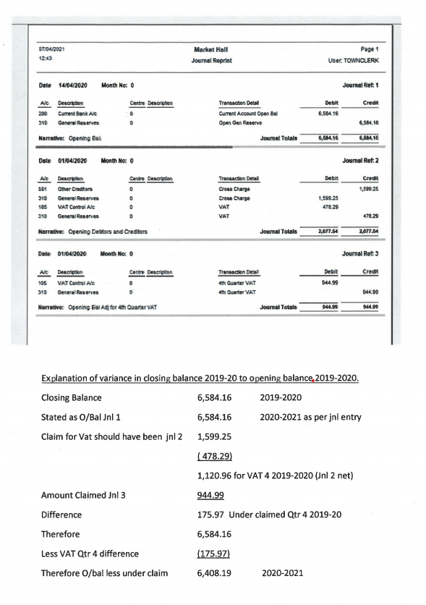

**Agenda item 12b – Appendix 15 Risk Register**

| Item 7b  Subject: | No. | Risk identified | Potential impact  (H/M/L) | Level of risk  (H/M/L) | Management/Control of risk | Review/Assess/Revise |
| --- | --- | --- | --- | --- | --- | --- |
| Business continuity | 1. | Council unable to continue business as a result of an unexpected or tragic event | H | **L** | All files and recent records are retained at the council’s office. There is a secure, cloud-based IT system for digital records. Paper documents, both current and archived, are filed in the Saxmundham Town House. | Review regular updating of user passwords.  Personnel files are stored in locked, metal filing cabinet.  All other paper-based documentation has been reviewed but historical documentation is yet to be logged and archived appropriately.  Assistant clerk and clerk share information about each other work. |
| Business  continuity | 2 | Town Clerk temporarily absent or otherwise unable to carry out duties. | H | M | In the event of the clerk being indisposed the assistant town clerk will provide clerical support. An operational plan is in place including temporary clerical support. | Ensure that both members of staff have reasonable day-to-day experience of all systems to ensure continuity.  Arrangements explored with SALC about cover for financial administration using Rialtas.  Council to revert to using cheques in an emergency. |
| Business continuity | 3. | Council records: Loss through damage, fire or theft | H | L | IT system files are backed-up using a cloud-based system. This occurs at file creation and updating. See Business Continuity 1. | Also refer to Business Continuity 1.  Provide an emergency contingency plan. |
| Business  continuity | 4 | Access to confidential information by non-authorised personnel. | M | L | Only the town clerk, the assistant town clerk and the IT administrator have access to the IT system. | Password updating procedure in place with our IT support.  Contact IT support if access is required.  See Financial Regulations.  Cabinets/Offices to be locked when Clerk/Assistant Clerk not present. |
| Business continuity | 5 | Meeting location adequacy: Health and Safety | H | L | Full Council meetings are normally held in the Market Hall. Committee meetings are normally held either in the Market Hall or Saxmundham Old Police Station. The clerk and assistant town clerk hold keys/access codes to both. The premises are considered satisfactory providing all statutory health and safety obligations are observed. | Statutory health and safety obligations for both the Market Hall and the old police station reviewed and will be continued Relevant documentation retained in STC Office. |
| Freedom of Information Act (FOA) | 1 | Policy Provision | M | L | The council has a model publication scheme for local Councils in place. The Town Clerk is aware that if a substantial request arrives it may necessitate additional hours of work. The council is able to request a fee if the work will take in excess of 15 hours to complete. The request can be resubmitted in sections to negate the payment of a fee. | Monitor any report and potential impacts made under the FOA.  Review files for any previous information requests.  On receipt of an FOI, the Chair and Vice-Chair should be informed and monitoring of compliance to time to respond should be monitored |
| Data Protection | 1. | Failure to comply with GDPR (General Data Protection Regulation) 2018 or later regulations | H | L | Follow good administrative practice for securing personal and GDPR related data | Members to receive a briefing on an annual basis. |
| Finance | 1. | Precept adequacy | H | L | Sound planning and budgeting process to support the annual precept requirement. The process should take account of each committees’ recommendations. The Resources Committee reviews the planned budget in October/November with recommendation/agreement by Full Council each January. | Minute to be made on budget, submission of precept request and receipt of precept payments.  Copy of the approved budget to be sent to all members. |
| Finance | 2. | Budgetary control | H | H | The RFO to regularly provide the council with regular updates regarding receipts and expenditure against each budget category. | Part of Financial Standing Orders Section 4. Budgetary Control and Authority to Spend. Financial Regulations reviewed 2020 and will be reviewed reported to Resource Committee & Council annually  Resources Committee to receive regular budget/forecast detailed update. Full council to receive regular updated summary budget sheet. |
| Finance | 3. | Insurance adequacy | M | H | Statutory requirement: Employers’ Liability, Public Liability, Fidelity Guarantee. Annual review completed. Part of annual audit. | Asset Register to be reviewed annually or updated more frequently as required.  Market Hall to have a separate asset list.  RFO to report to Council on general adequacy of insurance. |
| Finance | 4. | Banking: Adequacy of checking procedure | L | L | The council has agreed Financial Regulations which determine the procedure. Annual independent audit. | Review Financial Regulations annually and as required.  Online banking mandate to be reviewed by Full Council, when necessary. |
| Finance | 5. | Cash: Control to prevent loss through theft | H | L | Regular reconciliation of bank statements prepared by RFO. Checked and signed by designated Councillor. Two authorised signatures required for cheques.  Annual internal and external audits completed.  For internet banking payments will be initiated by the clerk and approved by an authorised signature. | Part of Financial Standing Orders. Review as required.  Review procedure for on-line banking and on-line payment authorisation. On-line banking mandate to be reviewed and agreed by Council |
| Finance | **6.** | Approval of expenditure: authorisation levels | H | L | Any financial decision must be resolved and clearly recorded prior to any commitment. This usually takes place at Committee meetings.  All income and expenditure must be detailed in the monthly financial reports presented to the Resources Committee and Full Council. | Financial Regulations reviewed and specific limits specified.  Order sheet which contains authorisation notes and minute numbers to be completed by Clerk and Assistant Clerk. |
| Finance | 7. | Fraud | H | L | Internal procedures are observed. Fidelity Guarantee insurance must be in place. | Monitor adherence to Financial Regulations.  Annual check of fidelity insurance. |
| Finance | 8. | VAT & other Taxes | H | L | The council has Financial Regulations which define the requirements for VAT recovery which is completed on a quarterly basis.  PAYE tax & NI paid as defined by HMRC regulations. | Council to review the VAT in relation to the Market Hall. |
| Land and Property |  | Don’t have key documents of ownership and possession. | L | L | Clerk to review all documents and seeing information from Land registry where there are gaps | Council to consider whether to pursue registering any unregistered property/land |
| Land and Property |  | Licences and Leases ha | L | L | Clerk to review all documents and seeing information from Land registry where there are gaps | Council to consider whether to pursue registering any unregistered property/land |
| Liability | 1. | Damage to building assets, street furniture, IT equipment, play equipment and other equipment | M | L | An Asset Register is maintained, and insurance is held at the appropriate level for all items. Regular checks are made on all equipment by the appropriate service providers and members of the council. | A central log should be maintained for any items of equipment or documentation which are lent out. This to include a signature by the borrowing party.  See comments on Asset Register and Insurance Cover.  Capital Replacement Fund now in place. |
| Liability | 2. | Legal Powers: Illegal activity or payments  Legal powers: Working Parties taking decisions | H  L | L  L | All activity and payments made within the powers of the Town Council (not ultra vires) are to be resolved and clearly recorded in the minutes.  Ensure clear terms of reference are in place for Committees and Working parties. | Existing procedures adequate.  Review inclusion of powers being used by Council in the minutes and papers.  Terms of reference in place and agreed. |
| Liability | 3 | Agendas, minutes and statutory documents: Accuracy and legality and/or non-compliance | L | L | Agendas and minutes are produced in the prescribed method and adhere to legal requirements.  Minutes are approved and signed at the next meeting where possible.  Agendas and minutes are displayed according to legal requirements.  Business conducted at Council meetings should be managed by the Chairman according to Standing Orders.  (Covid -19 has impacted on signatures) | Existing procedures adequate.  Undertake adequate training to ensure adherence to procedure.  Members to adhere to Code of Conduct and Standing Orders.  Review Standing Orders at least annually to ensure relevance. |
| Liability | 4. | Public Liability: Risk to third party, property or individuals | H | L | Insurance is in place. Risk assessment of any individual event is undertaken. Separate insurance is taken for one-off events. Health and safety risk assessment, training and instruction routinely completed. | Existing procedures adequate. An annual review of insurance cover to be completed at the start of each financial year. |
| Council Reputation | 1. | Conflict of interest  Register of Members’ Interests | L  L | L  L | Councillors have a duty to declare any interest at the start of a meeting or when an interest becomes apparent during a meeting. Councillors with a pecuniary interest must leave the meeting while that item is discussed.  Register of Members’ Interests form to be reviewed at least annually. | Existing procedures are adequate. Reminder to be issued regarding updates to the Interest Register at the start of each financial year.  Members to take individual responsibility to update the register on-line. |
| Council Reputation | 1. | Councillors and Staff: Bringing the Council into disrepute | M | L | Councillors understand and receive training on the Code of Conduct. A professional approach is undertaken for all Town Council matters.  An e-mail protocol policy is available. | Members to identify training requirements.  Clerk to issue a reminder covering available training at the start of each financial year.  Review e-mail protocol policy and update as required. |
| Health & Safety |  | Accident/injury public and staff | H | H | Staff have risk assessments and regularly monitor the Health & Safety risks | Councillors are not systematically involved in the strategic management of Health and Safety risks for the Council. Annual sites visit to be arranged to review sites, procedures in place and identify any areas for improvement. |
| COVID-19 |  | Sustained disruptions to service and budget.  Public health risks to staff and public | H | H | Specific risk assessments in place which are constantly reviewed considering government guidance. | Budget to include contingency for responding to unexpected events.  Staff & public welfare to be considered by relevant Committee in the event of a changing situation. |

**Agenda item 12c – Appendix 16 Internal Control Statement**

**SAXMUNDHAM TOWN COUNCIL**

**INTERNAL CONTROL STATEMENT FOR YEAR ENDING 31 MARCH 2022**

1. **SCOPE OF RESPONSIBILITY**

Saxmundham Town Council is responsible for ensuring that its business is conducted in accordance with the law and proper standards, and that public money is safeguarded and properly accounted for, and used economically, efficiently, and effectively.

The council is responsible for ensuring that there is a sound system of internal control which facilitates the effective exercise of the Council’s functions and which includes arrangements for the management of risk.

1. **THE PURPOSE OF THE SYSTEM OF INTERNAL CONTROL**

The system of internal control is designed to manage risk to a reasonable level rather than to

eliminate all risk of failure to achieve policies, aims and objectives; it can, therefore, only provide

reasonable and not absolute assurance of effectiveness. The system of internal control is based on an on-going process designed to identify and prioritise the risks to the achievement of the Council’s policies, aims and objectives, to evaluate the likelihood of those risks being realised and the impact should they be realised, and to manage them efficiently, effectively and economically.

1. **THE INTERNAL CONTROL ENVIRONMENT**

**The Council:**

The council reviews its obligations and objectives and approves budgets for the following year at its December or January meeting. The January meeting of the council approves the level of precept for the following financial year.

The Council has appointed a Resources Committee. The Committee normally meets 10 times during the financial year. Members of the Committee monitor progress against objectives, financial systems and procedures, budgetary control and carry out regular reviews of financial matters. The minutes of the meetings of the Committee are available to all members of the Council. A Councillor is appointed to have responsibility for bank reconciliation checks.

The full council normally meets 11 times each year and monitors progress against its aims and objectives at each meeting by receiving relevant reports from the Resource Committee and the Town clerk. The council carries out an annual review of its internal controls, systems and procedures.

**Clerk to the Council/Responsible Finance Officer:**

The Council has appointed a Clerk to the Council who acts as the Council’s advisor and administrator. The Clerk is the Council’s Responsible Financial Officer and is responsible for administering the Council’s finances. The Clerk is responsible for advising on the day to day compliance with laws and regulations that the Council is subject to and for managing risks. The Clerk also provides advice to help the Council ensure that its procedures, control systems and policies are adhered to.

**Payments:**

All payments are reported to the council for ratification. Most of the Council payments are made electronically or by direct debit with the clerk entering the payment and these being authorised by a councillor.

Where cheques are used two members of the council must sign every cheque and counterfoil.

The signatories should consider each payment against the relevant invoice, initial the invoice and initial the cheque counterfoil. All authorised cheque signatories are members of the Council. No officer of the Council can sign cheques.

**Income:**

All income is received and banked in the council’s name in a timely manner and reported to the council.

**Risk Assessments/Risk Management:**

The council reviews its risk assessment annually normally in March and regularly reviews its systems and controls.

**Internal Audit:**

The council appoints an independent and competent internal auditor who reports to the council on an annual basis on the adequacy of its:

* Records
* Procedures
* Systems
* Internal control
* Regulations
* Risk management

**External Audit:**

The council’s external auditors, submit an annual certificate of audit which is presented to the

Council.

**4. REVIEW OF EFFECTIVENESS**

The council has responsibility for conducting an annual review of the effectiveness of the system of internal control, which should include a review of the effectiveness of internal audit. The results of that review must be considered by the Council, which should also approve the Statement of Internal Control.

-------------------------------- ----- -----------------------------------

Chairman RFO/Clerk

Approved and adopted by Saxmundham Town Council)

Meeting date:

INTERNAL CONTROL REPORT

The Accounts & Audit (England) Regulations 2015 aims to strengthen governance and accountability through requirements related to internal control and internal audit.

Whilst the Parish Council has reviewed the effectiveness of the internal audit (independence, competence, proportionate and scope), it has a requirement to ensure that its financial management is adequate and effective and that it has a sound system of internal control: -

As part of its internal control, the Town Council has appointed a non-signatory Councillor to conduct a review of the system of internal control via the following tests on an annual basis with a written report of any findings to be submitted to the Council and minuted as received.

|  |  |  |
| --- | --- | --- |
| CONTROL TEST | TEST DONE | COMMENTS – check documents and initial |
| cH | Yes or No |  |
| Ensuring an up-to-date Register of Assets |  |  |
| Regular maintenance arrangement for  physical assets |  |  |
| Annual review of risk and the adequacy of  Insurance cover |  |  |
| Annual review of financial risk |  |  |
| Awareness of Standing Orders and  Financial regulations |  |  |
| Adoption of Financial and Standing Orders |  |  |
| Regular reporting on performance by  contractors |  |  |
| Regular review of contracts |  |  |
| Regular bank reconciliation, independently  reviewed |  |  |
| Regular scrutiny of financial records and  proper arrangements for the approval of  expenditure |  |  |
| Recording in the minutes or appendices of  the minutes the precise powers under  which expenditure is being approved |  |  |
| Payments supported by invoices, authorised and minuted |  |  |
| Regular scrutiny of income records to ensure income is correctly received, recorded and banked |  |  |
| Scrutiny to ensure precept recorded in  the cashbook agrees to District Council notification |  |  |
| Contracts of employment for staff  Contract annually reviewed  Updating records to record changes in  relevant legislation  PAYE/NIC properly operated by the  Council as an employer |  |  |
| VAT correctly accounted for VAT payments identified, recorded, and reclaimed in the cashbook |  |  |
| Regular financial reporting to Parish Council |  |  |
| Regular budget monitoring statements as reported to Parish Council |  |  |
| Compliance with Local Transparency Code  Of 2014: |  |  |
| Verifying that the Council is compliant with the General Data Protection Regulation requirements  Are the following in place:   * Audit / Impact Assessment * Privacy Notices * Procedures for dealing with Subject Access Requests * Procedure for dealing with Data breaches. * Data Retention & Disposal Policies |  |  |
| Minutes properly numbered and  paginated with a master copy kept in for safekeeping |  |  |
| Procedures in place for recording and  monitoring Members’ Interests and Gifts  of Hospitality |  |  |
| Adoption of Codes of Conduct for Members |  |  |
| Declaration of Acceptance of Office |  |  |

Date of review of system of Internal Controls……………………………………………………………………………………………….

Review of system of Internal Controls carried out by:

Name………………………………………………………………Signature…………………………………………………………………………….

Report submitted to Council (date)…………………………… ……………………………………………………

(minute reference) …………………………… ……………………… ………

Next review of system of Internal Controls due…………………………………………………………………………………………….

Additional comments by reviewer:

**Agenda item 14 – Appendix 17 Co-option of new councillor statement**

I would like to apply to Saxmundham Town Council, as I have recently moved to the town in South Entrance with my partner and I am interested in learning more about the town, as well as supporting the town as much as I possibly can. I grew up in Suffolk, on the coast and I have a keen interest in the preservation of English buildings and culture.

 I have worked as a Chef/Pastry Chef for over 10 years, and I feel the skills I have gained in this time will greatly benefit the council. I am currently working at Two Magpies Bakery. I am a keen Horticulturist, and my hobbies include Food Preserving, Travel, Long Distance Walking and Soap making. I also work freelance around the country, as a Duke of Edinburgh trainer and assessor.

**Rose Webster**