Roz Barnett
Saxmundham Town Council
Resources Committee 25 April 2022

- Finance
  - To note payments and receipts and reconciliation reports for March for the Town Council (Appendix 3)
- 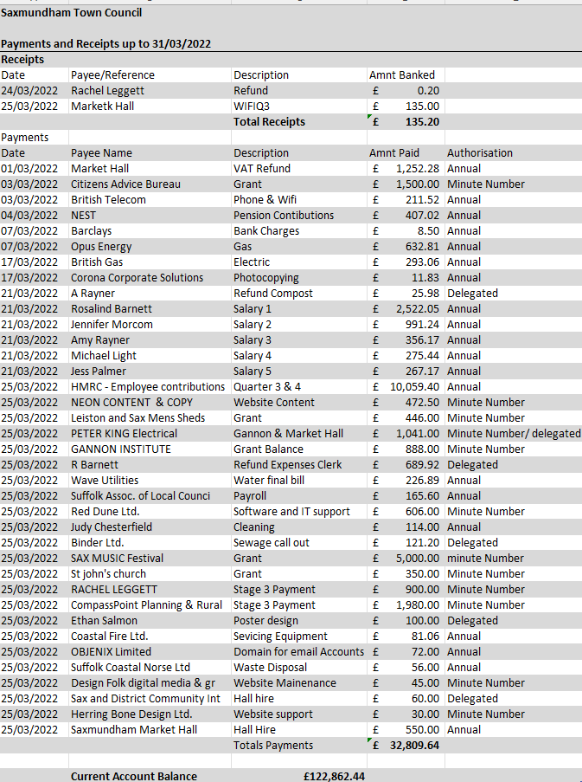

- Item 5: To note payments and receipts and reconciliation reports for March for the Market Hall (Appendix 4)
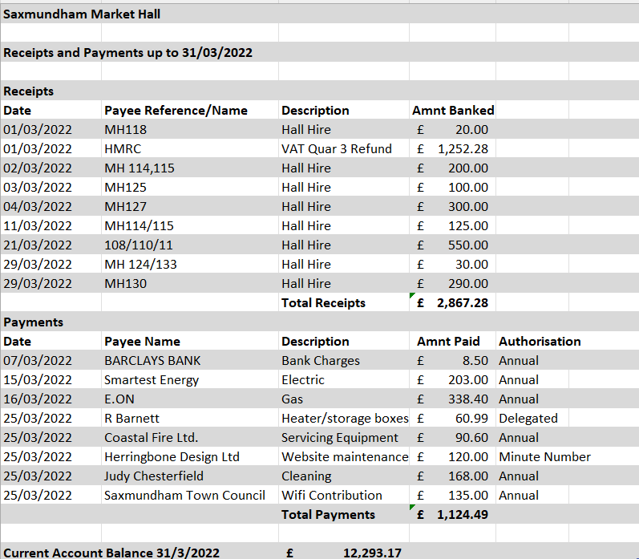

- To note April payments and authorise any payments outside of the Clerk’s delegated powers for the Town Council and Market Hall (Appendix 5).
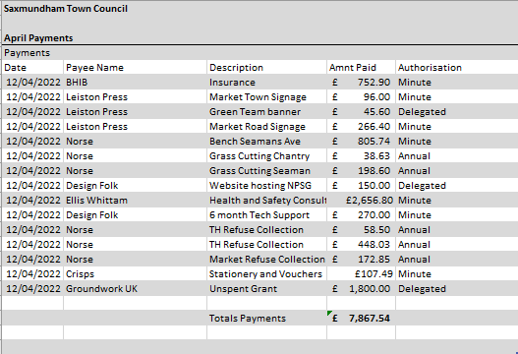

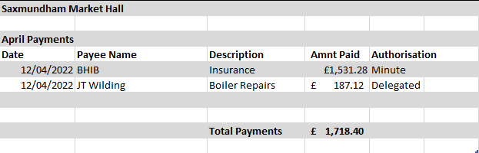

- To receive end of year financial reports for Town Council & Market Hall (Appendix 6).

