Roz Barnett
Saxmundham Town Council
Resources Committee 31 may 2022

- Finance
  - To note payments and receipts and reconciliation reports for April for the Town Council (Appendix 3)
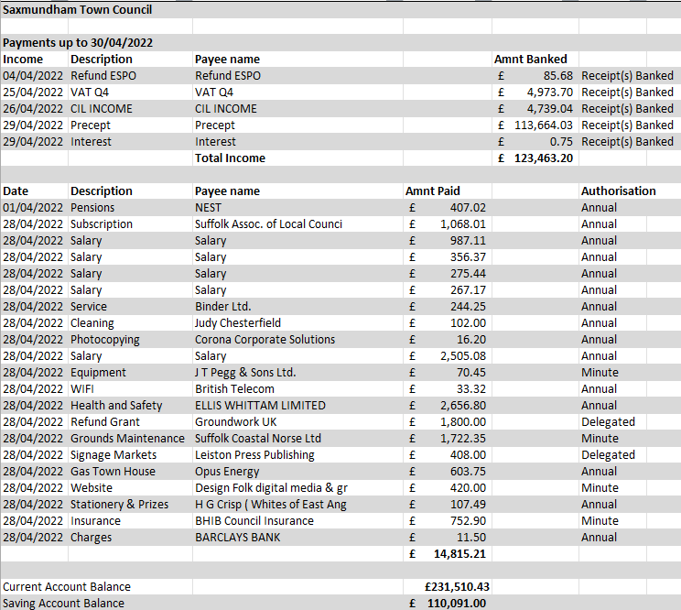

- Item 5: To note payments and receipts and reconciliation reports for April for the Market Hall (Appendix 4)

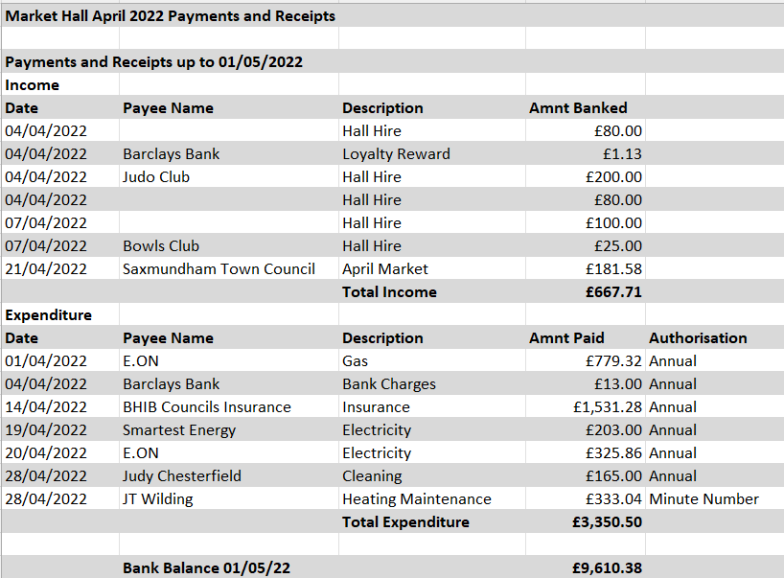

- To note May payments and authorise any payments outside of the Clerk’s delegated powers for the Town Council and Market Hall (Appendix 5).
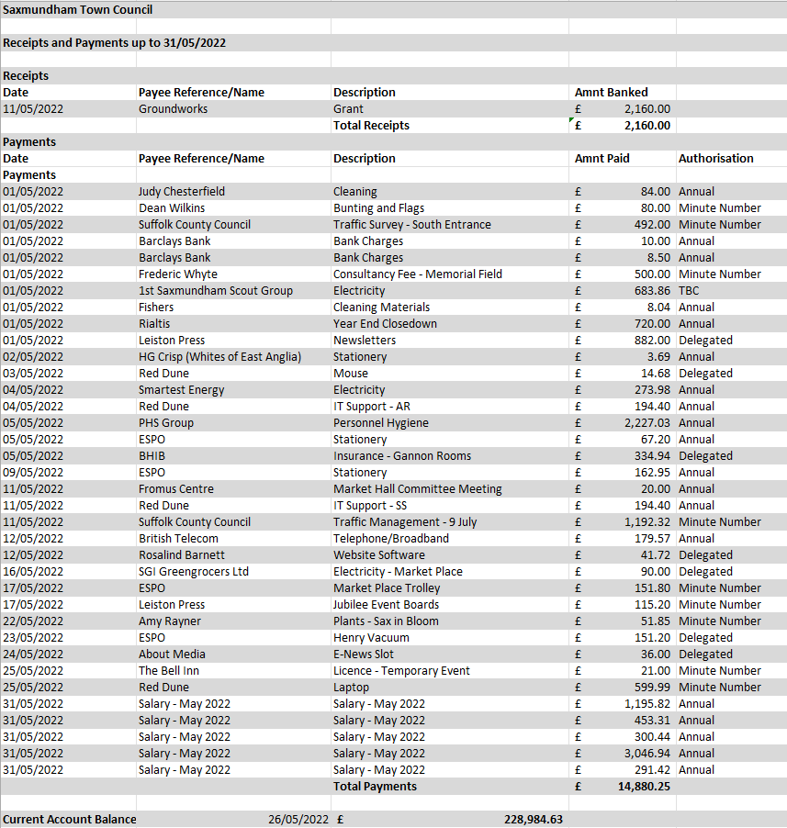

Market Hall Payments

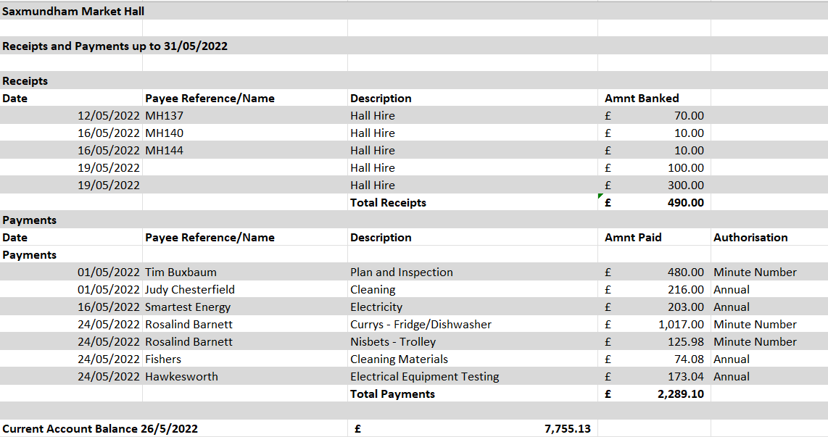

- Annual Approved Payments List
